Design and Verification of an Application Specific Integrated Circuit (ASIC)

Senior Project II



Kevin Cao, Whitley Forman, Dhruvit Naik,

Zachary Nelson* and Julie Swift

*Team Leader

Dr. Orlando Hernandez and Dr. Larry Pearlstein

May 2016

**Fulfillment Page**

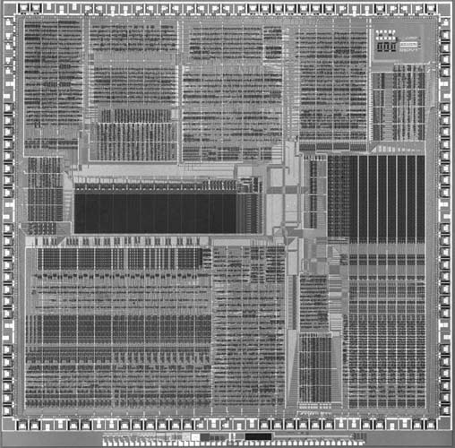

Submitted to the Faculty of the Electrical and Computer Engineering Department

of The College of New Jersey

Written and Researched by:

Kevin Cao

Whitley Forman

Dhruvit Naik

Zachary Nelson

Julie Swift

In partial fulfillment of the Bachelor of Science degree in Electrical and Computer Engineering

**Acknowledgements**

The team would like to acknowledge Ian Patel’s work on helping to set up the realistic FPGA test environment. Ian wrote the PSoC microcontroller code to generate an I2S audio stream and capture it back from the FPGA. He also wrote Matlab code that produced different types of waveforms in I2S format. We would also like to thank MOSIS for sponsoring the chip fabrication aspect of the project through the MOSIS Educational Program (MEP).

**Abstract**

The goal of this project is to gain experience in VLSI design by designing a chip that will process digital streaming audio data. More specifically, we will implement a 512-tap digital finite impulse response (FIR) filter, which will be applied to an input stream in order to create an output stream. We used the I2C protocol to allow a host to control the chip and the serial I2S protocol for transferring digital audio streams in and out.

Our hardware design was represented using Verilog register-transfer level (RTL) code. Development has been done using Xilinx ISE Design Suite 14.7. Test-benches were also designed and implemented using Verilog. The end goal of the project is to implement the design on a field-programmable gate array (FPGA). We will bring up our FPGA design with a realistic environment including an audio source, audio sink, and a microcontroller for reading and writing registers. We also plan to send a simple CMOS integrated circuit design for fabrication by MOSIS that will help us gain experience in physical chip design and prepare future groups to fabricate our full design.

**Keywords:** Application-specific integrated circuit (ASIC), Very large scale integration (VLSI) I2S, I2C, Digital filtering

**Table of Contents**

List of Tables 5

List of Illustrations 6

Nomenclature 7

Introduction 8

Specifications 10

Chapter 1: Background 11

Chapter 2: System Design 13

Chapter 3: I2S Interface 16

Chapter 4: Digital Filtering 26

Chapter 5: Register Block 33

Chapter 6: I2C Interface 41

Chapter 7: Simulation/Verification 11

Chapter 8: FPGA Implementation 11

Chapter 9: EDA Tools and Physical Design 11

Chapter 10: Conclusion 57

References 58

Appendix A: Project Overview 59

Biography 59

Engineering Standards and Realistic Constraints Form 59

Engineering Standards, Specifications, and Codes 59

Modern Engineering Tools 59

Appendix B: Management 61

Schedule 59

Meeting Minutes 59

List of Contacts 59

Material List 59

Financial Budget 59

Appendix C: Source Code 81

Appendix D: Test Benches 125

Appendix E: Industry Specifications 125

**List of Tables**

Table 1.1: Comparison of MOSIS Academic Account Types 12

Table 3.1: Interface Signals for I2S Input 19

Table 3.2: Interface Signals for Synchronizer Sub-Module ??

Table 3.3: Interface Signals for Deserializer Sub-Module ??

Table 3.4: Interface Signals for BIST Generator Sub-Module ??

Table 3.5: Interface Signals for Multiplexer Sub-Module ??

Table 3.6: Interface Signals for FIFO Sub-Module ??

Table 3.7: Interface Signals for I2S Output ??

Table 3.8: Interface Signals for Serializer Sub-Module ??

Table 4.1: Interface Signals for Filter

Table 4.2: Interface Signals for Filter Finite-State Machine

Table 4.3: Interface Signals for Filter Storage Module

Table 4.4: Interface Signals for Filter Mux Module

Table 4.5: Interface Signals for Filter Accumulator Module

Table 4.6: Interface Signals for Shift Round Truncate Module

Table 5.1: Register Mapping of Each Bit in the Address it is Stored

Table 8.1: Verilog Signals to FPGA Mapping ??

**List of Illustrations**

Figure I.1: Process of Designing a System on a Chip 8

Figure 1.1: Multi-Project Wafer 11

Figure 2.1: Top-Level Drawing of Chip 13

Figure 2.2: Detailed Top-Level Drawing of Chip 14

Figure 2.3: FPGA Testing Environment 15

Figure 3.1: Overall Chip Diagram with I2S Interfaces Highlighted 17

Figure 3.2: I2S Input Block Diagram 18

Figure 3.3: Sample of I2S Input Interface Simulation 20

Figure 3.4: Sample of Synchronizer Simulation ??

Figure 3.5: Sample of Deserializer Simulation ??

Figure 3.6: Sample of BIST Generator Simulation ??

Figure 3.7: Sample of Multiplexer Simulation ??

Figure 3.8: Sample of FIFO Simulation ??

Figure 3.9: Block Diagram of I2S Output Interface ??

Figure 3.10: Sample of I2S Output Interface Simulation ??

Figure 3.11: Sample of Serializer Simulation ??

Figure 4.1: Frequency Response of Filter Structures

Figure 4.2: Chip Diagram with Filter Highlighted

Figure 4.3: Top Level Block Diagram of Filter

Figure 4.4: Detailed Block Diagram of Filter

Figure 4.5: Finite State Machine: States and Transitions

Figure 4.6: Impulse Response of 512-Tap Low-Pass Filter

Figure 4.7: Simulation of Accumulator

Figure 4.8: Simulation of Filter Storage Module-Test 1

Figure 4.9: Simulation of Filter Storage Module-Test 2

Figure 4.10: Simulation of Mux

Figure 4.11: Simulation of Filter-Test 1

Figure 4.12: Simulation of Filter-Test 2

Figure 4.13: Simulation of Filter-Test 3

Figure 4.14: Simulation of Filter-Test 4

Figure 4.15: Simulation of Filter-Test 5

Figure 5.1: Chip Diagram with Register Highlighted

Figure 5.2: Internal Micro-Architecture of Register

Figure 5.3: Top Level Interface Design of reg.v

Figure 5.4: The Start of the Test Fixture Simulation

Figure 5.5: Bits trig_i2si_fifo_overrun_clr and trig_i2so_fifo_underrun_clr are Triggered

Figure 5.6: Bits are Triggered in Second Testbench

Figure 5.7: Test data properly being written from the I2C into the Register Part 1

Figure 5.8: Test data properly being written from the I2C into the Register Part 2

Figure 7.1: Lowpass Filter: Square Wave Samples 0 - 1000

Figure 7.2: Lowpass Filter: Square Wave Samples 2000 - 3000

Figure 7.3: Highpass Filter: Square Wave Samples 0 - 1000

Figure 7.4: Highpass Filter: Square Wave Samples 2000 - 3000

Figure 7.5: Average Filter: Square Wave Samples 0 - 1000

Figure 7.6: Average Filter: Square Wave Samples 2000 - 3000

Figure 8.1: FPGA Testing Set Up

Figure 8.2: FPGA Waveforms (Pass-Through Filter)

Figure 9.1: Project Manager Window

Figure 9.2: New Project Wizard – Screen 1

Figure 9.3: New Project Wizard – Screen 2

Figure 9.4: 38 x 40 μm 25Ω Resistor

Figure 9.5: 40 x 40 μm Spiral Inductor

**Nomenclature**

**ASIC**: Application Specific Integrated Chip

**BIST**: Built in Self-Test

**CIF**: Caltech Intermediate Form

**DIP**: Dual in-line package

**EDA**: Electronic Design Automation

**FPGA**: Field Programmable Gate Architecture

**FSM**: Finite-State Machine

**GDSII**: Graphic Data System II

**I2C**: Inter-Integrated Circuit

**I2S**: Integrated Interchip Sound

**IC**: Integrated Circuit

**LSB**: Least Significant Bit

**MEP**: MOSIS Educational Program

**MPW**: Multi-Project Wafer

**MSB**: Most Significant Bit

**OCP**: Open Cavity Plastic

**PCB**: Printed Circuit Board

**RO**: Read Only

**RTL**: Register-Transfer Level

**RTR**: Ready to Receive

**RTS**: Ready to Send

**RW**: Read/Write

**WO**: Write Only

**XFC**: Transfer Complete

**VLSI:** Very Large Scale Integration

**Introduction**

The goal of this project is to design a chip that is capable of processing digital streaming audio data and apply a 512-tap filter to the input stream. The design was implemented and tested on a Nexys 4 Artix-7 FPGA board. We also are close to submitting a simple circuit to MOSIS for fabrication in order to gain experience with using EDA tools. Two senior project groups for next year will be using certain aspects of our project. One group will be taking the Verilog code that we designed and tested and will fabricate a chip out of it. This group can also use the information that we recorded about using the EDA tools. The other group will be designing a RISC-V processor that may reuse some of the code that we have written. It should be noted that the terms VLSI and ASIC will be used interchangeably throughout the report and refer to designing the chip.

In industry, some of the advantages of an FPGA are it can be reprogrammed, there is no manufacturing involved, and it is as simple as just downloading code onto a board. Some of the advantages of an ASIC include being a fully custom design so that the device is manufactured to the designer’s specifications, a lower unit cost when producing in high volume, a smaller chip since there are no unwanted components included, higher clock rates, and lower power dissipation. ASICs are used ubiquitously throughout industry (e.g. smartphones, laptops) and a major part of our senior project was learning the steps for producing one. We chose our application to be audio processing because digital audio filtering has a wide range of real world applications. We are implementing an extremely high order filter that is capable of producing almost any type of frequency response. The chip’s application is relatively simple because the bulk of the time was spent going through the chip design process since this is the first chip any of the students have designed.

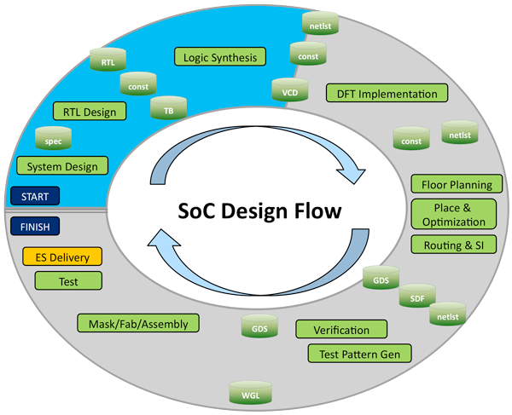

**Fig I.1:** Process of Designing a System on a Chip

Even though we will not be following every step, Fig. I.1 shows the general process for designing a chip. The first task is system design where the requirements of the system are documented and the major functionality of the chip is described. The second task is RTL design which involves writing code in a hardware description languages (HDL) such as Verilog in order to create a high-level representation of the chip. The next step is logic synthesis which involves turning the RTL design into a netlist of logic gates. Floor planning involves determining the location of the major blocks on the IC schematic. Place and optimization is placing all of the electronic components, circuitry, and logic elements into a limited amount of space in an effective manner. Routing is connecting all of the different components and must follow the rules and limitations of the fabrication process. This step is mostly done automatically by an EDA tool but sometimes has to be done manually. It should be noted that testing and verification will be performed throughout the entire process. The last step is submitting a verified design to be fabricated (commonly in the form of a GSDII file).

**Specifications**

**General:**

* Maximum Clock Rate: 100 MHz
* Clock frequency will be a minimum of 1200 times the audio sampling rate

**I2S:**

* I2S input and output interfaces comply with I2S standard, included here in Appendix E
* Maximum Serial Clock Rate: 1.44 MHz
* Audio input sample rates ranges of 8 kilosamples/sec - 48 kilosamples/sec
* Digital audio bit clock and word select lines will be controlled from I2S master, which can be our chip, or the external I2S source
* Audio input and output must have same sample rate – our chip will be the timebase master on the output I2S interface
* Audio input and output will be two 16 bit channels (i.e. one stereo pair)

**Filter:**

* Filter Design: FIR Filter
* 512-tap filter, 16-bit coefficients, all independently settable
* Programmable filter coefficients to achieve different filter types
* Maintain integer headroom of 4 bits

**I2C:**

* 8-bit slave address space
* 12-bit register address space
* Data transfer rate of up to 400 kbits/second desired (both I2C standard and fast modes supported)
* Slave only capability
* Write operation (Burst write functionality)
* Read operation (Single read, optional burst read request)
* User selectable slave address with strap pins
* Simple strobe interface to register block (read and write)

**Register:**

* Simple strobe interface to I2C block
* Provides read/write access to control/status registers, including the following
  + Source select bit (I2S vs. BIST)
  + Filter bypass bit (pass through or filter input streams)
  + 512 16-bit filter coefficients
  + Overflow/saturation detector
  + Audio FIFO overrun/underrun

**Chapter 1: Background – Z. Nelson**

*1.1 Who is MOSIS?*

The simple chip that we are designing will be produced by MOSIS, at no cost to The College of New Jersey. MOSIS was the first well-known multi-project wafer (MPW) service, and was established by DARPA (Defense Advanced Research Projects Agency) in 1981. The acronym MOSIS stands for Metal Oxide Semiconductor Implementation Service and the company has processed over 60,000 IC designs over the last 30 years [1]. The MOSIS Service is known for MPWs, which is how they are able to keep the cost of fabrication low. A MPW is when multiple IC designs are shared on a single wafer and an illustration of this concept in shown in Figure 1.1. This means that designs from private companies and students could be on the same wafer. The reasoning behind this approach is that the cost of fabrication can be kept at a reasonable price if the cost of mask making, wafer fabrication and assembly are shared throughout multiple projects. This idea of a MPW is also attractive because designers can create a prototype of their design without making a huge investment. It should also be noted that MOSIS offers using a single project for a wafer (dedicated run) for all processes and can start the fabrication at any time.

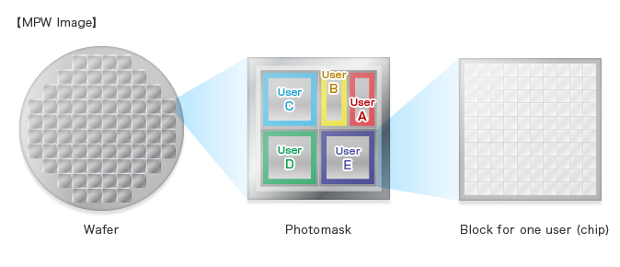

**Fig 1.1:** Multi-Project Wafer

*1.2 Fabrication Process*

MOSIS offers three different options for an accredited college or university to use. These options are registering for a Commercial account, a MOSIS Educational Program (MEP) Instructional account, or a MOSIS Educational Program (MEP) Research account. A comparison of these three accounts is listed on MOSIS’s website and is also shown in Table 1.1. Our advisors registered for a MEP Instructional account and we will be using a GlobalFoundaries 180 nm8RF process.

**Table 1.1:** Comparison of MOSIS Academic Account Types

|  |  |  |  |
| --- | --- | --- | --- |
| **Topic** | **Commercial** | **MEP Instructional** | **MEP Research** |
| Primary Purpose | Customers pays for fabrication and packaging | Classroom instruction | Unfunded research |
| Available Processes | All | 1. ON Semi 0.50 $μm$ CMOS (C5N)  2. GlobalFoundaries 180 *nm* CMOS (7HV) | 1. ON Semi 0.50 $μm$ CMOS (C5N)  2. GlobalFoundaries 130 *nm* SiGe BICMOS (8HP)  3. GlobalFoundaries 130 *nm* CMOS (8RF-DM) |
| Size Limits | No restrictions | 5 deliverable parts of a project no larger than 1.5 mm x 1.5 mm | Less than 16 ${mm}^{2}$ |
| Number of Submissions per Year | Unlimited | Annual request subject to review | One submission per academic year per institution after approval of proposal |
| Run Restrictions | All MPW runs except for MEP-only | MEP-only and space available for COM runs | Space available for COM runs |
| IP Access through MOSIS | Yes | No | Yes |
| Fabrication Costs | Customer pays fabrication cost | Free | Free |
| Packaging | No restrictions, customer pays | Free ceramic and OCP packaging; lids cannot be sealed. Fully encapsulated packaging not available. | No restrictions, customer pays |

*1.3 Submitting a Design to MOSIS*

When submitting a MPW run, MOSIS has specified certain steps that need to be taken in order to submit a design. The first step is to submit a new project request by logging onto their website. The designer then needs to assign their Export Control Classification Number (ECCN) before they make a fabrication request. Next, a fabrication request needs to be made specifying the process that will be used. The last step is to submit that actual design layout to MOSIS in either Caltech Intermediate Form (CIF) or Graphic Data System II (GSDII) format. Both of these formats are used to describe the layout of the integrated circuit and will be generated by an EDA tool.

**Chapter 2: System Design – Z. Nelson**

The system design of our project started in April 2015 when we wrote a senior project proposal. The proposal discussed the basic functionality that should be accomplished and how the tasks should be broken down. A top level block diagram of the chip is shown in Fig. 2.1. The chip was broken down into five major modules. These modules included the I2S input interface, I2S output interface, filter, register block, and I2C slave interface. Kevin’s responsibility was the I2S interface, Dhruvit’s was the filter, Julie’s was the register, and Whitley’s was the I2C interface. Over the 2015 summer, each team member worked on creating a specification document for their module.

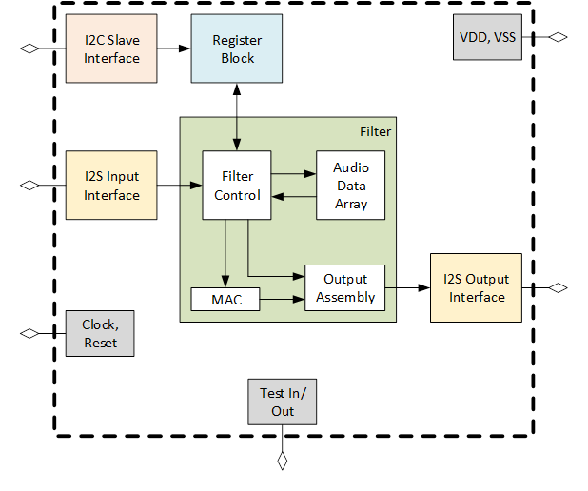

**Fig 2.1:** Top Level Drawing of Chip

The main purpose of the I2S input interface was to convert a serial audio stream into left and right 16-bit parallel data. This module also included a Built in Self-Test (BIST) feature that would use a predefined sawtooth signal as the audio data stream. After the audio stream was converted into parallel data, it was put through a 512-tap FIR filter in the filter module. The filter audio signal was then converted back to the I2S serial standard in the I2S output interface. The combination of these three modules was how data flowed within our chip.

**Data Flow:** I2S Input Interface 🡪 Filter 🡪 I2S Output Interface

The control flow of the chip started with the I2C slave interface module reading or writing register values to the chip. The register block is where the actual filter coefficient values were stored along with other information such as chip info, control bits, and status bits. The filter block would then read the 512 filter coefficients from the register block in order to implement the FIR filter.

**Control Flow:** I2C Slave Interface 🡪 Register Block 🡪 Filter

The next step in the system design process was creating block documents that stored the details of each module. These block documents can be found on the GitHub repository. After the interfaces for each module were agreed upon, we created a detailed schematic of the top-level module of our chip (refer to Fig. 2.2).

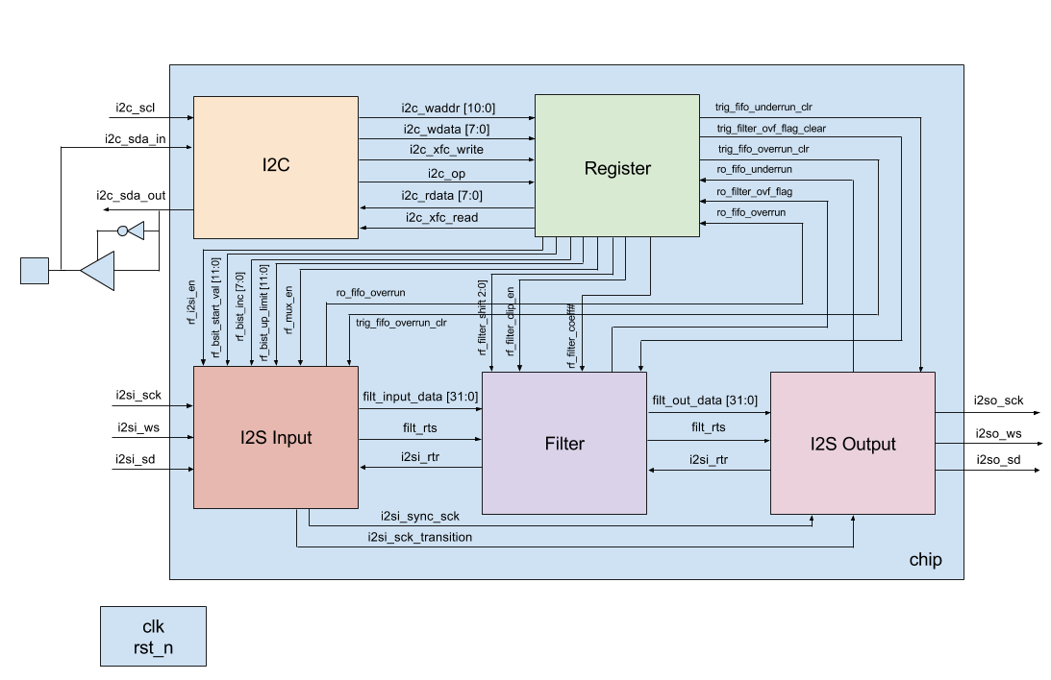

**Fig. 2.2:** Detailed Top-Level Drawing of Chip

The PSoC microcontroller will be used to generate the audio stream and provide I2C read/write access for the chip. Since we will create the audio stream in the PSoC environment, we should know exactly what the output stream will be based on the filter coefficients we are using. The microcontroller will also have the ability to read and write filter coefficients to the chip. This is an important feature of our project because the user will be able to manually set and check the values of all 512 filter coefficients. A diagram of the PSoC microcontroller interfaced with the FPGA is shown in Fig. 2.3.

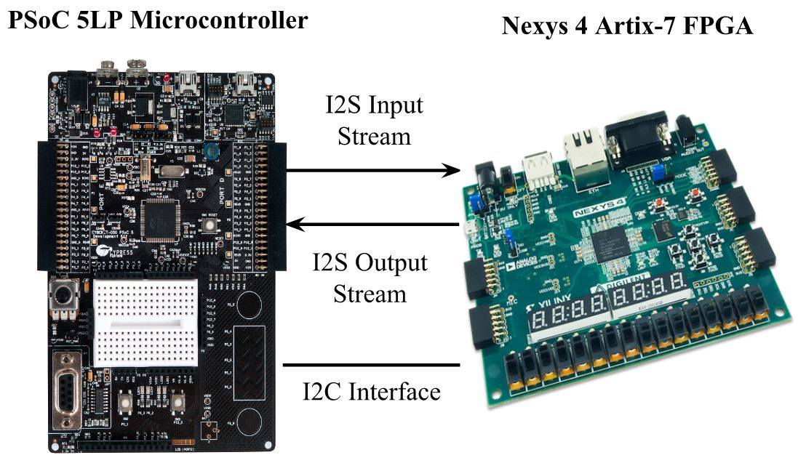

**Fig. 2.3:** FPGA Testing Environment

**Chapter 3: I2S Interface – K. Cao**

*3.1 Introduction*

Integrated Interchip Sound (I2S) buses are used to pass digital audio into our chip for processing, and to carry processed digital audio streams that are outputted by our chip. I2S an electrical serial bus interface standard that is used for connecting digital audio devices together. I2S is used to communicate pulse-code modulation (PCM) audio data between integrated circuits in an electronic device. PCM is a standard format for digital audio in computers. It is a method used to digitally represent sampled analog signals.

The **i2s_in** block is responsible for receiving the I2S signals that are inputted to our chip, and converting this to a natural parallel PCM format, suitable for processing by the filter block. The **i2s_out** block is responsible for converting parallel PCM data produced by the filter block to a serial I2S stream, for output by the chip.

*3.2 I2S Bus Specification*

The I2S protocol contains three lines: serial data bus (SD), a bit clock (SCK), and word select (WS). These three lines are used to reduce the number of pins required and to keep wiring simple. The SCK signal pulses once for each discrete bit of data on the data line and its frequency can be calculated by multiplying the sample rate, number of bits per channel, and the number of channels. The WS signal informs the chip whether the left or right channel is being currently sent. I2S allows a device to have two channels that send data over the same data line. In this chip when WS is 0, data is being sent over the left channel and when WS is 1, data is being sent over the right channel. The WS signal is a 50% duty signal that has the same frequency as the audio sample frequency.

The SD signal is a serial representation of a two’s complement signed value, and is transmitted with the most significant bit (MSB) first. The transmitter and receiver may have different natural word lengths. The transmitter and receiver doesn’t need to know how many bits the other can handle. The least significant data bits are set to 0 when the receiver’s word length is greater than the transmitter word length. However, if the sent bits are larger than the word length of the receiver, then the bits after the least significant bit are ignored. The MSB is always located in the same position, however, the least significant bit (LSB) position depends on the word length. The MSB of the new word is also always sent one clock period after the WS signal changes. The serial data being transmitted can either be synchronized with either the trailing or leading edge of the clock signal. In this implementation the serial data is synchronized with the leading edge. However, the serial data must be latched by the receiver on the leading edge of serial clock signal. The WS signal is also changes with the leading edge of the serial clock and is set to change one clock period before the MSB is transmitted. This early transition allows the slave transmitter to derive synchronous timing of the serial data.

*3.3 I2S Interfaces*

The I2S interfaces for the custom chip were split into two Verilog modules, **i2s_in** and **i2s_out**. The **i2s_in** module represented the receiver and handled all data being inputted into the I2S interface, and the **i2s_out** module represented the transmitted and handled all data being outputted. The following figure displays the overall block diagram of the chip, with the I2S interfaces highlighted.

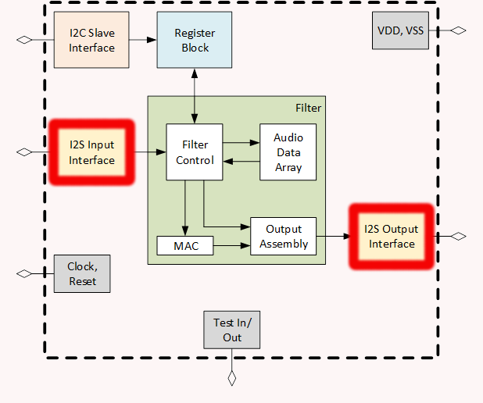

**Fig 3.1:** Overall Chip Diagram with I2S Interfaces Highlighted

*3.4 I2S Input Interface*

The I2S input interface handles all input audio and relays it to the filter for processing. It is primarily responsible for reading in serialized data and converting it back into parallel data. The I2S Input interface is made of five different sub-modules, the synchronizer, deserializer, Audio Built-In Self-Test (BIST) generator, mux, and FIFO. The following figure displays the block diagram of the I2S input interface with all of its signals and sub-modules.

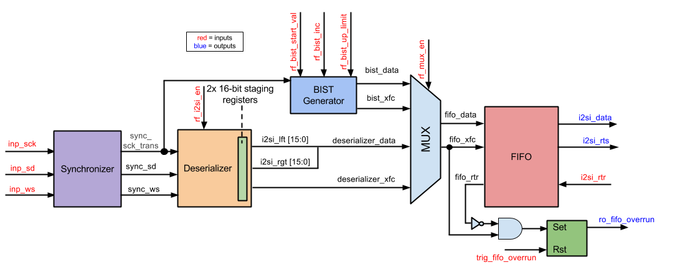

**Fig 3.2:** I2S Input Block Diagram

The following table displays all the input and output signals the I2S input interface interacts with. The table provides the name, direction, bit size, and a short description of each signal.

**Table 3.1:** Interface Signals for I2S Input

|  |  |  |  |
| --- | --- | --- | --- |
| **Signal Name** | **Direction** | **Bits** | **Comment** |
| **General** | | | |
| clk | in | 1 | Master Clock |
| rst_n | in | 1 | Reset |
| **I2S Input Interface** | | | |
| inp_sck | in | 1 | Digital Audio Bit Clock |
| inp_sd | in | 1 | Digital Audio Serial Data |
| inp_ws | in | 1 | Word Select |
| **Control/Status Register Fields** | | | |
| trig_fifo_overrun_clr | in | 1 | Reset FIFO Overrun |
| ro_fifo_overrun | out | 1 | Input Audio FIFO Overrun |
| rf_i2si_en | in | 1 | Serializer Enable Bit |
| rf_mux_en | in | 1 | Built in Self-Test (BIST) |
| rf_bist_start_val | in | 12 | Start Value |
| rf_bist_inc | in | 8 | Increment |
| rf_bist_up_limit | in | 12 | Upper Limit |
| **Streaming Audio Interface with Filter Block** | | | |
| i2si_rtr | in | 1 | Ready to Receive |
| i2si_rts | out | 1 | Ready to Send |
| i2si_data | out | 32 | Output Digital Audio |

The signal inp_sck is the digital audio bit clock of the I2S interface, inp_sd is the serial data that is being sent in, and inp_ws is the word select signal that informs the module whether the left or right audio channel is being received. The signals i2si_rtr and i2si_rts are the handshake interface signals interacting with the filter block. They inform the I2S input interface when the filter block is ready to receive data, and inform the filter block when the I2S input interface is read to send data. The i2si_data signal contains the 32 bit words that will be sent to the filter block for processing. The rf_i2si_en signal informs the I2S input block to start converting data from serial into parallel. The rf_mux_en signal is the select bit that informs the I2S input interface either to output the deserialized data or the BIST data to the filter block. The signals rf_bist_start_val, rf_bist_inc, and rf_bist_up_limit are used as parameters to create a sawtooth wave to test the chip. The signal ro_fifo_overrun indicates whether data is written to the block faster than it can be read. The trig_fifo_overrun signal indicates whether or not to clear the ro_fifo_overrun signal.

The I2S input interface was verified by inputting a list of 32 bit words into the inp_sd signal line. The i2si_data signal was then observed to see if it outputted the same words inputted. To make verification easier, two outputs files were created with the input and output words. A brief summary at the bottom of the text files confirmed if the test was successful or not. The inputted words were tested with random 32 bit values, and values coming from the BIST generator. It was observed that the same data inputted is also outputted within the block and appears to be working. The select bit for the multiplexer was also toggled to verify that the data outputted came from either the BIST or input serial data. It was confirmed that the data outputted was dependent on the select bit and the block was functioning properly. The i2si_rts signal line was also observed. The signal is supposed to pulse after each half word within the block. When observing the test benches this can be seen functioning correctly. Additional testing was conducted to test the underrun and overrun signals. Testing showed that both signals trigger under the correct conditions, and the signals can be cleared with the proper reset signals.

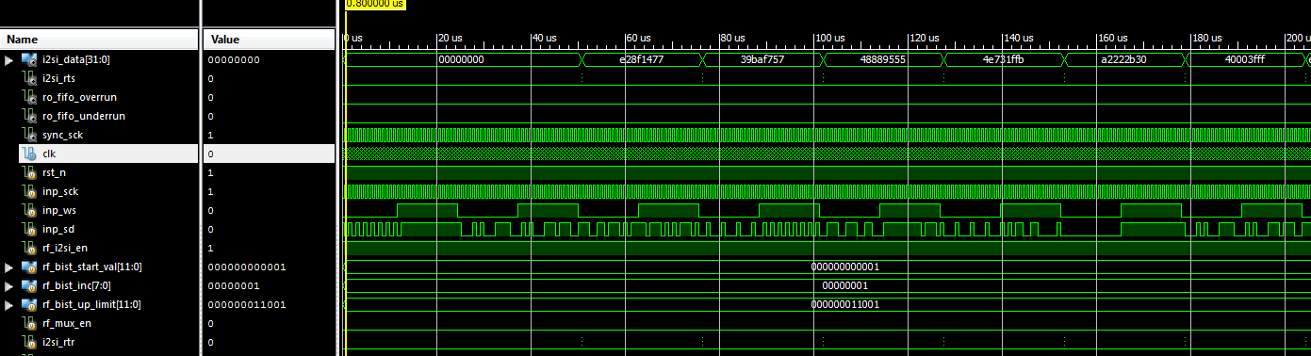

**Figure 3.3**: Sample of I2S Input Interface Simulation

Sample of I2S Input Interface Text File

Input: d6095663 --- Output: d6095663 --- Pass

Input: 7b0d998d --- Output: 7b0d998d --- Pass

Input: 84655212 --- Output: 84655212 --- Pass

Input: e301cd0d --- Output: e301cd0d --- Pass

Input: f176cd3d --- Output: f176cd3d --- Pass

Input: 57edf78c --- Output: 57edf78c --- Pass

Input: e9f924c6 --- Output: e9f924c6 --- Pass

Input: 84c5d2aa --- Output: 84c5d2aa --- Pass

Input: f7e57277 --- Output: f7e57277 --- Pass

Input: d612db8f --- Output: d612db8f --- Pass

Input: 69f296ce --- Output: 69f296ce --- Pass

Input: 7ae84ec5 --- Output: 7ae84ec5 --- Pass

Input: 495c28bd --- Output: 495c28bd --- Pass

Input: 582d2665 --- Output: 582d2665 --- Pass

Input: 6263870a --- Output: 6263870a --- Pass

Input: 22802120 --- Output: 22802120 --- Pass

Input: 45aacc9d --- Output: 45aacc9d --- Pass

Input: 3e96b813 --- Output: 3e96b813 --- Pass

Input: 380dd653 --- Output: 380dd653 --- Pass

Input: dd6b2ad5 --- Output: dd6b2ad5 --- Pass

Input: 4a023eae --- Output: 4a023eae --- Pass

Input: e91d72cf --- Output: e91d72cf --- Pass

Input: 4923650a --- Output: 4923650a --- Pass

Input: 0aca4c3c --- Output: 0aca4c3c --- Pass

Input: bdf2618a --- Output: bdf2618a --- Pass

Input: b34134d8 --- Output: b34134d8 --- Pass

Input: f3781289 --- Output: f3781289 --- Pass

Input: 0deb65b6 --- Output: 0deb65b6 --- Pass

Input: f9c613ae --- Output: f9c613ae --- Pass

Input: 02bcdd2a --- Output: 02bcdd2a --- Pass

Input: 9a0bbe71 --- Output: 9a0bbe71 --- Pass

Input: 4185554f --- Output: 4185554f --- Pass

Input: 603b333a --- Output: 603b333a --- Pass

Input: 327e4b15 --- Output: 327e4b15 --- Pass

Input: 9bf14bd9 --- Output: 9bf14bd9 --- Pass

Input: 0762fb4c --- Output: 0762fb4c --- Pass

Input: 559fa18f --- Output: 559fa18f --- Pass

Input: a9f860b7 --- Output: a9f860b7 --- Pass

Input: 569f945c --- Output: 569f945c --- Pass

Input: c05b3789 --- Output: c05b3789 --- Pass

Input: 32493ed0 --- Output: 32493ed0 --- Pass

Input: c0d7fc51 --- Output: c0d7fc51 --- Pass

Input: 2f967f0c --- Output: 2f967f0c --- Pass

Input: cec2edc8 --- Output: cec2edc8 --- Pass

Input: 5a77ed3d --- Output: 5a77ed3d --- Pass

Input: db12007e --- Output: db12007e --- Pass

Input: 816de739 --- Output: 816de739 --- Pass

Input: 8f1ff6d3 --- Output: 8f1ff6d3 --- Pass

Input: 2f858878 --- Output: 2f858878 --- Pass

Input: 595b4b49 --- Output: 595b4b49 --- Pass

Input: ae3faf2a --- Output: ae3faf2a --- Pass

Input: 63583886 --- Output: 63583886 --- Pass

Input: 0c8ef29c --- Output: 0c8ef29c --- Pass

Input: 99fabc26 --- Output: 99fabc26 --- Pass

Input: 1773b4a3 --- Output: 1773b4a3 --- Pass

Input: a82f92b3 --- Output: a82f92b3 --- Pass

Input: 565f0d44 --- Output: 565f0d44 --- Pass

Input: fdf736cb --- Output: fdf736cb --- Pass

Input: 1ae6db5a --- Output: 1ae6db5a --- Pass

Input: c129e2ed --- Output: c129e2ed --- Pass

Input: 6cdab665 --- Output: 6cdab665 --- Pass

Input: e2b594df --- Output: e2b594df --- Pass

Input: 1979ff44 --- Output: 1979ff44 --- Pass

Input: 0cd00b2a --- Output: 0cd00b2a --- Pass

Input: adabcf0e --- Output: adabcf0e --- Pass

Input: addcbc9a --- Output: addcbc9a --- Pass

Input: 72fd02c3 --- Output: 72fd02c3 --- Pass

Input: ed56e94e --- Output: ed56e94e --- Pass

Input: 7667340a --- Output: 7667340a --- Pass

Input: b9b68a38 --- Output: b9b68a38 --- Pass

Input: 8779c4b8 --- Output: 8779c4b8 --- Pass

Input: bf945d93 --- Output: bf945d93 --- Pass

Input: 2c04ca59 --- Output: 2c04ca59 --- Pass

Input: 69dbde4d --- Output: 69dbde4d --- Pass

Input: b7d9266d --- Output: b7d9266d --- Pass

Input: e27649ca --- Output: e27649ca --- Pass

Input: 2db67195 --- Output: 2db67195 --- Pass

Input: 1a469b04 --- Output: 1a469b04 --- Pass

Input: 61f70769 --- Output: 61f70769 --- Pass

Input: bab48d88 --- Output: bab48d88 --- Pass

Input: d928042d --- Output: d928042d --- Pass

Input: 30c79c2e --- Output: 30c79c2e --- Pass

Input: e408451c --- Output: e408451c --- Pass

Input: a6fd0729 --- Output: a6fd0729 --- Pass

Input: 901c6786 --- Output: 901c6786 --- Pass

Input: 08dac63d --- Output: 08dac63d --- Pass

Input: a766c470 --- Output: a766c470 --- Pass

Input: 047399ba --- Output: 047399ba --- Pass

Input: b35e79fa --- Output: b35e79fa --- Pass

Input: 05d5f61a --- Output: 05d5f61a --- Pass

Input: 00b96137 --- Output: 00b96137 --- Pass

Input: 379621c0 --- Output: 379621c0 --- Pass

Input: 9f261ab6 --- Output: 9f261ab6 --- Pass

Input: 837d0fdc --- Output: 837d0fdc --- Pass

Input: 5786ff78 --- Output: 5786ff78 --- Pass

Input: 9b7e80db --- Output: 9b7e80db --- Pass

Input: b6cf2b79 --- Output: b6cf2b79 --- Pass

Input: e4faee61 --- Output: e4faee61 --- Pass

Input: 091778a1 --- Output: 091778a1 --- Pass

Input: 91869650 --- Output: 91869650 --- Pass

Number of Comparisons: 100

Number of Successful Comparisons: 100

Number of Failed Comparisons: 0

*3.4.1 Synchronizer*

The synchronizer sub-block takes the inputs of serial clock, word select, and serial data and delays the signals and sync them with the master clock. This is done in order to ensure that no metastability occurs. The sub-block was also created to consolidate and shorten the amount of code needed to be written. Multiple blocks make use of the delayed and synced signals. It was appropriate to define these signals once and then to output them to the other blocks that need them. The inputs and outputs of the synchronizer sub-block can be seen in the following table.

**Table 3.2:** Interface Signals for Synchronizer Sub-Module

|  |  |  |  |
| --- | --- | --- | --- |
| **Signal Name** | **Direction** | **Bits** | **Comment** |
| **General** | | | |
| clk | in | 1 | Master Clock |
| rst_n | in | 1 | Reset |
| **Synchronizer Input Interface** | | | |
| _sck | in | 1 | Digital Audio Bit Clock |
| _ws | in | 1 | Word Select |
| _sd | in | 1 | Digital Audio Serial Data |
| **Synchronizer Output Interface** | | | |
| sck | out | 1 | Delayed and Synced Serial Clock |
| sck_transition | out | 1 | Serial Clock Level to Pulse Converter |
| ws | out | 1 | Delayed and Synced Word Select |
| sd | out | 1 | Delayed and Synced Serial Data |

The _sck signal is the serial clock input signal and sck is the same signal synced and delayed by 2 master cycles. The sck_transition signal is a level to pulse converter of the serial clock. The signal is high anytime sck transitions from 0 to 1. The _ws signal is the word select input signal and ws is the same signal synced and delayed by 4 master clock cycles. The _sd signal is the serial data input signal and sd is the same signal synced and delayed by 4 master clock cycles.

The synchronizer was verified by checking if the _sck, _ws, and _sd signals were delayed by correct amount of clock cycles. Within the sample simulation that the sck signal was delayed by 2 clock cyles, and both the ws and sd signals were delayed by 4 clock cycles. In addition, the level to pulse converter signal, sck_transition was verified as high each time sck transitioned from low to high.

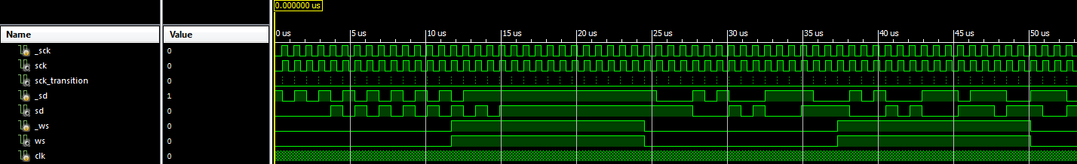

**Figure 3.4:** Sample of Synchronizer Simulation

*3.4.2 Deserializer*

The deserializer sub-block is responsible for taking the audio serial data and converting it to parallel data. The list of inputs and outputs of the deserializer sub-block can be seen in the following table.

**Table 3.3:** Interface Signals for Deserializer Sub-Module

|  |  |  |  |
| --- | --- | --- | --- |
| **Signal Name** | **Direction** | **Bits** | **Comment** |
| **General** | | | |
| clk | in | 1 | Master Clock |
| rst_n | in | 1 | Reset |
| **Deserializer Input Interface** | | | |
| sck_transition | in | 1 | Serial Clock Level to Pulse Converter |
| in_sd | in | 1 | Digital Audio Serial Data |
| in_ws | in | 1 | Word Select (Left/Right Audio Channel) |
| **Deserializer Output Interface** | | | |
| out_lft | out | 16 | Left Audio Channel |
| out_rgt | out | 16 | Right Audio Channel |
| out_xfc | out | 1 | Read Data Transfer Complete |
| **Control/Status Register Fields** | | | |
| rf_i2si_en | in | 1 | I2S input Enabled |

The inputs sck_transition, in_sd, and in_ws are the outputs coming from the synchronizer sub-block. These are the level to pulse converter of the serial clock and the delayed and synced signals of the serial data and word select signals. The rf_i2si_en signal is an enable bit for the deserializer sub-block. The signals out_lft and out_rgt are the outputs of the left and right audio parallel data respectively. The signal out_xfc informs the FIFO that the transfer of a word has been completed.

The deserializer was verified by running a simulation that checked if the left and right output channels properly read in the input of the serial data signal. First it was verified that the serializer began properly outputting data after it becomes active. After properly becoming active the inputted data was verified to match up with the output data. It was also ensured that the data was properly stored into the proper channels depending on the value of the word select signal. Next the least significant bit was checked to see if it was stored after the first clock cycle after the word select signal transitioned. Lastly, the xfc signal was verified to pulse after the last bit of the right channel was stored.

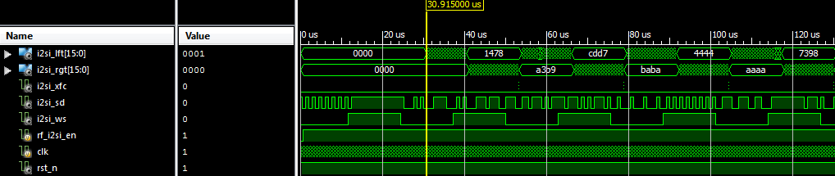

**Fig. 3.5:** Sample of Deserializer Simulation

*3.4.3 Audio Built-In Self-Test (BIST) Generator*

The BIST generator sub-block is used to create a saw-tooth wave to test the I2S input interface. The saw-tooth wave is then outputted to the multiplexer. The following table lists the inputs and outputs of the BIST generator sub-block.

**Table 3.4:** Interface Signals for BIST Generator Sub-Module

|  |  |  |  |
| --- | --- | --- | --- |
| **Signal Name** | **Direction** | **Bits** | **Comment** |
| **General** | | | |
| clk | in | 1 | Master Clock |
| rst_n | in | 1 | Reset |
| sck_transition | in | 1 | Serial Clock Level to Pulse Converter |
| **BIST Reg Interface** | | | |
| rf_bist_start_val | in | 12 | Start Value |
| rf_bist_inc | in | 8 | Increment |
| rf_bist_up_limit | in | 12 | Upper Limit |
| **BIST Output Interface** | | | |
| i2si_bist_out_xfc | out | 1 | Transfer Complete |
| i2si_bist_out_data | out | 32 | Output Data |

Signals rf_bist_start_val, rf_bist_inc, and rf_bist_up_limit are used to create a saw-tooth wave. The signals inform what value to start at, how much to increment by, and what the upper limit of the saw-tooth wave is respectively. The signals i2si_bist_out_data is the output data describing the saw-tooth wave, and i2si_bist_out_xfc is the output that represents that a saw-tooth wave word transfer was complete.

The BIST generator was verified by running a simple test that set the starting value to 0x800. The data value was then incremented on every 32nd pulse of the serial clock by a value of 0x700. The xfc output signal was verified by checking if it was high after the data incremented. The sub-block was further tested by ensuring that the output was reset to starting value after the output data reaches the upper limit of the BIST generator.

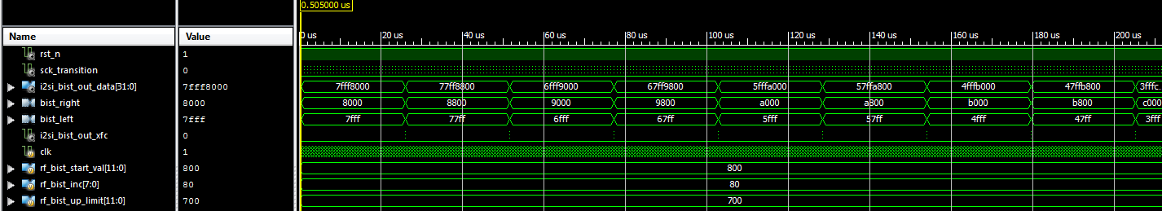

**Fig. 3.6:** Sample of BIST Generator Simulation

*3.4.4 Multiplexer*

The multiplexer sub-block is responsible for outputting either the BIST data and xfc output signals or the deserializer data and xfc output signals. The following table lists the multiplexer’s input and output signals.

**Table 3.5:** Interface Signals for Multiplexer Sub-Module

|  |  |  |  |
| --- | --- | --- | --- |
| **Signal Name** | **Direction** | **Bits** | **Comment** |
| **Data Lines Input Interface** | | | |
| in_0_data | in | 32 | Input 0 Data |
| in_0_xfc | in | 1 | Input 0 Transfer Complete |
| in_1_data | in | 32 | Input 1 Data |
| in_1_xfc | in | 1 | Input 1 Transfer Complete |
| **Enabled Bit** | | | |
| sel | in | 1 | Select Bit |
| **Multiplexer Output Interface** | | | |
| mux_data | out | 32 | Data Output |
| mux_xfc | out | 1 | Transfer Complete Output |

The signals in_0_data, in_0_xfc, in_1_data, and in_1_xfc are the outputs of either the BIST generator or deserializer data and xfc signals. The sel signal is the select bit that either outputs the BIST data and xfc or deserializer data and xfc signals. The signals mux_data and mux_xfc represent the data and xfc signals being outputted to the FIFO sub-block.

The multiplexer was verified by running a simple simulation that inputted two sets of values for the pairs in_0 and in_1. The enabled bit was then toggled to see if the multiplexer outputted the correct pair of values.

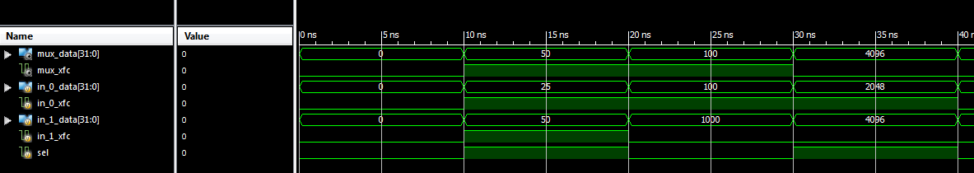

**Figure 3.7:** Sample of Multiplexer Simulation

*3.4.5 First-In-First-Out (FIFO) Buffer*

The FIFO sub-block organizes and manipulates a data buffer, where the first entry is the first output. In this particular block the FIFO is responsible for manipulating the audio data inputted and outputted in the I2S interfaces. The following table lists the inputs and outputs of the sub-block.

**Table 3.6:** Interface Signals for FIFO Sub-Module

|  |  |  |  |
| --- | --- | --- | --- |
| **Signal Name** | **Direction** | **Bits** | **Comment** |
| **General** | | | |
| clk | in | 1 | Master Clock |
| rst_n | in | 1 | Reset |
| **Streaming Audio Interface with Multiplexer** | | | |
| fifo_inp_data | in | 32 | Input Data |
| fifo_inp_rts | in | 1 | Write Client Asserts Ready to Send |
| fifo_inp_rtr | out | 1 | Output FIFO Asserts Ready to Receive |
| **Streaming Audio Interface with Filter Block** | | | |
| fifo_out_data | out | 32 | Output Data |
| fifo_out_rts | out | 1 | Output FIFO Asserts Ready to Send |
| fifo_out_rtr | in | 1 | Read Client Asserts Read to Receive |

The fifo_inp_data is the parallel audio data being transferred into the FIFO block. The fifo_inp_rts and fifo_inp_rtr signals are the handshaked interface signals that inform whether data is ready to be sent and read respectively between the multiplexer and filter if in the I2S input interface or between the filter and FIFO if in the I2S output interface. The fifo_out_data signal is the parallel audio output data being sent to either the filter block if in the I2S input interface or serializer if in the I2S output interface. The fifo_out_rts and fifo_out_rtr signals are the handshaked interface that signals whether data is ready to be sent between the filter and FIFO if in the I2S input interface or read between the FIFO and filter if in the I2S output interface.

The FIFO sub-block was verified by queuing and de-queuing random values within a test bench. A quick simulation was run to check if the FIFO queued and de-queued the values defined within the test bench. If the FIFO was full the FIFO should have stopped queuing more data into the buffer, and if the FIFO was empty the FIFO should have outputted nothing from the buffer.

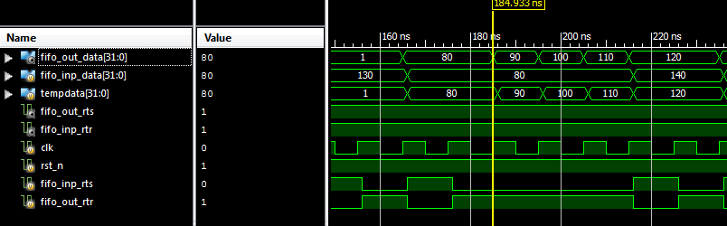

**Fig. 3.8:** Sample of FIFO Simulation

*3.5 I2S Output Interface*

The I2S output interface is primarily responsible for converting the received parallel audio data from the filter block to serial data as an output. The I2S output interface is made of two sub-blocks, the serializer and FIFO. The following diagram shows the sub-blocks that make the I2S_out block and displays the input, output, and interconnecting signals.

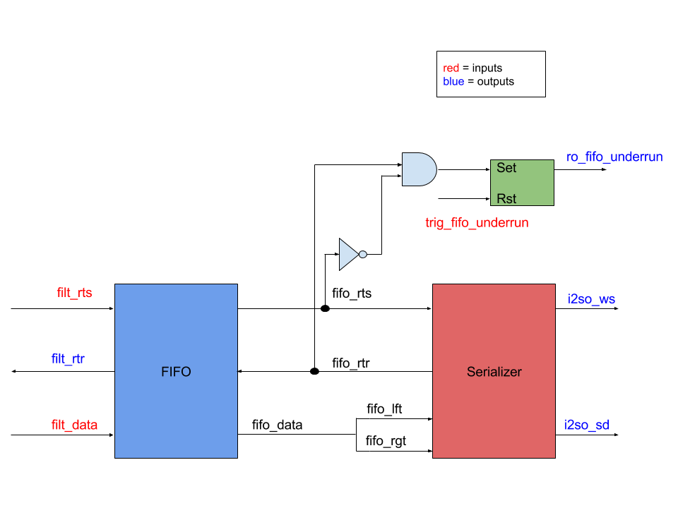

**Fig 3.9:** Block Diagram of I2S Output Interface

The following table displays all the input and output signals the I2S output interface interacts with. The table provides the name, direction, bit size, and a short description of each signal.

**Table 3.7:** Interface Signals for I2S Output

|  |  |  |  |
| --- | --- | --- | --- |
| **Signal Name** | **Direction** | **Bits** | **Comment** |
| **General** | | | |
| clk | in | 1 | Master Clock |
| rst_n | in | 1 | Reset |
| **Streaming Audio Interface with Filter Block** | | | |
| sck_transition | in | 1 | Serial Clock Pulse Converter |
| filt_data | in | 32 | Parallel Digital Audio |
| filt_rtr | out | 1 | Ready to Receive |
| filt_rts | in | 1 | Ready to Send |
| **I2S Output Interface** | | | |
| i2so_sck | out | 1 | Digital Audio Bit Clock |
| i2so_ws | out | 1 | Word Select (Left/Right Audio Channel) |
| i2so_sd | out | 1 | Digital Audio Serial Data |
| **Control/Status Register Fields** | | | |
| trig_fifo_underrun_clr | in | 1 | Reset FIFO Underrun |
| ro_fifo_underrun | out | 1 | Output Audio FIFO Underrun |

The sck_transition signal is the level to pulse converter signal that will be provided by the I2S input interface. The signal filt_data will be provided by the filter block that contains the 32-bit parallel audio data. The signals filt_rtr and filt_rts are the handshaked interface signals that indicate whether the filter is ready to send data and the I2S output interface is ready to receive data. The i2so_sck is the serial clock that is outputted in the I2S Input interface that will be transmitted to the I2S output interface. The i2so_ws is an output signal that indicates whether the data being transmitted belongs either to the left or right channel. The i2so_sd signal is the serial data that is converted from the parallel audio input data. The ro_fifo_underrun signal indicates whether the data being fed to the I2S output interface is slower than the rate it can process the data, and the trig_i2so_fifo_underrun_clr signal clears the ro_fifo_underrun bit.

The I2S output interface was verified by inputting a list of 32 bit words and confirming that they were being serialized upon exiting the block. To make verification easier, the test bench rebuilt the serial data back into a parallel form based on the word select signal. It was confirmed that the input matched the output within the text files, thus the serializer was working.

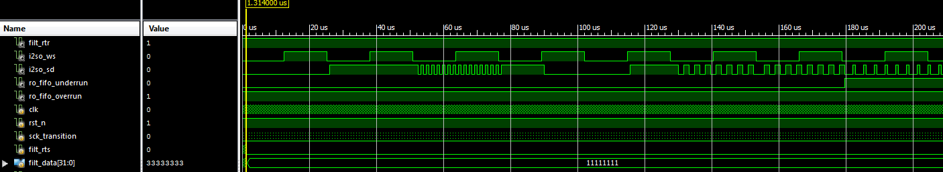

**Figure 3.10**: Sample of I2S Output Interface Simulation

Sample of I2S Output Interface Text Files

Input: 12153524 --- Output: 12153524 --- Pass

Input: c0895e81 --- Output: c0895e81 --- Pass

Input: 8484d609 --- Output: 8484d609 --- Pass

Input: b1f05663 --- Output: b1f05663 --- Pass

Input: 06b97b0d --- Output: 06b97b0d --- Pass

Input: 46df998d --- Output: 46df998d --- Pass

Input: b2c28465 --- Output: b2c28465 --- Pass

Input: 89375212 --- Output: 89375212 --- Pass

Input: 00f3e301 --- Output: 00f3e301 --- Pass

Input: 06d7cd0d --- Output: 06d7cd0d --- Pass

Input: 3b23f176 --- Output: 3b23f176 --- Pass

Input: 1e8dcd3d --- Output: 1e8dcd3d --- Pass

Input: 76d457ed --- Output: 76d457ed --- Pass

Input: 462df78c --- Output: 462df78c --- Pass

Input: 7cfde9f9 --- Output: 7cfde9f9 --- Pass

Input: e33724c6 --- Output: e33724c6 --- Pass

Input: e2f784c5 --- Output: e2f784c5 --- Pass

Input: d513d2aa --- Output: d513d2aa --- Pass

Input: 72aff7e5 --- Output: 72aff7e5 --- Pass

Input: bbd27277 --- Output: bbd27277 --- Pass

Input: 8932d612 --- Output: 8932d612 --- Pass

Input: 47ecdb8f --- Output: 47ecdb8f --- Pass

Input: 793069f2 --- Output: 793069f2 --- Pass

Input: e77696ce --- Output: e77696ce --- Pass

Input: f4007ae8 --- Output: f4007ae8 --- Pass

Input: e2ca4ec5 --- Output: e2ca4ec5 --- Pass

Input: 2e58495c --- Output: 2e58495c --- Pass

Input: de8e28bd --- Output: de8e28bd --- Pass

Input: 96ab582d --- Output: 96ab582d --- Pass

Input: b2a72665 --- Output: b2a72665 --- Pass

Input: b1ef6263 --- Output: b1ef6263 --- Pass

Input: 0573870a --- Output: 0573870a --- Pass

Input: c03b2280 --- Output: c03b2280 --- Pass

Input: 10642120 --- Output: 10642120 --- Pass

Input: 557845aa --- Output: 557845aa --- Pass

Input: cecccc9d --- Output: cecccc9d --- Pass

Input: cb203e96 --- Output: cb203e96 --- Pass

Input: 8983b813 --- Output: 8983b813 --- Pass

Input: 86bc380d --- Output: 86bc380d --- Pass

Input: a9a7d653 --- Output: a9a7d653 --- Pass

Input: 359fdd6b --- Output: 359fdd6b --- Pass

Input: eaa62ad5 --- Output: eaa62ad5 --- Pass

Input: 81174a02 --- Output: 81174a02 --- Pass

Input: d7563eae --- Output: d7563eae --- Pass

Input: 0effe91d --- Output: 0effe91d --- Pass

Input: e7c572cf --- Output: e7c572cf --- Pass

Input: 11844923 --- Output: 11844923 --- Pass

Input: 0509650a --- Output: 0509650a --- Pass

Input: e5730aca --- Output: e5730aca --- Pass

Input: 9e314c3c --- Output: 9e314c3c --- Pass

Input: 7968bdf2 --- Output: 7968bdf2 --- Pass

Input: 452e618a --- Output: 452e618a --- Pass

Input: 20c4b341 --- Output: 20c4b341 --- Pass

Input: ec4b34d8 --- Output: ec4b34d8 --- Pass

Input: 3c20f378 --- Output: 3c20f378 --- Pass

Input: c48a1289 --- Output: c48a1289 --- Pass

Input: 75c50deb --- Output: 75c50deb --- Pass

Input: 5b0265b6 --- Output: 5b0265b6 --- Pass

Input: 634bf9c6 --- Output: 634bf9c6 --- Pass

Input: 571513ae --- Output: 571513ae --- Pass

Input: de7502bc --- Output: de7502bc --- Pass

Input: 150fdd2a --- Output: 150fdd2a --- Pass

Input: 85d79a0b --- Output: 85d79a0b --- Pass

Input: b897be71 --- Output: b897be71 --- Pass

Input: 42f24185 --- Output: 42f24185 --- Pass

Input: 27f2554f --- Output: 27f2554f --- Pass

Input: 9dcc603b --- Output: 9dcc603b --- Pass

Input: 1d06333a --- Output: 1d06333a --- Pass

Input: bf23327e --- Output: bf23327e --- Pass

Input: 0aaa4b15 --- Output: 0aaa4b15 --- Pass

Input: 78d99bf1 --- Output: 78d99bf1 --- Pass

Input: 6c9c4bd9 --- Output: 6c9c4bd9 --- Pass

Input: 31230762 --- Output: 31230762 --- Pass

Input: 2635fb4c --- Output: 2635fb4c --- Pass

Input: 4fa1559f --- Output: 4fa1559f --- Pass

Input: 47b9a18f --- Output: 47b9a18f --- Pass

Input: 7c6da9f8 --- Output: 7c6da9f8 --- Pass

Input: dbcd60b7 --- Output: dbcd60b7 --- Pass

Input: cfc4569f --- Output: cfc4569f --- Pass

Input: ae7d945c --- Output: ae7d945c --- Pass

Input: adcbc05b --- Output: adcbc05b --- Pass

Input: 44de3789 --- Output: 44de3789 --- Pass

Input: a4ae3249 --- Output: a4ae3249 --- Pass

Input: e8233ed0 --- Output: e8233ed0 --- Pass

Input: ebfec0d7 --- Output: ebfec0d7 --- Pass

Input: a8c7fc51 --- Output: a8c7fc51 --- Pass

Input: 4b212f96 --- Output: 4b212f96 --- Pass

Input: 061d7f0c --- Output: 061d7f0c --- Pass

Input: e12ccec2 --- Output: e12ccec2 --- Pass

Input: 6457edc8 --- Output: 6457edc8 --- Pass

Input: bb825a77 --- Output: bb825a77 --- Pass

Input: 1ef2ed3d --- Output: 1ef2ed3d --- Pass

Input: 090cdb12 --- Output: 090cdb12 --- Pass

Input: bf05007e --- Output: bf05007e --- Pass

Input: 36e5816d --- Output: 36e5816d --- Pass

Input: 1cd9e739 --- Output: 1cd9e739 --- Pass

Input: 0fd28f1f --- Output: 0fd28f1f --- Pass

Input: e9ebf6d3 --- Output: e9ebf6d3 --- Pass

Input: 42d92f85 --- Output: 42d92f85 --- Pass

Input: bc148878 --- Output: bc148878 --- Pass

Number of Comparisons: 100

Number of Successful Comparisons: 100

Number of Failed Comparisons: 0

*3.5.1 Serializer*

The serializer sub-block is where the parallel audio data is converted into serial data. The following table shows the inputs and outputs of the serializer sub-block.

**Table 3.8:** Interface Signals for Serializer Sub-Module

|  |  |  |  |
| --- | --- | --- | --- |
| **Signal Name** | **Direction** | **Bits** | **Comment** |
| **General** | | | |
| clk | in | 1 | Master Clock |
| rst_n | in | 1 | Reset |
| **Serializer Input Interface** | | | |
| sck_transition | in | 1 | Serial Clock Level to Pulse Converter |
| filt_i2so_lft | in | 16 | Left Audio Channel |
| filt_i2so_rgt | in | 16 | Right Audio Channel |
| filt_i2so_rts | in | 1 | Ready to send |
| filt_i2so_rtr | out | 1 | Ready to read |
| **Serializer Output Interface** | | | |
| i2so_sd | out | 1 | Digital Audio Serial Data |
| i2so_ws | out | 1 | Word Select |

As previously stated the sck_transitoin signal is the output created from the synchronizer sub-block. The signals filt_i2so_lft and filt_i2so_rgt are the parallel audio data channels that were outputted by the FIFO. The filt_i2so_rts and filt_i2so_rtr are the handshaked interface signals that indicate whether the FIFO is ready to send and the serializer is ready to read data. However, it is important to note in this case that the serializer only cares when the rtr signal becomes high on its first instance. The serializer will continue to be active regardless if the rtr signal becomes 0 again. The i2so_sd and i2so_ws as mentioned before are the output of the I2S output interface of the serial data and word select signals.

The serializer sub-block was verified by running a test bench that fed in data to the left and right channels. To ensure that the block was working properly it needed to become active after the first rtr signal that goes from low to high. After becoming active the serial data output should correspond to the input data coming in from the left and right channel depending on the value of word select. These conditions were all verified within the test bench simulation.

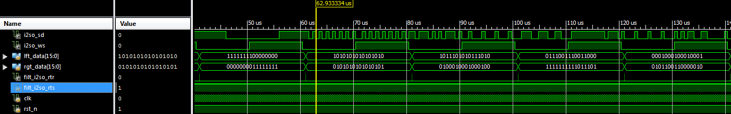

**Fig. 3.11:** Sample of Serializer Simulation

**Chapter 4: Digital Filtering – D. Naik**

*4.1 Introduction*

The main function of the ASIC chip is as a digital filter for audio processing. A digital filter operates on an input signal and produces a new signal, or filtered signal. In DSP, two of the most basic uses of a digital filter are signal separation and signal restoration. Separation is done when an input signal is polluted with interference, noise, or other signals. Filtering, removes any unwanted features from an input signal. Restorations is used when the signal has been distorted. One example of restorations is when an image is focused after being acquired due to a shaky lens. These filters are implemented in many types of devices and range in complexity. More advance filters are used for enhancements, compensation for listening room dynamics, special effects, and many other features. For example, MP3 players have a multitude of digital filters structures for different applications within the system. The four most basic types of filters are high pass, low pass, band pass, and band reject. Below in Figure 3.1, shows the frequency response of each filter structure. A digital filter can be represented with its frequency response, which is the discrete Fourier transform of its impulse response.

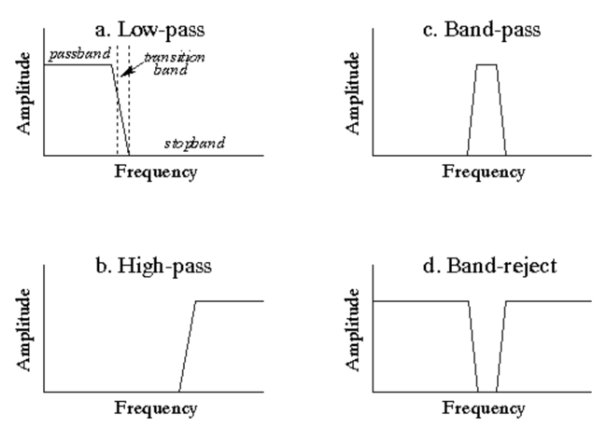

**Fig. 4.1:** Frequency Response of Filter Structures

Above, each filter structure has 3 interesting regions. The passband is the area in which frequency is allowed to pass freely. The stopband is the area in which the frequency is attenuated. Finally, the transition band is the transition between the passband and the stopband. Digital filters can be implemented two ways: by convolution and by recursion. Convolution is also called finite impulse response or FIR and recursion is called infinite impulse response or IIR. In FIR filters the filter coefficients are derived from the impulse response of the system. The given filter coefficients characterize the type of the digital filter. Convolution is defined by the equation:

$$y\left[n\right]=\sum_{k=0}^{N-1}{h\left[k\right]x[n-k]}$$

Here x is the discrete time input signal and h is the filter coefficients/impulse response. For the TCNJ ASIC, the filter will have 512 taps or 512 delays. Thus the filter will need to store, present and past inputs and index them appropriately.

In order to design a digital filter for audio processing, the human auditory system needs to be taken into consideration. The perception of continuous sound, can be separated into three parts: loudness, pitch, and timbre. Our audio quality goal will be to match the sound quality from a high fidelity compact disc. The specifications for the sound quality are the following. The chip will support sampling rates up to 48 kHz with precision of 16 bits per audio channel (left and right). The bit depth refers to the number of bits of precision when quantizing the sampled signal. The number of bits reduces the quantization error. Thus reducing the “hiss” associated with lower bit precision.

*4.2 Filter*

The filter block is a sub-block of the top level chip. Figure 3.2 shows the filter with respect to the other interfaces.

**Fig 4.2:** Chip Diagram with Filter Highlighted 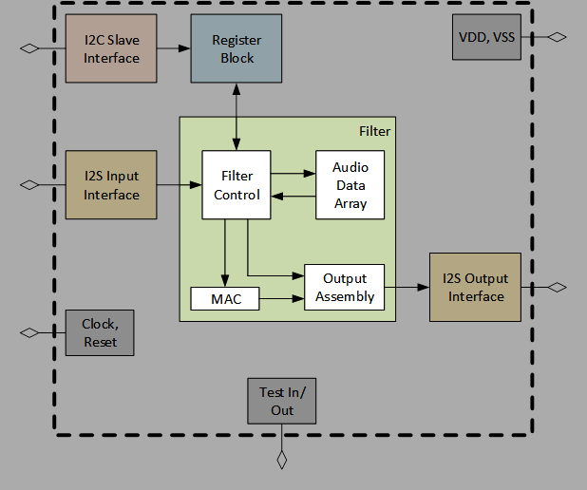

The filter interfaces with the I2S input and output blocks, and the Register block. The incoming audio signal is streamed in from the I2S input as serial data. Both channels (right and left) are sent as the same data line. In addition to providing control bits for the shift and clip, the register is responsible for providing the filter with filter coefficients. The input signal, including past input samples are convolved with the filter coefficients. Before the filter output is sent to the I2S output, three operations are performed: rounding, shifting, and clipping. Figure 3.2 is the top level view of the filter. Table 3.1 describes the corresponding signals for the top level filter.

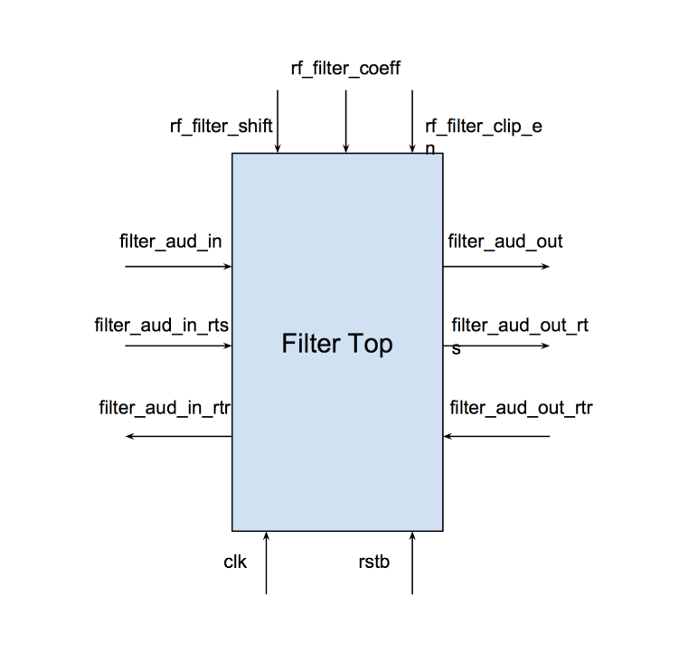

**Fig 4.3:** Top Level Block Diagram of Filter

**Table 4.1:** Interface Signals for Filter

|  |  |  |  |
| --- | --- | --- | --- |
| **Signal Name** | **Direction** | **Bits** | **Comment** |
| General | | | |
| clk | in | 1 | Master Clock |
| rstb | in | 1 | Asynchronous Reset |
| Audio In | | | |
| filter_aud_in | in | 32 | Input Digital Audio |
| filter_aud_in_rts | in | 1 | Input FIFO Asserts Ready to Send |
| filter_aud_in_rtr | out | 1 | Filter STM Asserts Ready to Receive |
| Audio Out | | | |
| filter_aud_out | out | 32 | Output Digital Audio |
| filter_aud_out_rts | out | 1 | Filter STM Asserts Ready to Send |
| filter_aud_out_rtr | in | 1 | Output FIFO Asserts Read to Receive |
| Register Fields | | | |
| rf_filter_shift | in | 3 | number of bit positions to shift |
| rf_filter_clip_en | in | 1 | 1-perform clipping 0-no clipping |
| rf_filter_coeff [0:511] | in | 8192 | Filter coefficient |

Referring to Table 3.3, *rstb*, represents an asynchronous reset. An asynchronous reset is typically active low, meaning that it triggers on the negedge as opposed to a synchronous reset, which is often active high. The advantage of using an asynchronous reset is, the reset has priority over any signal, including the master clock. This allows the block to reset with or without the presence of a clock. The second signals to consider are *filter_aud_in* or *filter_aud_out*. These digital audio signals contain bits for both audio channels. The right audio channel bits are stored in the first 16 LSB [15:0] and the left audio channel bits are stored in the first 16 MSB [31:16]. The final signal to consider further is *rf_filter_coeff*. The filter coefficients are assumed to be stable. If they change during any calculation of an output sample the result will be unpredictable. Figure 3.3 is a more detailed block diagram of the filter. Two things of note. First the multiplication will be signed multiplication. This is done by defining wires and registers as signed type. Secondly, there will be two instainations of the accumulator for left and right audio signals. *Filter_aud_in* will be split into two before the multiplication and concatenated before the three operations.

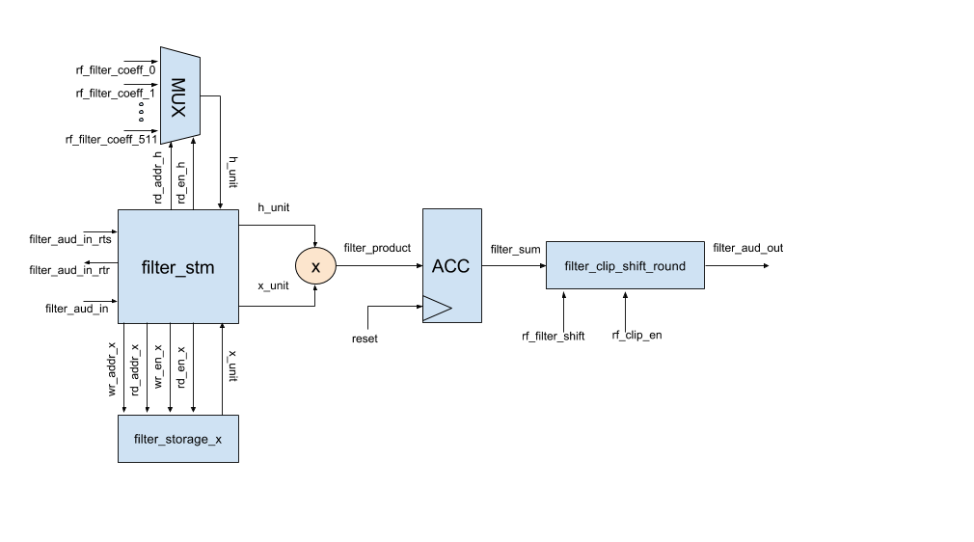

**Fig 4.4:** Detailed Block Diagram of Filter

The following subsections, will highlight specific submodules of the filter and describe them in detail.

*4.2.1 Filter State Machine*

The filter is controlled by a centralized finite state machine (FSM). A FSM can only function in a single state, or the current state. It is defined by its different states and trigger conditions (transitions). The states of a FSM can be encoded in various ways – one convient encoding is known as One-Hot. In a One-Hot encoding each state is represented by a single bit. For the TCNJ ASIC, the filter has 4 different states, so for this instance 4 flip-flops will be reserved to represent the filter FSM. Table 3.2 shows the highlights and describes the signals for the FSM.

**Table 4.2:** Interface Signals for Finite State Machine

|  |  |  |  |
| --- | --- | --- | --- |
| **Signal Name** | **Direction** | **Bits** | **Comment** |
| General | | | |
| clk | in | 1 | Master Clock |
| rstb | in | 1 | Asynchronous Reset |
| Audio Signals | | | |
| filter_aud_in | in | 32 | Input Digital Audio |
| rf_filter_coeff | in | 16 | Filter Coefficient |
| filter_aud_out | out | 32 | Output Digital Audio |

In addition to the signals described above, the submodule uses additional internal wires and signals. These specific signals can be found in the Source Code section in the Appendix.

**IDLE:**

The FSM enters the IDLE state if, and only if, the RESET signal is asserted. Upon assertion of XFC the FSM will transition to the TRANSFER state.

**TRANSFER:**

Once XFC is asserted, the filter will transition into the TRANSFER state. In this state, *filter_aud_in* is written into the storage module and the write pointer is incremented. Once the transfer is complete, read enable for the storage module and *filter_aud_in_rtr* are deasserted. The FSM will transition to MULTIPLY_1ST after this is complete.

**MULTIPLY_1ST:**

The convolution phase is separated into two states because the accumulator needs to load the first product. After the first computation is completed the state will transition to MULTIPLY.

**MULTIPLY:**

In the MULTIPLY_1ST and MULTIPLY states the FSM access the storage module for computation. The TCNJ ASIC filter is a 512 tap filter. The filter needs to access previous inputs, as far as 511 inputs from the past. Further discussion of the storage module is found in the next subsection. The 512 most recent input samples are multiplied against a corresponding filter coefficient. The filter coefficients are accessed from 0 to 511 for each iteration of the states. The inputs are accessed from the newest input to the input from the last iteration. Below are a few iterations of the convolution process.

1. y[0] = h[0] x[0] + h[1] x[-1] + … + h[510] x[-510] + h[511] x[-511]
2. y[1] = h[0] x[1] + h[1] x[0] + … + h[510] x[-509] + h[511] x[-510]
3. y[2] = h[0] x[2] + h[1] x[1] + … + h[510] x[-508] + h[511] x[-509]

Each of these products are computed each clock cycle. Each of these products are sent to an accumulator, which stores the sum of products until the next iteration. The accumulator will store a 40-bit signal, so there is little chance of an overflow. This 40-bit signal is rounded, clipped, and shifted and is ready to be sent to the Output I2S. Once the state is ready for a new input, read enable for both storage modules is deasserted and *filter_aud_in_rtr* is asserted. The filter will go through each of the discussed states until the chip is reset and the filter will transition into the IDLE state.

*4.2.2 Filter Storage Module*

The storage module is responsible for storing, indexing, writing, and reading the input signal. Table 3.3 shows the highlights and describes the signals for the Filter Storage Module. These signals are representations for both instances of the submodule.

**Table 4.3:** Interface Signals for Filter Storage Module

|  |  |  |  |
| --- | --- | --- | --- |
| **Signal Name** | **Direction** | **Bits** | **Comment** |
| General | | | |
| clk | in | 1 | Master Clock |
| Write Data | | | |
| wren | in | 1 | 1-wrdata will be written into wrptr |
| wrptr | in | 9 | Current Location of Write Pointer |
| wrdata | out | 32 | Data to be Written |
| Read Data | | | |
| rden | out | 1 | 1-rddata will be read from rdptr |
| rdptr | in | 9 | Current Location of Read Pointer |
| rddata | out | 32 | Data Being Read |

In addition to the signals stated above, the storage module defines a 2D array. The width of the array is 32 bits and the depth is 512 locations. The array behaves in a circular manner. Once the *wrptr* or *rdptr* indexes the last position it will wrap back to the beginning of the array. Consequently, the data will be overwritten. The signals *wren*, *rden*, *wrptr*, and *rdptr* are controlled by the state machine.

*4.2.3 Mux*

The storage module is sufficient for indexing and reading filter coefficients but does not satisfy our requirements. Using the storage module will be inefficient in reading the filter coefficients because the data is already stored in Register block and would be redundant to write them in an array located in the Filter block. Instead, a mux can be used to read the correct filter coefficients using a bus of wires.

In the Register block, a single filter coefficient is represented by two signals: rf_filter_coeff*n*_a and rf_filter_coeff*n*_b. Instead of reading two signals for a single filter coefficient, the mux concatenates the two wires into a single wire. Signal rf_filter_coeff*n*_a is stored in the first 8 LSB [7:0] and rf_filter_coeff*n*_b is stored in the first 8 MSB [15:8]. Below in Table 3.4, shows the signals for the mux submodule. A clock is placed to keep it in sync with *filter_aud_in* values.

**Table 4.4:** Interface Signals for Mux Module

|  |  |  |  |
| --- | --- | --- | --- |
| **Signal Name** | **Direction** | **Bits** | **Comment** |
| General | | | |
| clk | in | 32 | Signal being performed on |
| Select Data | | | |
| rden | in | 1 | Read enable |
| rdptr | in | 9 | Location of data to be selected |
| rf_filter_coef[0:511] | in | 8196 | Filter Coefficient |
| rddata | out | 15 | Selected Data |

*4.2.3 Accumulator*

An accumulator, at the posedge clock, takes the input signal and adds it to the current value that is stored in a D flip-flop. The resulting value is stored for future computations until the accumulator is reset. To avoid overflow, the value being stored will be 40 bits long. The signals are defined in the below table. When *enable* is asserted, the accumulator will function as normal. When *load* is enabled, *D* is set to the new value.

**Table 4.5:** Interface Signals for Accumulator Module

|  |  |  |  |
| --- | --- | --- | --- |
| **Signal Name** | **Direction** | **Bits** | **Comment** |
| General | | | |
| clk | in | 1 | Master Clock |
| rstb | in | 1 | Asynchronous Reset |
| Control Signals | | | |
| enable | in | 1 | 1-Accumulate 0-Idle |
| load | in | 1 | Load new value |
| Input/Output Data | | | |
| D | in | 32 | Input Value |
| Q | out | 40 | Current Total |

*4.2.3 Shift, Round, and Truncate*

This module is to receive the final accumulated value and perform shifting, rounding, and truncating. The final value is a 16-bit value representing digital audio data. Below is a diagram of the arithmetic.

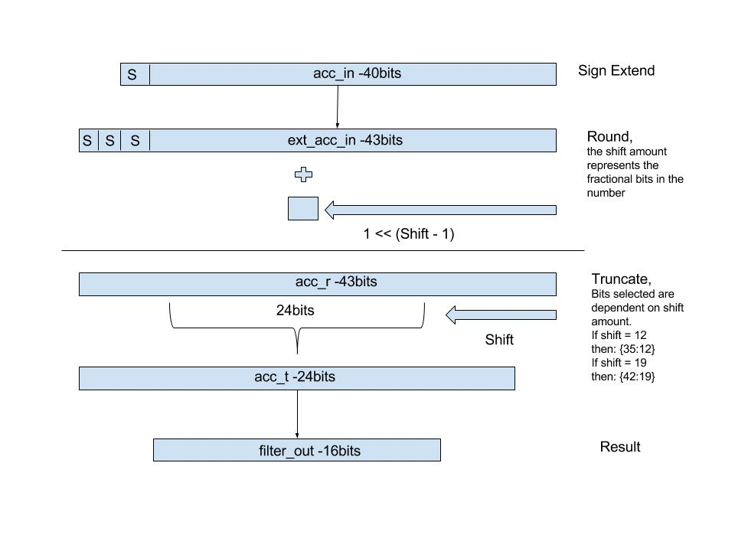

**Fig 4.5:** Finite State Machine: States and Transitions

**Table 4.6:** Interface Signals for Shift Round Truncate Module

|  |  |  |  |
| --- | --- | --- | --- |
| **Signal Name** | **Direction** | **Bits** | **Comment** |
| General | | | |
| clk | in | 1 | Master Clock |
| rstb | in | 1 | Asynchronous Reset |
| Control Fields | | | |
| rf_shift | in | 3 | Shift Amount |
| rf_clip | in | 1 | Allow clipping when overflow |
| trig_filter_ovf_flag | in | 1 | Reset overflow flag |
| ro_filter_ovf_flag | out | 1 | Triggered when overflow occurs |
| Audio Data | | | |
| acc_in | in | 40 | Final accumulator input |
| filter_out | out | 16 | Output Digital Audio |

*4.3 Verification*

To verify the Filter Block, I performed two types of tests, individual unit testing for each submodule and full block level test. The full block level test was to verify the functionaily of the block. I did testing of actual filter responses. The following sections will outline testing from the lowest module to the highest module. As far as functianilty, the filter block passes all the current tests. The filter was also verified with the entire chip in the Verification Section. This was done by using filter coeffiecents produced by the Matlab FDA toolbox. Below are is an example impulse response of 512-tap Low-Pass filter. Using coeffiecents produced by Matlab, I compared results from the Verilog simulation with a Java Model.

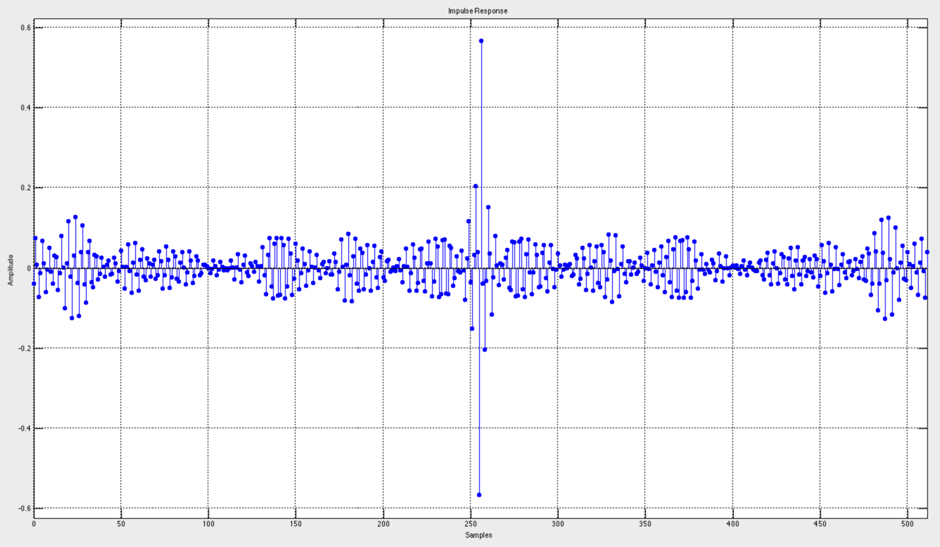

**Fig 4.6:** Impulse Response of 512-Tap Low-Pass Filter

*4.3.1 Accumulator*

To verify the Accumulator, I tested three functions: loading, normal operation, and reset. The first test was to verify when load and enable were both asserted. What I expected was that the output would not accumulate and would equal to the input signal. The second test was to verify when load = 1’b0 and enable = 1’b1. I expected to see the accumulator increment by the input signal each clock cycle. The output signal has a 4 bit overhead to avoid overflow. The final test was to check what occurred when rstb = 1’b0. I expected the reset to take priority over the other signals and set the output to 1’b0. Below is the simulation output. All three of my assertions were proven correct.

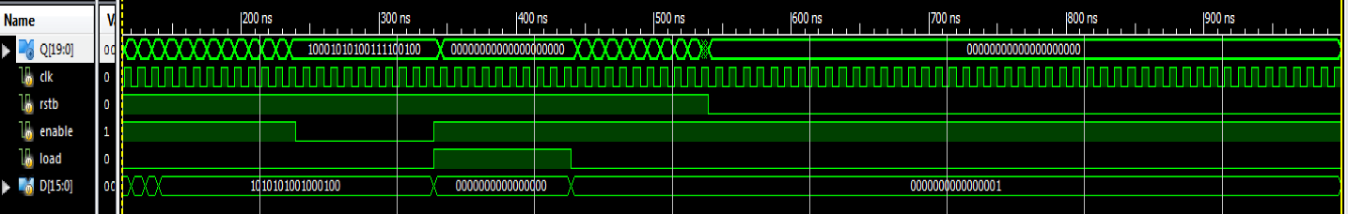

**Fig 4.7:** Simulation of Accumulator

*4.3.2 Filter Storage Module*

To verify the Filter Storage Module, I first tested basic writing and reading. I set the *wren = 1’b1*. I expect this to allow the module to write into the array at the given pointer. Starting with *wrdata = 32’hAAAAAAAA*, then *wrdata = 32’hBBBBBBBB*, and finally *wrdata = 32’hCCCCCCCC*. I increment the *wrptr* by 1’b1 after a 100 ns delay. To verify the values were stored correctly, I set *wren = 1’b0* and *rden = 1’b1*. I read the array from ram[0] to ram[2], by incrementing *rdptr* by 1’b1 after a 100ns delay. To verify that the data is not lost when reading it, once I reached ram[2], I decremented by 1’b1 after 100ns delay. I expected to see *rddata = 32’hAAAAAAAA*, *rddata = 32’hBBBBBBBB*, *rddata = 32’hCCCCCCCC*. *rddata = 32’hCCCCCCCC*, *rddata = 32’hBBBBBBBB*, *rddata = 32’hAAAAAAAA*. Below is the simulation output. My assertions were proven correct.

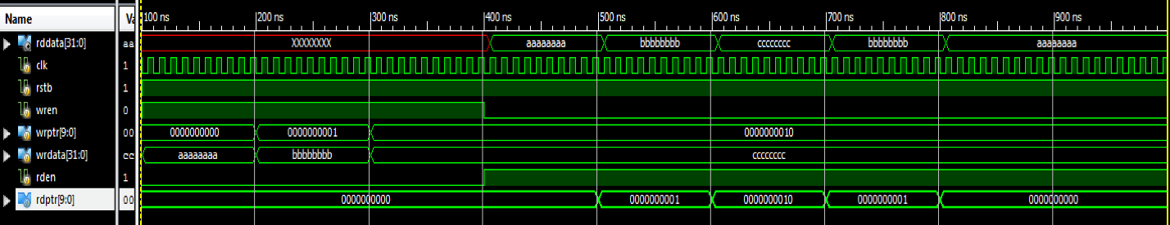

**Fig 4.8:** Simulation of Filter Storage Module Test 1

The second, test I performed was to check how storage module performed when the write and read pointer went above 511. I expect the storage module to perform circularly. To perform this test, I incremented the *wrptr* by 513. I expected the pointer to go back to *wrptr = 1‘d1*. The write data was *wrdata = 32’hBBBBBBBB*. I then read ram[1]. I expected to have an output

of *rddata = 32’hBBBBBBBB*. Below is the simulation output.

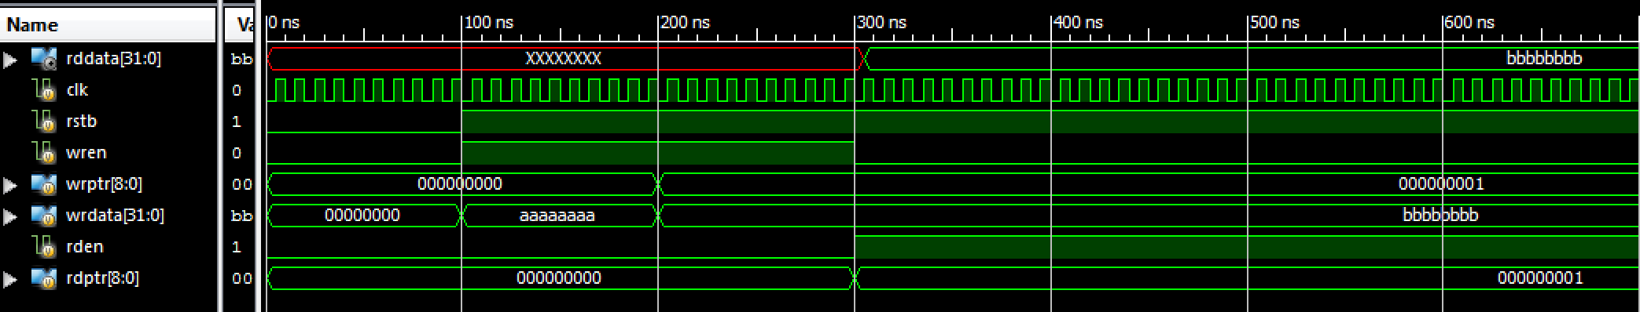

**Fig 4.9:** Simulation of Filter Storage Module Test 2

*4.3.3 Mux*

To verify the mux, I tested if I received the correct 16bit filter_coeffiecients. In addition, I tested if the mux correctly concatenated *rf_filter_coeffn_a* and *rf_filter_coeffn_b*. The ‘a’ component is stored from [7:0] and the ‘b’ component is stored from [15:8]. I set *rf*_filter_coeff(0-8)_*a* to 8’h00 to 8’h08, respectively. For *rf_filter_coeff(0-8)_b*, I set it to 8’h08 to 8’h00, respectively. For example, *rf_filter_coeff0* should output *16’h0800*. Another example would be, rf*_filter_coeff3* should output *16’h0503*. My test was successful as seen in the simulation output below.



**Fig 4.10:** Simulation of Mux

*4.3.4 Filter STM/Filter*

I tested by filter state machine by testing my top level. For the first test I observed if the states were transitioning properly. For my design, the filter will kick-off when XFC is complete. After a delay of 100ns, I asserted *aud_in_rts*. Below is my simulation. Note: for testing I am using an 8 tap filter. In the simulation once the filter kicks-off, it will cycle through the states until it is reset around 1000ns. The *do_transfer, do_multiply_1st, and do_multiply* represent when the states are running. For my STM implementation, it takes a single clock cycle to transition.

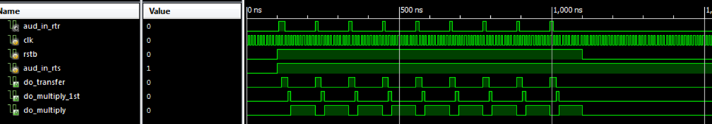

**Fig 4.11:** Simulation of Filter Test 1

The next test I performed was to vary the *aud_in_rts* signal from deasserted to asserted. It is possible for the I2S block to be not ready to send data when the filter block is ready to take data. To test this, I asserted aud_in_rts and desserted it after 100ns. I then waited 400ns to asserted it again. The MULTIPLY states will not be affected by this, but the TRANSFER state will get delayed until *aud_in_rts* is asserted again.

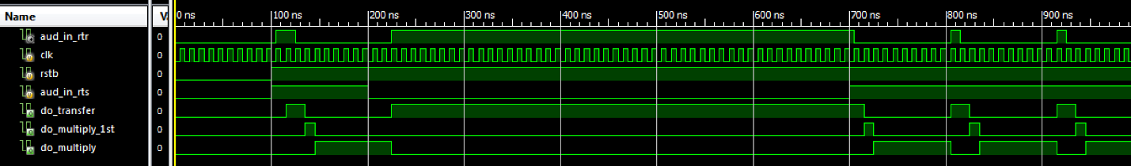

**Fig 4.12:** Simulation of Filter Test 2

Above the simulation, shows that the TRANSFER state is prolonged as it is waiting for XFC to be complete before it can transfer aud_in and change states. This can be proven by the simulation below. Here when *aud_in_rtr* and *aud_in_rts* are both deasserted the *aud_in data* will not be stored in the ram array. Around 700ns, *aud_in_rts* is asserted and *aud_in* is transferred into the current *wrptr*. After the transfer the state changes to the MULTIPLY_1ST stage.

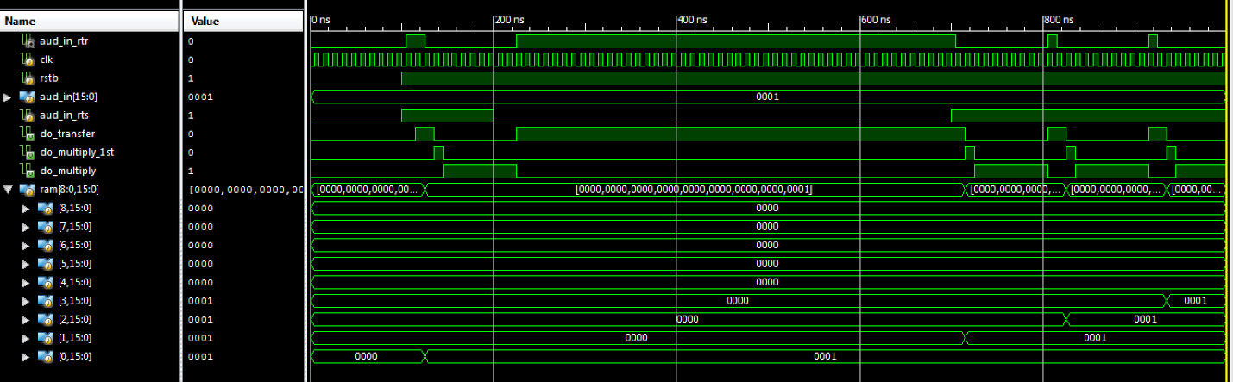

**Fig 4.13:** Simulation of Filter Test 3

The next test I performed was to observe the behavior of the read pointer for both the mux and storage module. I am expecting the read pointer for the storage module to decrement and increment for the mux. Each cycle should have 8 (or the number of Taps) increments or decrements.

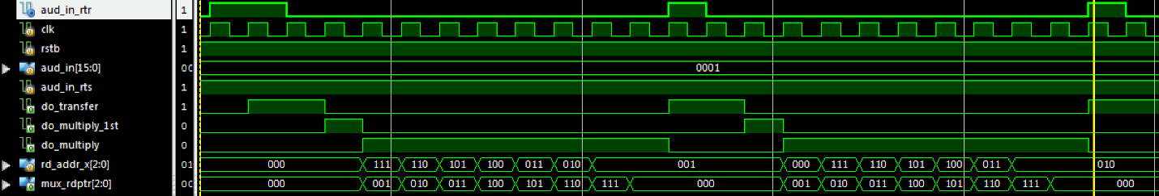

**Fig 4.14:** Simulation of Filter Test 4

Note that the last clock cycle of the multiply state is superfluous for the current cycle. Also for the read pointer for the storage module (*rd_addr_x*), it starts at the current location of the writer pointer. This proves that the filter follows, which is the convolution process.

1. y[0] = h[0] x[0] + h[1] x[-1] + … + h[510] x[-510] + h[511] x[-511]
2. y[1] = h[0] x[1] + h[1] x[0] + … + h[510] x[-509] + h[511] x[-510]
3. y[2] = h[0] x[2] + h[1] x[1] + … + h[510] x[-508] + h[511] x[-509]

The next test, was functionality of the filter. Here are the following testing parameters:

*rf_coeff0_b | rf_coeff0_a = 16’h0001*

*rf_coeff1_b | rf_coeff1_a = 16’h0002*

*rf_coeff2_b | rf_coeff2_a = 16’h0003*

*rf_coeff3_b | rf_coeff3_a = 16’h0004*

*rf_coeff4_b | rf_coeff4_a = 16’h0005*

*rf_coeff5_b | rf_coeff5_a = 16’h0006*

*rf_coeff6_b | rf_coeff6_a = 16’h0007*

*rf_coeff7_b | rf_coeff7_a = 16’h0008*

The audio values vary from *32’h00000000* to *32’h00FF00FF*, again the 16 most MSB are the left audio and 16 most LSB are the right. We are assuming that the I2S is always ready to send. In addition, I am only clipping and not shifting currently. The state machine outputs a 40bit audio out signal (due to the accumulator), so at the filter.v level the audio out is defined by:

*assign aud_out = convo_signal[39:8];*

Below is the simulation result.

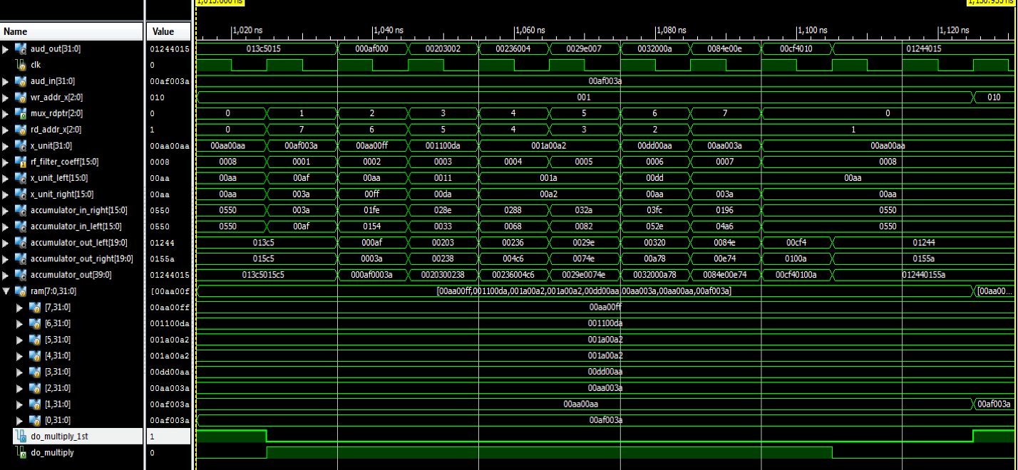

**Fig 4.15:** Simulation of Filter Test 5

To check our simulation, I am going to check the results by hand. Note: all values in Hex

Here is the input signal and impulse response:

*x[n] = {00af003a, 00aa00aa, 00aa003a, 00dd00aa, 001a00a2, 001a00a2, 001100da, 00aa00ff}*

*xleft[n] = {00af, 00aa, 00aa, 00dd, 001a, 001a, 0011, 00aa}*

*xright[n] = {003a, 00aa, 003a, 00aa, 00a2, 00a2, 00da, 00ff}*

*h[n] = {0001, 0002, 0003, 0004, 0005, 0006, 0007, 0008}*

The sum of products is defined by:

Note: I am using hex values for the index values

*y[0] = x[0]h[0] + x[7]h[1] + x[6]h[2] + x[5]h[3] + x[4]h[4] + x[3]h[5] + x[2]h[6] + x[1]h[7]*

There are two multipliers and accumulators for left and right audio. The calculations, done with WolframAlpha.com , are the following:

*Left:*

*yLeft = 00af*0001 + 00aa*0002 +0011*0003 + 001a*0004 +001a*0005 + 00dd*0006 +00aa*0007 + 00aa*0008*

*yLeft = 0x01244*

*Right:*

*yRight = 003a*0001 + 00ff*0002 +00da*0003 + 00a2*0004 +00a2*0005 + 00aa*0006 +003a*0007 + 00aa*0008*

*yRight = 0x0155a*

If I concatenate yLeft and yRight, I get *y = 0x012440155a*. Then we clip the least significant bit to get a 32 bit value of *0x01244015*.

This matches what we get in our simulation.

**Chapter 5: Register Block – J. Swift**

*5.1 Introduction*

The register block provides storage and access for control and status information. In Fig 5.1 the interaction of register block and the other blocks can be observed. The I2C slave interface sends byte-wide control data to the register block. Many of the registers represent filter coefficients and act as the filter’s parameters. These parameters can be changed by the user and written to the register block to control the audio filter behavior. Each filter coefficient is represented by two 8 bit values that are concatenated when sent to the filter control block. The I2C must be able to specify an address and write data to the specified address for the register to hold. When reading data, the I2C block will be able to read the stored data of a specified address. When an underrun occurs in the I2S’s FIFO, the register block will be able to clear the sticky bit that is flagged when the filter is producing data at a lower rate than the I2S Output is consuming.

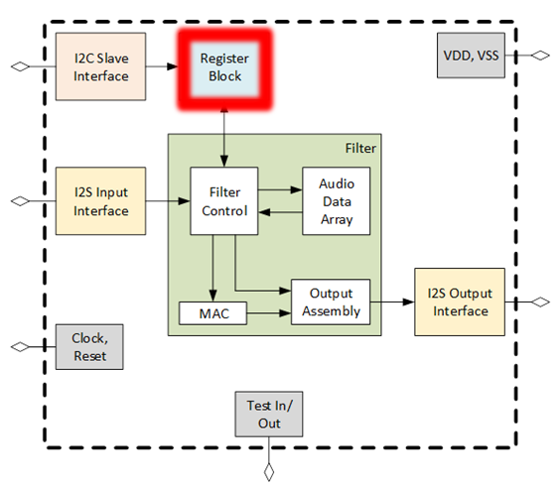

**Fig 5.1:** Chip Diagram with Register Highlighted

Internally, the register block is broken down into a data demultiplexer that takes the write enable, address, and write data, and writes to the appropriate register bits based on the address. With the rising edge of the write enable, the data demultiplexer allows data to be stored in the register. This low level logic is controlled by the rising edge of the clock, which can be seen in Fig 5.2.

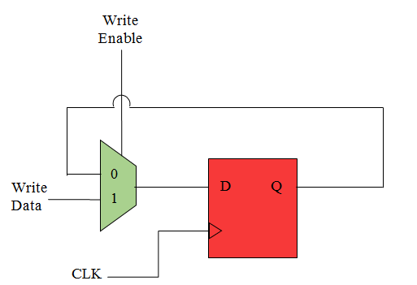

**Fig 5.2:** Internal Micro-Architecture of Register

*5.2 Interfaces*

The top level interface of the register block is described in Fig 5.3 which shows the signal’s flow of direction and number of bits in each signal. The addr input signal is an 11-bit variable that holds the value of the address in the register block in which data can be read from or written to.

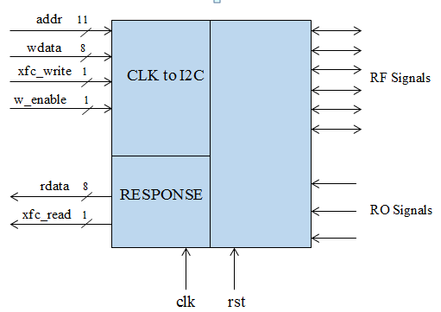

**Fig 5.3:** Top Level Interface Design of reg.v

The wdata is an input variable array that writes 8-bits of data to a specified 11-bit address. Similarly, the rdata output array returns the 8-bits of data demanded by any signal request of a specified address. The write_xfc is an input 1-bit transfer signal that indicates when the transfer of the data written is complete. The read_xfc is an output 1-bit signal that similarly goes high when read data transfer is complete. Master clock, clk, and reset, rst, are 1 bit signals that regulate activity to occur on the positive edge of the clock or the negative edge of the rst signal. Lastly, the i2s_inoverrun will turn into a sticky bit that is manipulated when I2S FIFO has an overrun or underrun condition.

*5.3 Register Mapping*

The register map seen in Table 4.1 includes a list of all the signals assigned to an address and shows the breakdown of bits in each address. The natural 32-bit word aggregation is indicated in bold. Each signal is prefixed with “ro” or “rf” in the beginning of the field name. When a signal is prefixed with “ro” it means the signal represents a “Read Only” field, and is an input signal to the register block.  The “rf” prefix indicates that the signal is a “Read/Write” register bit, and is an output signal. The CONTROL signals are either on, meaning they are set to the value 1, or off when set to a value of 0. The I2S_CLOCK_CONTROL are addresses that control the clock for the I2S module. The STATUS addresses are 1 bit signals used when the I2S FIFO exhibits an overrun or underrun in which the signals will then be set to a value of 1 to alert the FIFO malfunction. BIST addresses will be dedicated to I2S’s predefined sawtooth wave. The read/write BIST signals are responsible for the starting value of the sawtooth wave, incrementing the sawtooth wave, and determining the upper limit of the sawtooth wave. The I2C_REG_INDIR_ADDR is the address register used for indirect addressing via I2C. Lastly, the 512 filter coefficients are broken down into two 8 bit coefficients with parts a and b. Each subdivided coefficient is assigned to an address in which data can be written and read from.

**Table 5.1:** Register Mapping of Each Bit in the Address it is Stored

|  |  |  |  |  |  |  |
| --- | --- | --- | --- | --- | --- | --- |
| **Address** | **Register Name** | **Field Name** | **Bits** | **Description** | **RO/WO/RW** | **Default Value** |
| **0x004** | **CONTROL** |  |  |  |  |  |
| 0x004 |  | rf_i2si_bist_en | 0:0 | 0- audio source is i2si. 1- audio source is BIST | RW | 0x1 |
| 0x004 |  | rf_filter_shift | 3:1 | number of bit positions to shift after filter accumulator | RW | 0xF |
| 0x004 |  | rf_filter_clip_en | 4:4 | 1- performs clipping 0- no clipping | RW | 0x1 |
| **Address** | **Register Name** | **Field Name** | **Bits** | **Description** | **RO/WO/RW** | **Default Value** |  |
| 0x004 |  | rf_i2si_en | 5:5 | Enable bit for Deserializer. 0 = inactive, 1 = active | RW | 0x01 |
| **0x008** | **STATUS** |  |  |  |  |  |
| 0x008 |  | trig_fifo_overrun | 0:0 | i2s input audio fifo overrun clear | WO | NA |
| 0x008 |  | ro_fifo_overrun | 1:1 | i2s input audio fifo overrun | RO | 0 |
| 0x008 |  | trig_fifo_unerrun | 2:2 | i2s output fifo underrun clear | WO | NA |
| 0x008 |  | ro_fifo_underrun | 3:3 | i2s output audio fifo underrun | RO | 0 |
| 0x008 |  | trig_filter_ovf_flag_clear | 4:4 | filter overflow flag clear | WO | NA |
| 0x008 |  | ro_filter_ovf_flag | 5:5 | filter overflow flag | RO | 0 |
| **0x00C** | **BIST** |  |  |  |  |  |
| 0x00C |  | rf_i2si_bist_incr | 7:0 | increment of sawtooth wave | RW | 0x010 |
| 0x00D |  | rf_i2si_bist_start_val_a | 7:0 | start value of sawtooth wave | RW | 0x80 |
| 0x00E |  | rf_i2si_bist_start_val_b | 3:0 |  | RW | 0x0 |
| **0x010** | **BIST** |  |  |  |  |  |
| 0x010 |  | rf_i2si_bist_upper_limit_a | 7:0 | upper limit of the sawtooth wave | RW | 0x7F |
| 0x011 |  | rf_i2si_bist_upper_limit_b | 3:0 |  | RW | 0xF |
| **0x0400** | **FILT_COEFFS_0_1** |  |  |  |  |  |
| 0x0400 |  | rf_filter_coeff0_a | 7:0 | Filter Coefficient 0 | RW | 0x0 |
| 0x0401 |  | rf_filter_coeff0_b | 7:0 | Filter Coefficient 0 | RW | 0x0 |
| **Address** | **Register Name** | **Field Name** | **Bits** | **Description** | **RO/WO/RW** | **Default Value** |
| 0x0402 |  | rf_filter_coeff1_a | 7:0 | Filter Coefficient 1 | RW | 0x0 |
| 0x0403 |  | rf_filter_coeff1_b | 7:0 | Filter Coefficient 1 | RW | 0x0 |
| **0x0404** | **FILT_COEFFS_2_3** |  |  |  |  |  |
| 0x0404 |  | rf_filter_coeff2_a | 7:0 | Filter Coefficient 2 | RW | 0x0 |
| 0x0405 |  | rf_filter_coeff2_b | 7:0 | Filter Coefficient 2 | RW | 0x0 |
| 0x0406 |  | rf_filter_coeff3_a | 7:0 | Filter Coefficient 3 | RW | 0x0 |
| 0x0407 |  | rf_filter_coeff3_b | 7:0 | Filter Coefficient 3 | RW | 0x0 |
| **0x7FC** | **FILT_COEFFS_510_511** |  |  |  |  |  |
| 0x07FC |  | rf_filter_coeff510_a | 7:0 | Filter Coefficient 510 | RW | 0x0 |
| 0x07FD |  | rf_filter_coeff510_b | 7:0 | Filter Coefficient 510 | RW | 0x0 |
| 0x07FE |  | rf_filter_coeff511_a | 7:0 | Filter Coefficient 511 | RW | 0x0 |
| 0x07FF |  | rf_filter_coeff511_b | 7:0 | Filter Coefficient 511 | RW | 0x0 |

*5.4 Sub-Blocks*

*5.4.1 trig_generator.v*

The trig_generator.v is responsible for generating a signal to clear the overrun and underrun status bits. The two output bits, trig_i2si_fifo_overrun_clr and trig_i2so_fifo_underrun_clr, are initialized to zero when not rst. If the address is the 11-bit hexadecimal number 0x00C and the xfc_write is set to one, then the if-statement returns true and the trigger bits are edited. Trig_i2si_fifo_overrun_clr and trig_i2so_fifo_underrun_clr are first initialized to zero in order to allocate them later only in the case of an overrun or underrun. When the data transfer is complete, meaning the XFC is 1, and the address is 0x00C, two if-statements are then checked. One stating that when data written to 0x00C is 0, the trig_i2si_fifo_overrun_clr bit is set to 1, and the other stating that when data written to 0x00C is 2, the trig_i2so_fifo_underrun_clr bit is set to 1. These 2-bits in the address 0x00C report back to the I2S block where the FIFO is signaled to either have an overrun or underrun.

*5.4.2 register.v*

The register.v is responsible for initializing all the signals and filter coefficients along with assigning all signals/coefficients to the proper address. The 16-bit filter coefficients are initialized to zero and the rest of the signals are initialized to the hexadecimal default values given in Table 4.1. When the write enable (w_enable) and the write file transfer (wxfc) are both 1, a case statement is entered; given an address, the corresponding bit(s) within the address are broken down and assigned to the data written to the register. A second always block includes setting the read file transfer (rxfc) to not-write enable (~w_enable) and write file transfer (wxfc). An if-statement states that if not-write enable and write file transfer are 1, the case-statement can begin. When entering the case-statement, a specified address is can be called and the stored data can be read. The register.v allows data to be written to an address that correlate to specific signal(s), and allows data to be read from signal(s) that are stored in a specific address.

*5.5 Test Fixtures*

*5.5.1 trig_generator_testbench.v*

The purpose of the trig_generator_testbench.v is to write data to the address and trigger the trig_i2si_fifo_overrun_clr and trig_i2so_fifo_underrun_clr bits at the appropriate time. First the test fixture initializes the count and clk variables to zero to create a fresh simulation. The wdata is set to 8 bit address 8’hFF. The count variable counts to the hexadecimal value 20 where the 11-bit address is then initialized by 4 every time the count variable is incremented as seen in Fig 5.4. The rising edge of the XFC signals that the transfer of data has been completed, which allows data to be written to the address space and increment the address signal by 4 from 0000 to 0100. This test fixture writes to every address in order to ensure data is properly being written and stored.

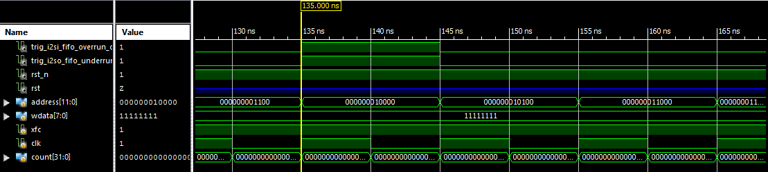

**Fig 5.4:** The Start of the Test Fixture Simulation

When the count variable reaches 20 and the hexadecimal value 0x00C is reached, the trig_i2si_fifo_overrun_clr and trig_i2so_fifo_underrun_clr bits are triggered to becomes 1 as seen in Fig 5.5. After the address 0x00C, or binary address 1100, goes low, the trigger bits go high for the length of the next address. This shows that the trigger bits are recognizing an overrun and underrun from the I2S FIFO because the conditions, XFC = 1, and address = 0x00C, are true. After the next clock cycle, the trigger bits will reset back to 0 because the I2S will have been signaled that an error has occurred in the buffer. A clock cycle after the address is incremented to 0x020, the XFC goes low to 0 and everything has reset again.

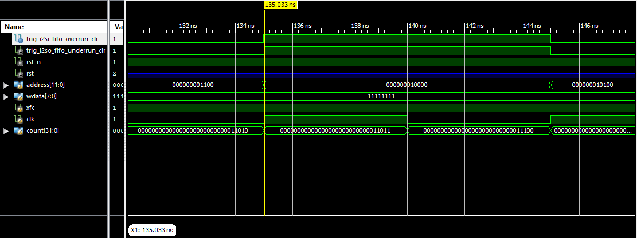

**Fig 5.5:** Bits trig_i2si_fifo_overrun_clr and trig_i2so_fifo_underrun_clr are Triggered

*5.5.2 trig_generator_testbench1.v*

The second testbench for the trigger generator differs from the first testbench by initializing the address first to the 11-bit address 0x00C. Like the first testbench, when wdata is less than the address 0x020, wdata is incremented by 1 and the XFC is set to 1. The overrun trigger bit is signaled every clock cycle when the XFC goes high. The underrun trigger bit is signaled through the duration of four addresses, or two clock cycles, and when the XFC is set to 1. The testbench in Fig 5.6 indicates the trig_generator.v is fully functional because the overrun trigger bit is cleared every time data is trying to be written to the full I2S FIFO, and the underrun trigger bit is cleared every four addresses when the empty I2S FIFO is trying to be read.

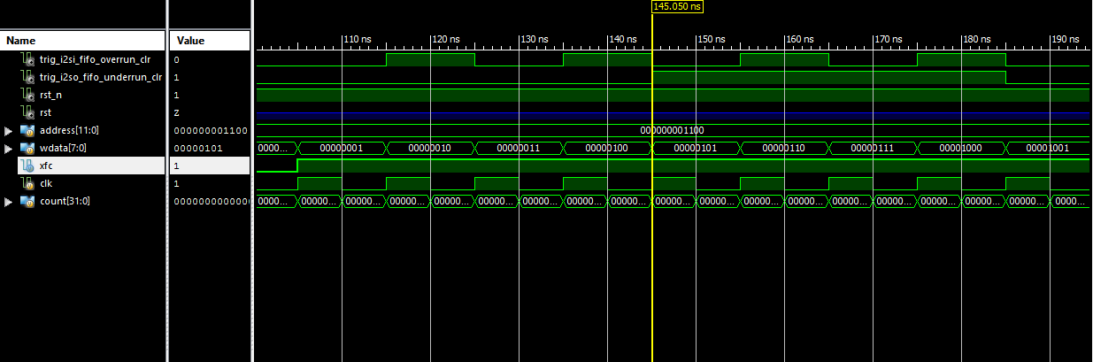

**Fig 5.6:** Bits trig_i2si_fifo_overrun_clr and trig_i2so_fifo_underrun_clr are Triggered in Second Testbench

*5.5.3 i2c_reg_test_automated.v*

To test the register.v file, a testbench was created that incorporated the I2C block. I2C was set up in a subsystem test with the register to check that coefficients could properly be written, read, and stored properly from the I2C into the register block. Test data was loaded into the 512 two-part coefficients and the state of the coefficient registers were set to the 11-bit address 0x400. The slave address was set to the hexadecimal value 0xD5 with the 3-bit I2C address bits set to the binary value 101. After waiting 100ns for the global reset, a series of conditions were produced in order to serialize the slave address and the read/write bit, and serialize the two-part register address. The resultant waveforms generated showed the test data being properly written and stored within to the register.

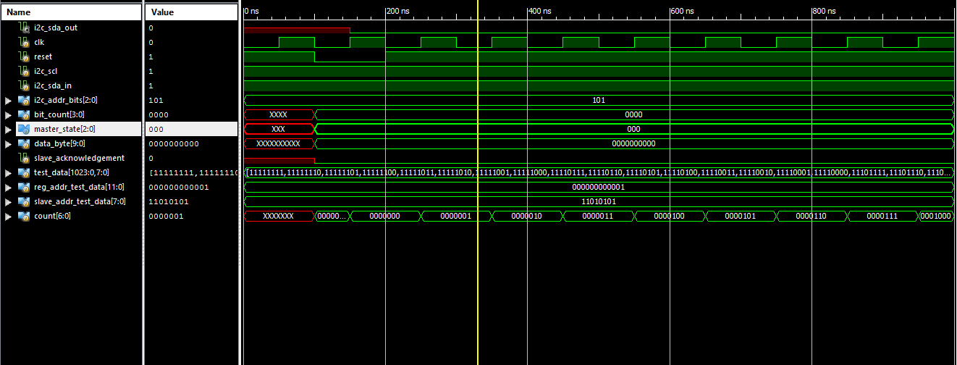

**Fig 5.7:** Test data properly being written from the I2C into the Register Part 1

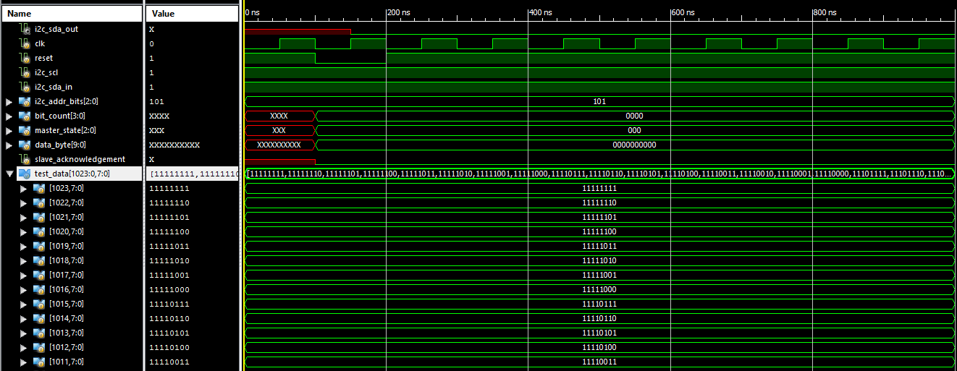

**Fig 5.8:** Test data properly being written from the I2C into the Register Part 2

*5.6 C Code Involvement*

*5.6.1 initialize_coeffs.c*

To initialize all 512 16-bit filter coefficients to a hexadecimal value of 0, a C program was generated in order to generate the thousand lines of code. Each coefficient is split into 8 bits, creating coefficients a and b. This created 1024 lines of Verilog code that was generated into a filter_coeffs_initialized text file that would loop 512 times and print the correct formatting of each coefficient. The C program generated both coefficients a and b with a variable y incremented each loop cycle. The code outputs the two tabs such that when copying the code from the text file into Xlinix, it is formatted correctly. A pointer to the 16 bit hexadecimal 0 value is next to each coefficient in order to initialize all filter coefficients to zero.

*5.6.2 set_coeffs.c*

To assign all 1024 8-bit filter coefficients to the correct address, a C program was created to generate the correct number of tabs, case statement of the 11-bit hexadecimal address, and a new line of the name of the coefficient pointing to the 8-bit written data variable. In C, there is a compatible hexadecimal format that permits an integer to be incremented by hexadecimal 0x01 while still including the correct hexadecimal character formatting as hexadecimal should. After the address case statement, the correct name of the filter coefficient is expressed in which coefficients a and b are toggled between such that every other for loop iteration switches between coefficient a and coefficient b. The 1024 coefficients are properly formatted such that the contents of filter_coeffs_set.txt could be copied and pasted into Xlinix directly.

*5.6.3 set_read_coeffs.c*

The set_read_coeffs.c program generates the correct formatting for the case-statement that varies slightly from set_coeffs.c. The fprintf() statement is rearranged from set_coeffs.c to have rdata point to the signal requesting to be read, instead of having the signal point to wdata. The 1024 filter coefficients are created that same way as set_coeffs.c, but printed differently to the text file such that the filter block is able to read the filter coefficients values that are written in the first always block.

**Chapter 6: I2C Slave Interface – W. Forman**

**Chapter 7: Simulation/Verification – K. Cao and D. Naik**

To verify the RTL design of the audio filtration ASIC, multiple simulations were run in Xilinx. Each simulation tested for a different filter configuration. A test bench for the top module of the chip was created. Each simulation was given the same input, a square wave. 10,000 words were inputted into I2S for each simulation. The input data values described a square wave with an amplitude of 3,276 and -3,276. This value is a tenth of the value of the max digital audio value for CD quality audio. This value was chosen to ensure that no overflow occurs within the filter block. If overflow occurred, the output audio would not be considered to be valid for testing. To ensure that the serial data inputted to the I2S block was being outputted instead of the BIST data, the enable signals for the I2S deserializer was set high and the enable signal for the multiplexer was set low.

The first type of verification that was performed was a simple pass through of data. The filter allows only the current input to output. The output of the chip was compared with the input data to ensure that the data matched exactly. This verified if data was moving through the chip correctly. Later tests would verify if the ASIC was capable of applying the correct filter. To have the input to simply pass through the filter, the very first filter coefficient was set to 1, and the rest of the 511 coefficients were set to 0. These coefficient values were changed within the register block when reset is asserted high. Then to simply apply the coefficients the reset signal is asserted.

The verification process for the lowpass, highpass, and average filters were similar to the pass through verification. The only difference in these verifications are the coefficients values. MATLAB was used to calculate the different coefficient values for each filter. Using the Filter Design and Analysis tool, or FDAtool, in MATLAB was used to calculate the different coefficient values for the lowpass and highpass filter. Matlab produced coefficient values that were in decimal format. Using the Java Program, the coefficients were converted into pairs of 2’s complementary binary numbers for each coefficient value. The register block was then edited each time when applying a new filter.

To verify the data for the lowpass, highpass, and average filters a model was created with Java. The Java model calculated the filtered values of the input data and stored the values within a text file. Within this file each line contained a word that was filtered by the chip. The various simulations within Xilinx also outputted a text file of the filtered input serial data in the same format as the Java model text file. Both text files were compared with each other to verify if the chip was working as intended.

Our initial tests for the low pass and high pass failed. The output for the Verilog simulations had similar shapes, but looked time shifted compared to the model. We hypothesized that there was a startup associated with the Verilog and the filter was not receiving the first couple I2S inputs due to it. After further digging, this was found to be true. After adjusting the input signal for the Model to match the signal entering the filter module, the tests passed.

The filter takes time to reach steady state, dependent on the magnitude of the number of taps of the filter. For our FIR filter, the first 512-1024 inputs are deemed invalid. This is due to the filter not having enough past inputs to convolute correctly.

Our results are below. Each verification we graphed two periods. The first figure contains the first 1000 samples and the second figure contains samples 2000 to 3000. This is when the filter reaches steady state.

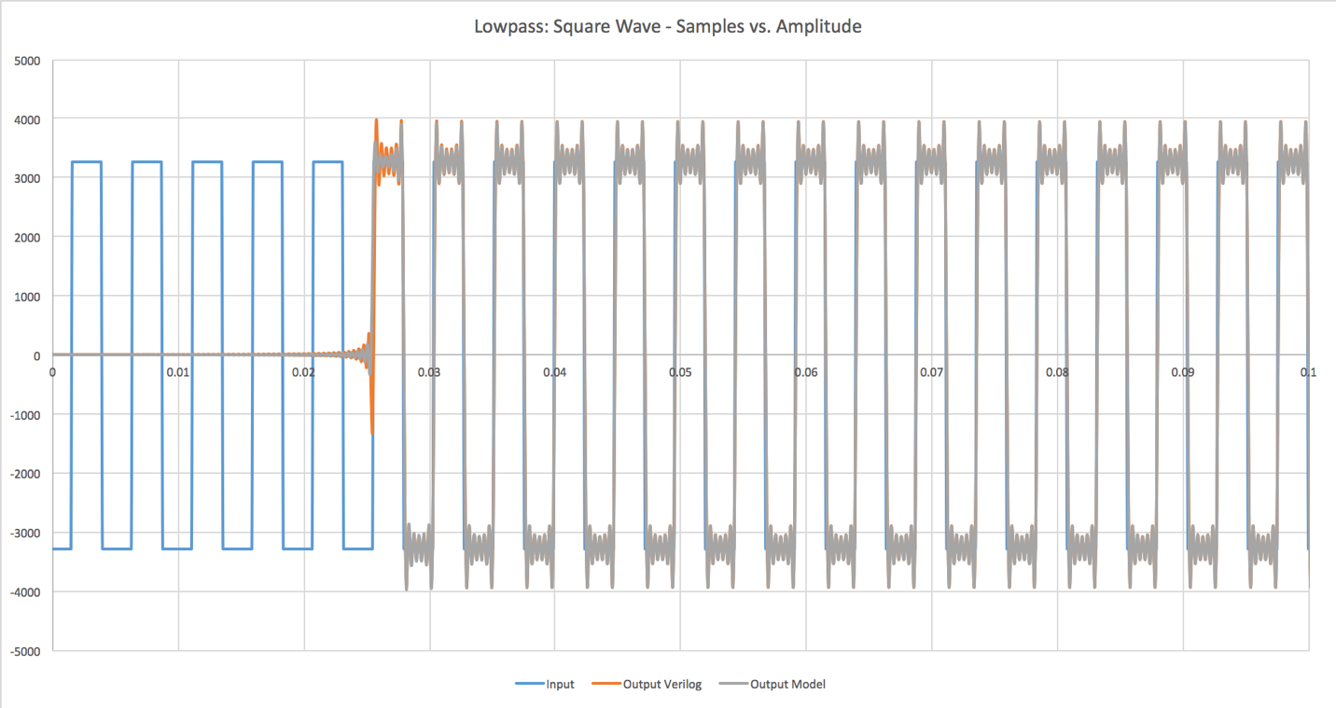

**Fig. 7.1:** Lowpass Filter: Square Wave Samples 0 - 1000

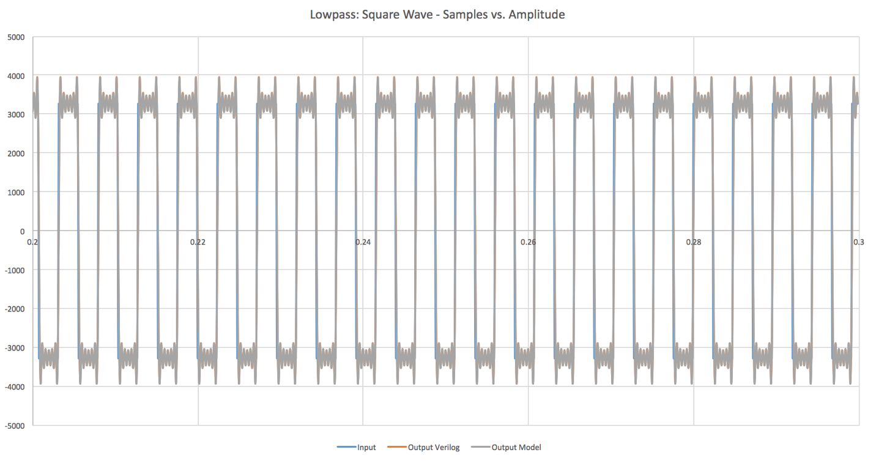

**Fig. 7.2:** Lowpass Filter: Square Wave Samples 2000 - 3000

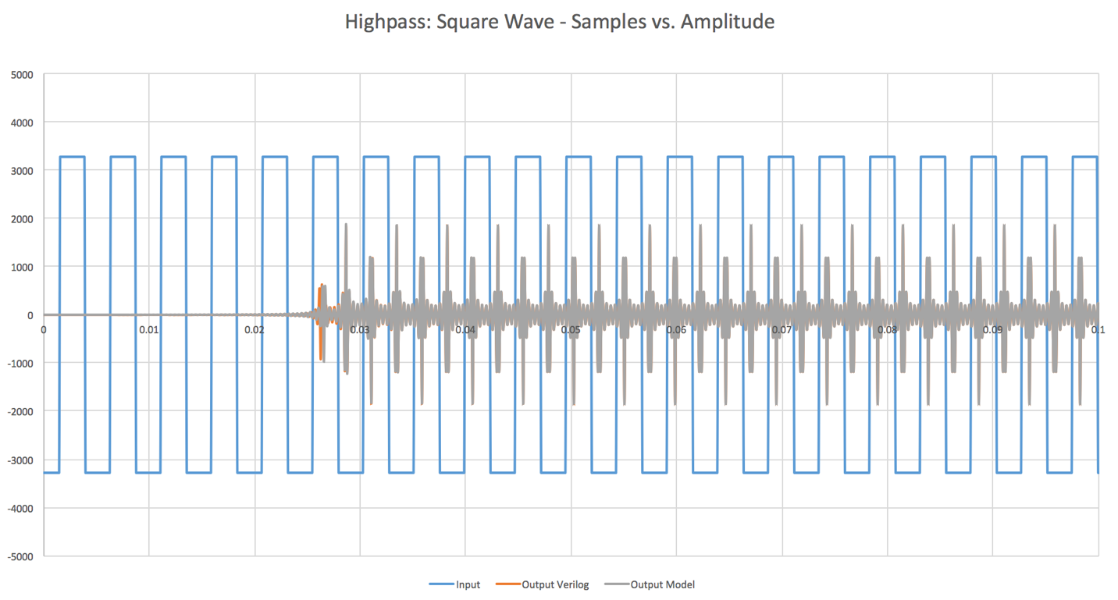

**Fig. 7.3:** Highpass Filter: Square Wave Samples 0 - 1000

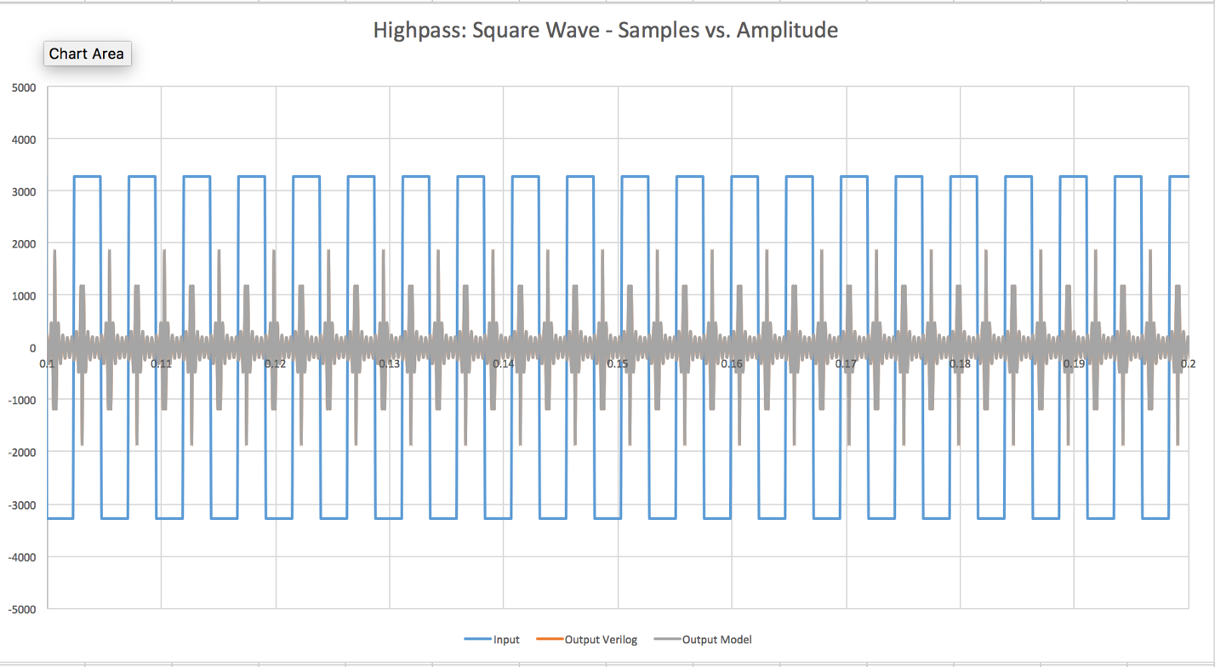

**Fig. 7.4:** Highpass Filter: Square Wave Samples 2000 - 3000

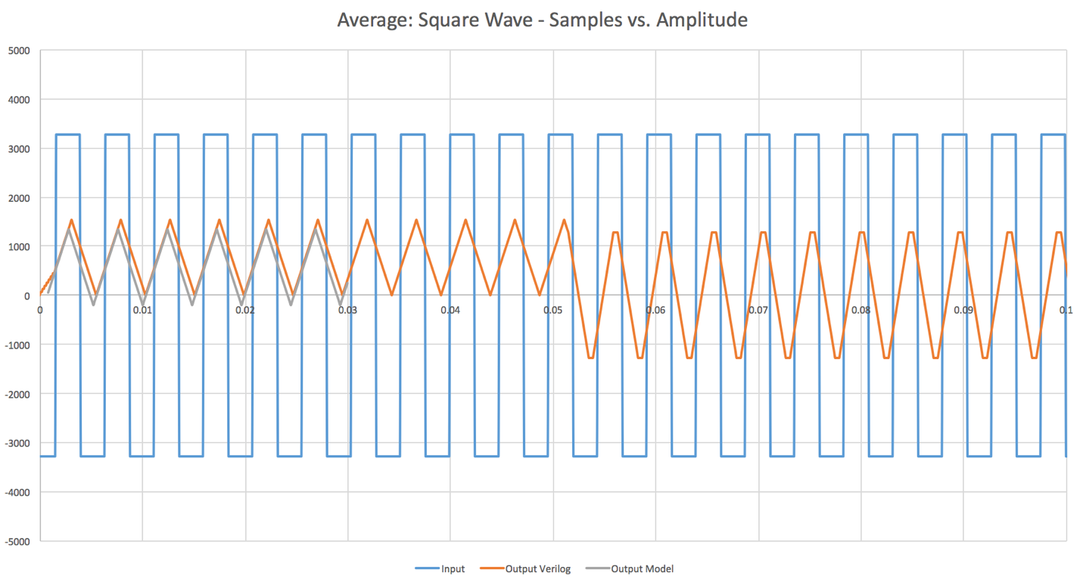

**Fig. 7.5:** Average Filter: Square Wave Samples 0 - 1000

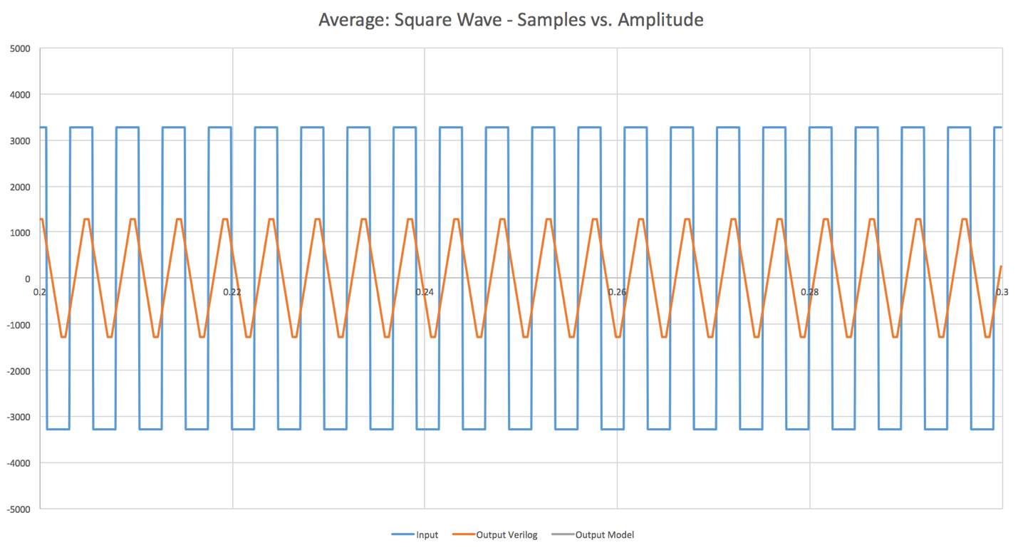**Fig. 7.6:** Average Filter: Square Wave Samples 2000 - 3000

**Chapter 8: FPGA Implementation - Zachary Nelson**

The FPGA implementation was primarily a way to show that our design worked in realistic setting. The first step of the FPGA portion of the project was purchasing a Nexys 4 Artix-7 FPGA. After we received the FPGA, we needed to assign pins to the inputs and outputs of our design. Table 8.1 shows how we mapped the signals to the FPGA pins. The pin assignments were done using the PlanAhead software that is included in the Xilinx ISE Design Suite.

**Table 8.1:** Verilog Signal to FPGA Mapping

|  |  |  |  |
| --- | --- | --- | --- |
| Signal Name | Direction | FPGA Pin | PlanAhead Site |
| clk | in | internal (crystal) | E3 |
| rst_n | in | reset button | C12 |
| i2si_sck | in | JB3 | V11 |
| i2si_ws | in | JB4 | V15 |
| i2si_sd | in | JB7 | K16 |
| i2so_sck | out | JB8 | R16 |
| i2so_ws | out | JB9 | T9 |
| i2so_sd | out | JB10 | U11 |
| i2c_addr_bits | in | JA9:JA7 | DC18, C17, G13 |
| i2c_scl | in | JA1 | B13 |
| i2c_sda_in | in | JA2 | F14 |
| i2c_sda_out | out | JA3 | D17 |

Since we now had synthesized Verilog code and pin assignments, we could generate a programming file and download it to the FPGA. A FGPA programming guide was created and the steps are listed below.

**Step #1:** Click the Synthesize button in Xilinx ISE. (This will take several minutes)

**Step #2:** Click the Implement Design button in Xilinx ISE. (This will take several minutes)

**Step #3:** Click the Generate Programming File button in Xilinx ISE. (This will take several minutes)

**Step #4:** Plug in FPGA via USB.

**Step #5:** Under “Configure Target Device”, click the Manage Configuration Project (IMPACT) button. The ISE iMPACT tool window will now open.

**Step #6:** Run the wizard by clicking Edit\Launch Wizard. The “Welcome to iMPACT” window will open.

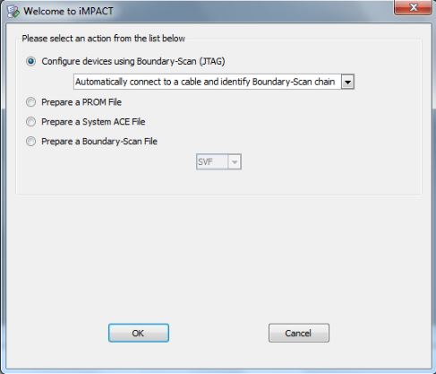

Click OK.

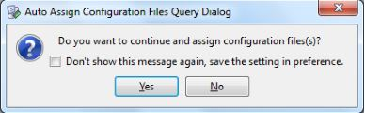

Click Yes.

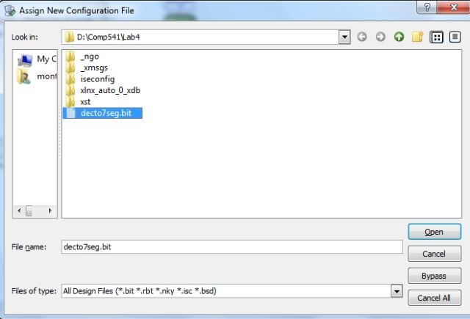

Select the .bit file that you generated in Step 3.

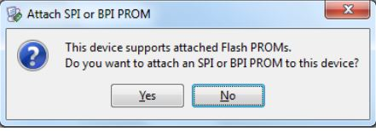

Select No.

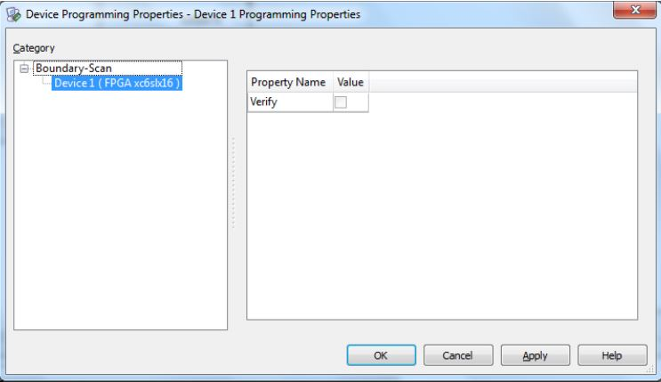

Click OK.

**Step #7:** If there are no errors, you will see an “Identify Succeeded” message. Right-click on the green Xilinx box and click program.

**Step #8:** Look at the port mappings in rtl_description.xlsx and configure test setup.

Since our FPGA was now successfully programed, we needed to create I2S and I2C PSoC programs that could test the FPGA. Fig. 8.1 below shows the FGPA wired up to two PSoC microcontrollers (the I2S one is showed in the picture). The I2S program was created by Ian Patel and the I2C program was created by Whitley Forman. The I2S program was originally intended to generate and capture back I2S data to verify that the filtering component of the design was working. However, there was some kind of bug in the I2S capture that we could not fix. For some reason, we could not get accurate data captured back to the PC. The I2S program was successfully able to generate different types of input waveforms including sinusoidal, square, and triangular waves.

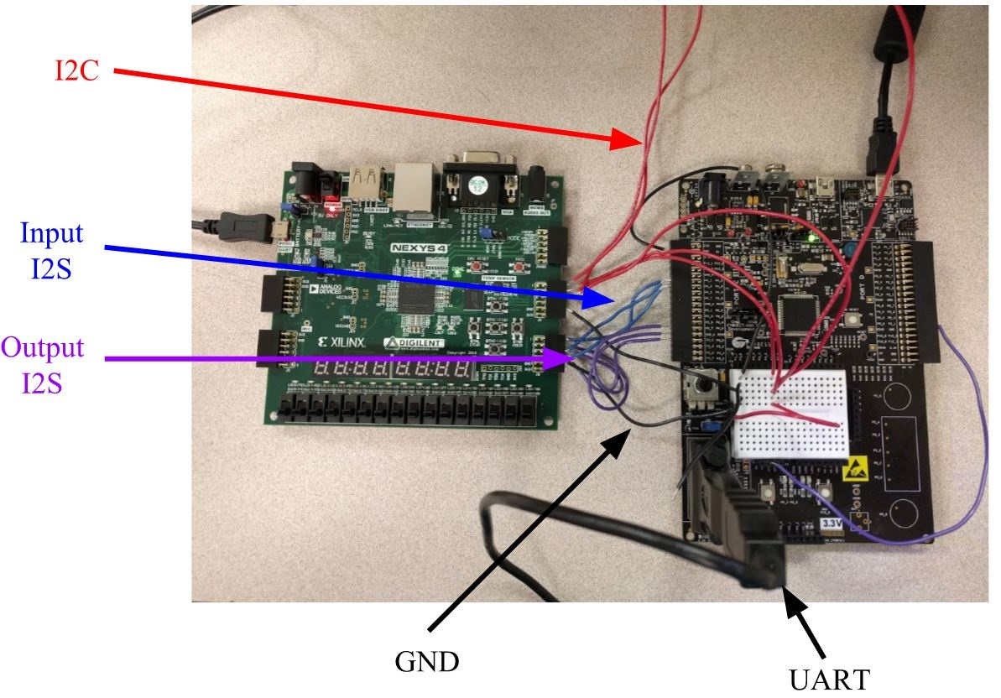

**Fig. 8.1**:FPGA Testing Set Up

Without the I2S capture working we were still able to do some testing of the FPGA. We first set the default filter coefficients to create a pass-through filter (the output signal is the same as the input signal). We then applied a square wave to the input since it can easily be observed on an oscilloscope. Fig. 8.2 show the serial clock and word select that was taken from the chip. Note that the input and output serial clock and word select matched in frequency. Fig. 8.2 also shows the square wave input and the corresponding output. It can be seen that output exactly matched the input besides being slightly delayed. This simple test gave us some physical proof that our design’s data flow worked not only in simulation but on hardware.

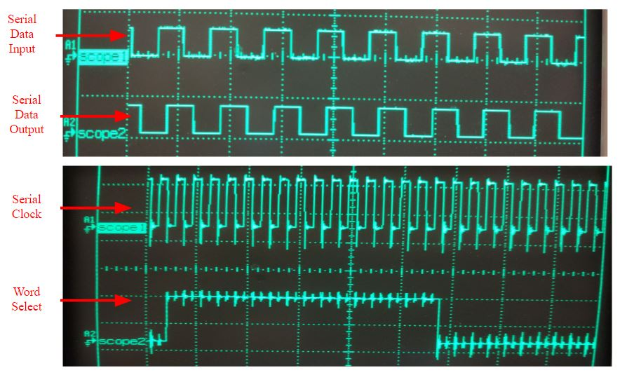

**Fig. 8.2**:FPGA Waveforms (Pass-Through Filter)

WHITLEY WILL BE ADDING HIS TESTING

**Chapter 9: EDA Tools and Physical Design – D. Naik**

**, J. Swift, K. Cao**

*9.1 Setting up Mentor Graphics*

Once Pyxis has been installed on a Linux machine, users need to set up environmental variables to use the products. If the user is using a bash shell, a script can be placed in the .bashrc folder. This script will run every time the user logs in, which allows the user to avoid setting the variables on every log in. The instructions are the following.

1. cd /home/username/
2. vi .bashrc
3. insert following script

# .bashrc

# Source global definitions

if [ -f /etc/bashrc ]; then

        . /etc/bashrc

fi

# User specific aliases and functions

export MGC_HOME=/home/eda/pyxis/pyxis_v10.5_3/

export MGLS_LICENSE_FILE=1717@lmservices2

1. logout and re-login

Once the environmental variables are set up, the user can invoke the Pyxis tool from the command line. Use *$MGC_HOME/bin/dmgr_ic* to launch the Pyxis project manager.

The user will see the following screen:

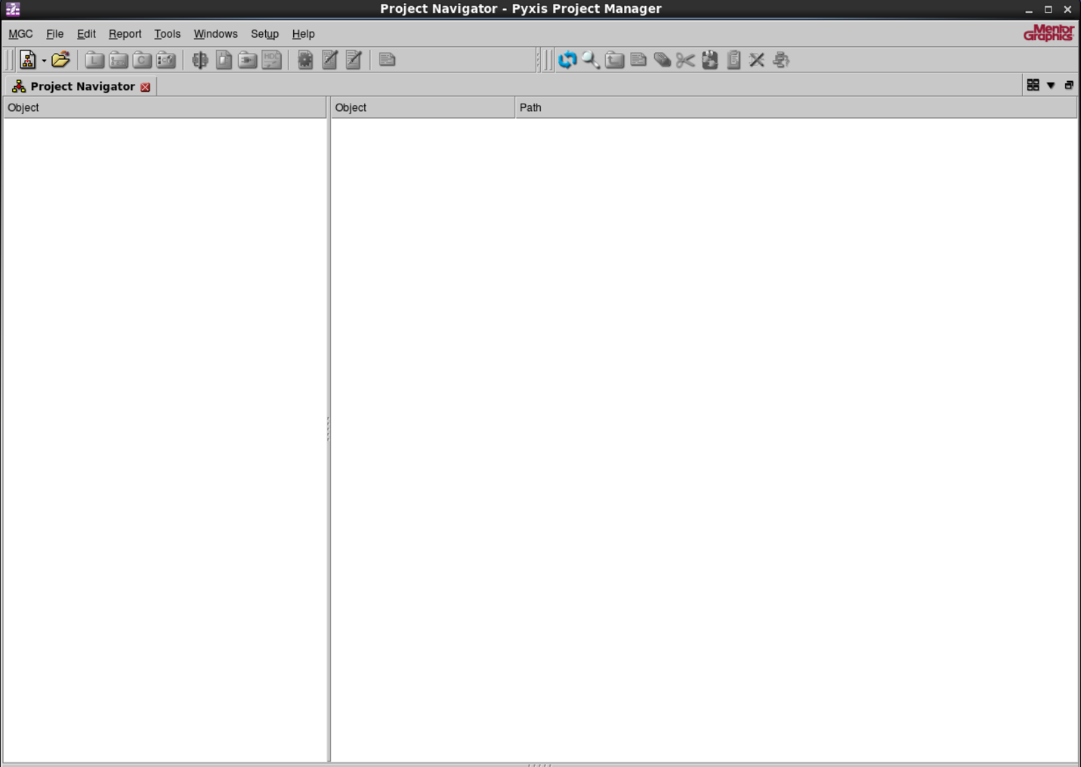

**Fig 9.1:** Project Manager Window

Within this screen, click on “Create New Project” at the top right.

A project wizard will pop up. Select the project path. For this example, we are using the *generic13* libraries provided from Mentor Graphics. Find the path for the libraries. Click ok.

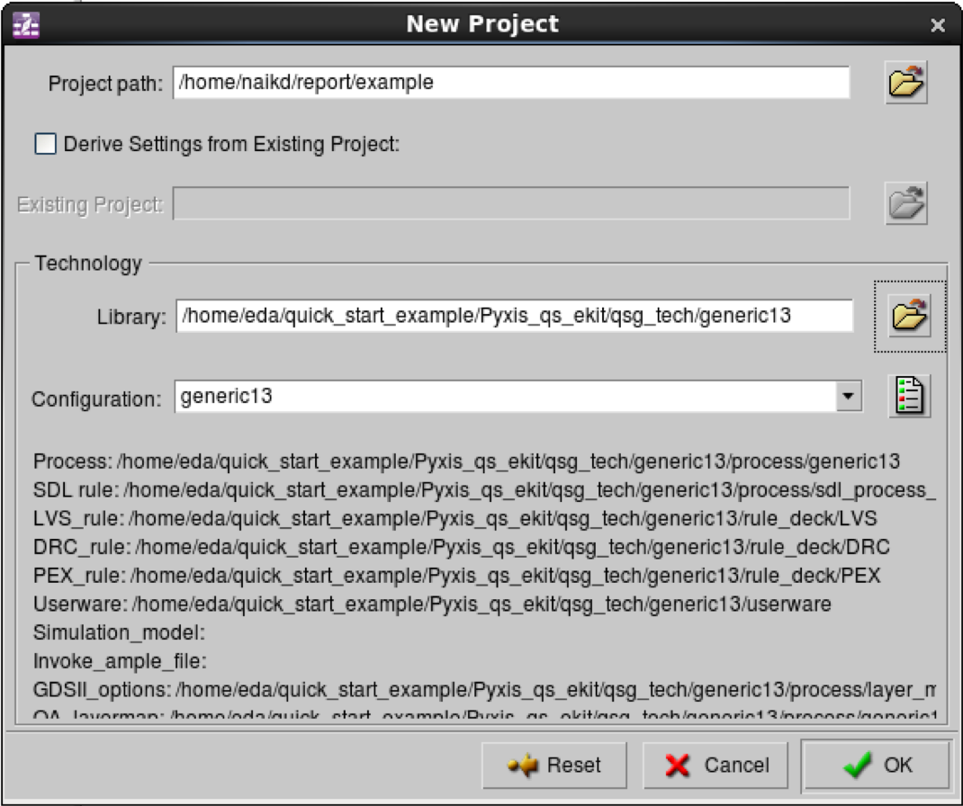

**Fig 9.2:** New Project Wizard – Screen 1

In the next screen, click on “Add Standard Libraries” this will populate the screen. Click ok. The project is now set up. Within the manager, schematics and layouts can be created.

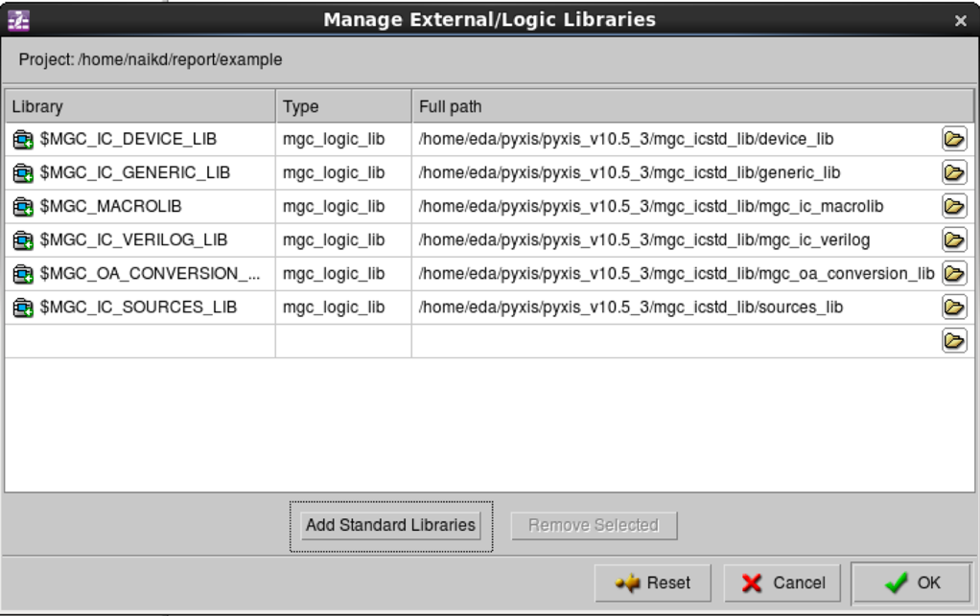

**Fig 9.3:** New Project Wizard – Screen 2

*9.2 Physical Design*

Given the time constraint of the project, we decided to make a physical design of an RLC circuit to send out to manufacturing. The layout would consist of three resistors, three spiral inductors, and three capacitors. All three components are in series with three capacitors being in parallel to one another. Using polysilicon on the predefined layer POLY2, a resistor and an indicator were created using the rectangle function. Figure 9.1 shows a 25ohm resistor that measures 38 by 40 μm in dimensions. Each rectangle is 2 μm wide with a spacing of all polysilicon to be at least 2 μm apart. The 3 by 3 μm contact was created from metal on the predefined layer M1 with a 2 by 2 μm carbon-oxide (CO layer) on top of the metal. These contacts serve as connectors to wire the components together.

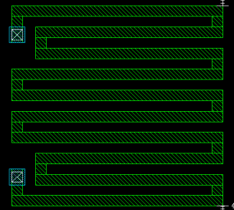

**Fig 9.4:** 38 x 40 μm 25Ω Resistor

The resistor was then copied and pasted two times in order to create a total resistance of 75 Ω. The inductor was the next component created from metal on the predefined layer M1. If time permitted, we would have produced a coiled conductor as well, but for now, the spiral inductor was chosen to be the three conductors in our RLC circuit. Figure 9.2 shows a 46 by 40 μm spiral inductor. The same dimensioned contacts as before were placed at the beginning and end of the inductor using VIA1 as the layer that connects the M1 inductor to the M2 wire. A copy was made and placed in series with the other components.

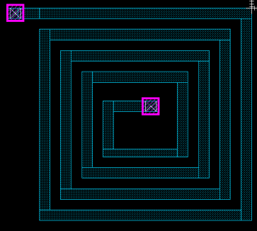

**Fig 9.5:** 40 x 40 μm Spiral Inductor

JULIE WILL BE UPDATING THIS

**Chapter 10: Conclusion**

In conclusion, we were able to successfully deliver fully functional Verilog code that satisfies the goals of the project. We performed extensive testing via testbench simulations and additional testing on a FPGA using different input signals. We also went through the process of installing EDA tools and using them to create a simple circuit with a resistor, inductor, and capacitor on it. Documenting the chip design process and code we created will definitely save next year’s groups time. Overall, one of the most valuable skills we learned was being able to write high quality synthesizable Verilog code. Some of the team members plan on using this skill in industry after graduation. Overall, this senior project was a valuable experience for us because we learned about the many steps that need to be completed in order to produce a chip.

**References**

[1] Mosis.com, ‘About Us’, 2015.[Online]. Available: https://www.mosis.com/what-is-mosis. [Accessed: 11 November 2015].

[2] nxp.com, ‘*I2C-bus specification and user manual - UM10204*’, 2015. [Online]. Available: <http://www.nxp.com/documents/user_manual/UM10204.pdf>. [Accessed: 10 November 2015]

**Appendix A: Project Overview**

Biography 4

Engineering Standards and Realistic Constraints Form 4

Engineering Standards, Specifications, and Codes 4

Modern Engineering Tools 4

**Biography:**

*Kevin Cao:*

* Kevin is from Morris Plains, NJ and is a Computer Engineering major who is planning to enter the workforce after graduating at TCNJ. Kevin has interned as a software engineer at LGS Innovations, located in Florham Park, NJ.



*Whitley Forman:*

* Whitley is from Ocean Grove, NJ and is an Electrical Engineering major who is continuing his education in the electrical field and will be obtaining his Master Electrician’s license after graduation. He is planning on using his new knowledge and experience with his current business to expand into new ventures.



*Dhruvit Naik:*

* A resident of Mount Laurel, NJ, Dhruvit is a senior Computer Engineering major at TCNJ. He plans on entering the workforce after graduation and continuing his education in the coming years. He is the Vice-President of a startup, ThinkSOAS, INC.



*Zachary Nelson:*

* From Cream Ridge, NJ, Zachary is a Computer Engineering major who has enrolled in a Ph.D. program at Johns Hopkins University specializing in controls starting in Fall 2016. He has experience as a software engineering intern at Teletronics Technology Corporation and an undergraduate student researcher at TCNJ as part of the MUSE program.

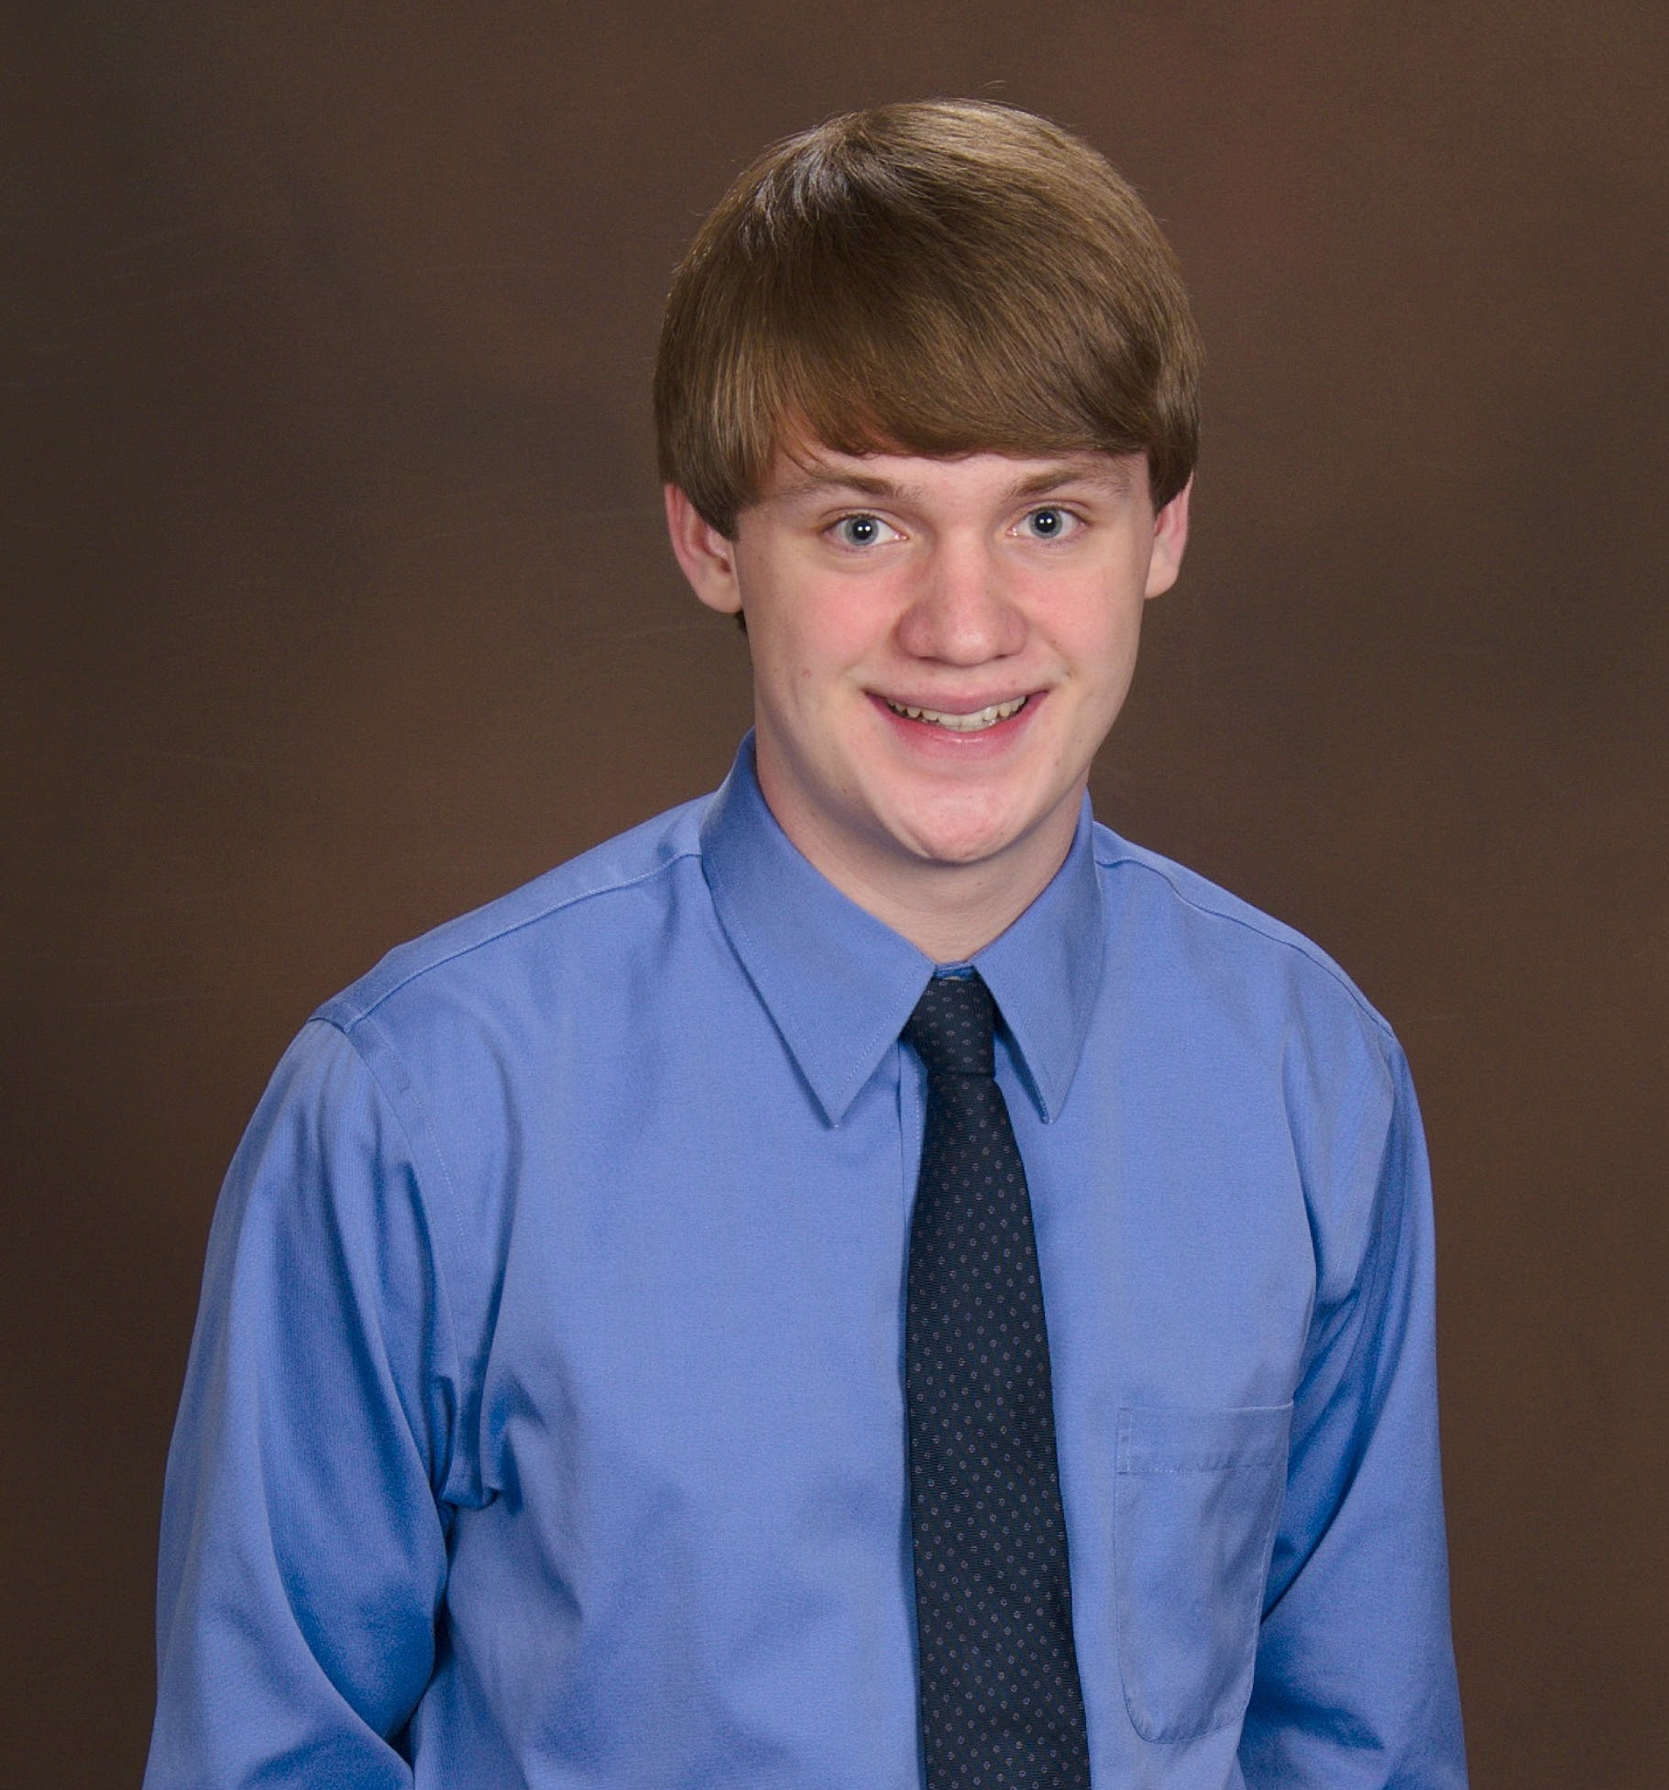

*Julie Swift:*

* From Robbinsville, NJ Juliann is a Computer Engineering major who is planning on entering the workforce after college. She has experience as a AutoCAD Designer interning at Linearization Technology and a Software Development Life Cycle Analyst interning at Educational Testing Services. She participated in the undergraduate student research program, MUSE, at TCNJ.



**Engineering Standards and Realistic Constraints Form:**

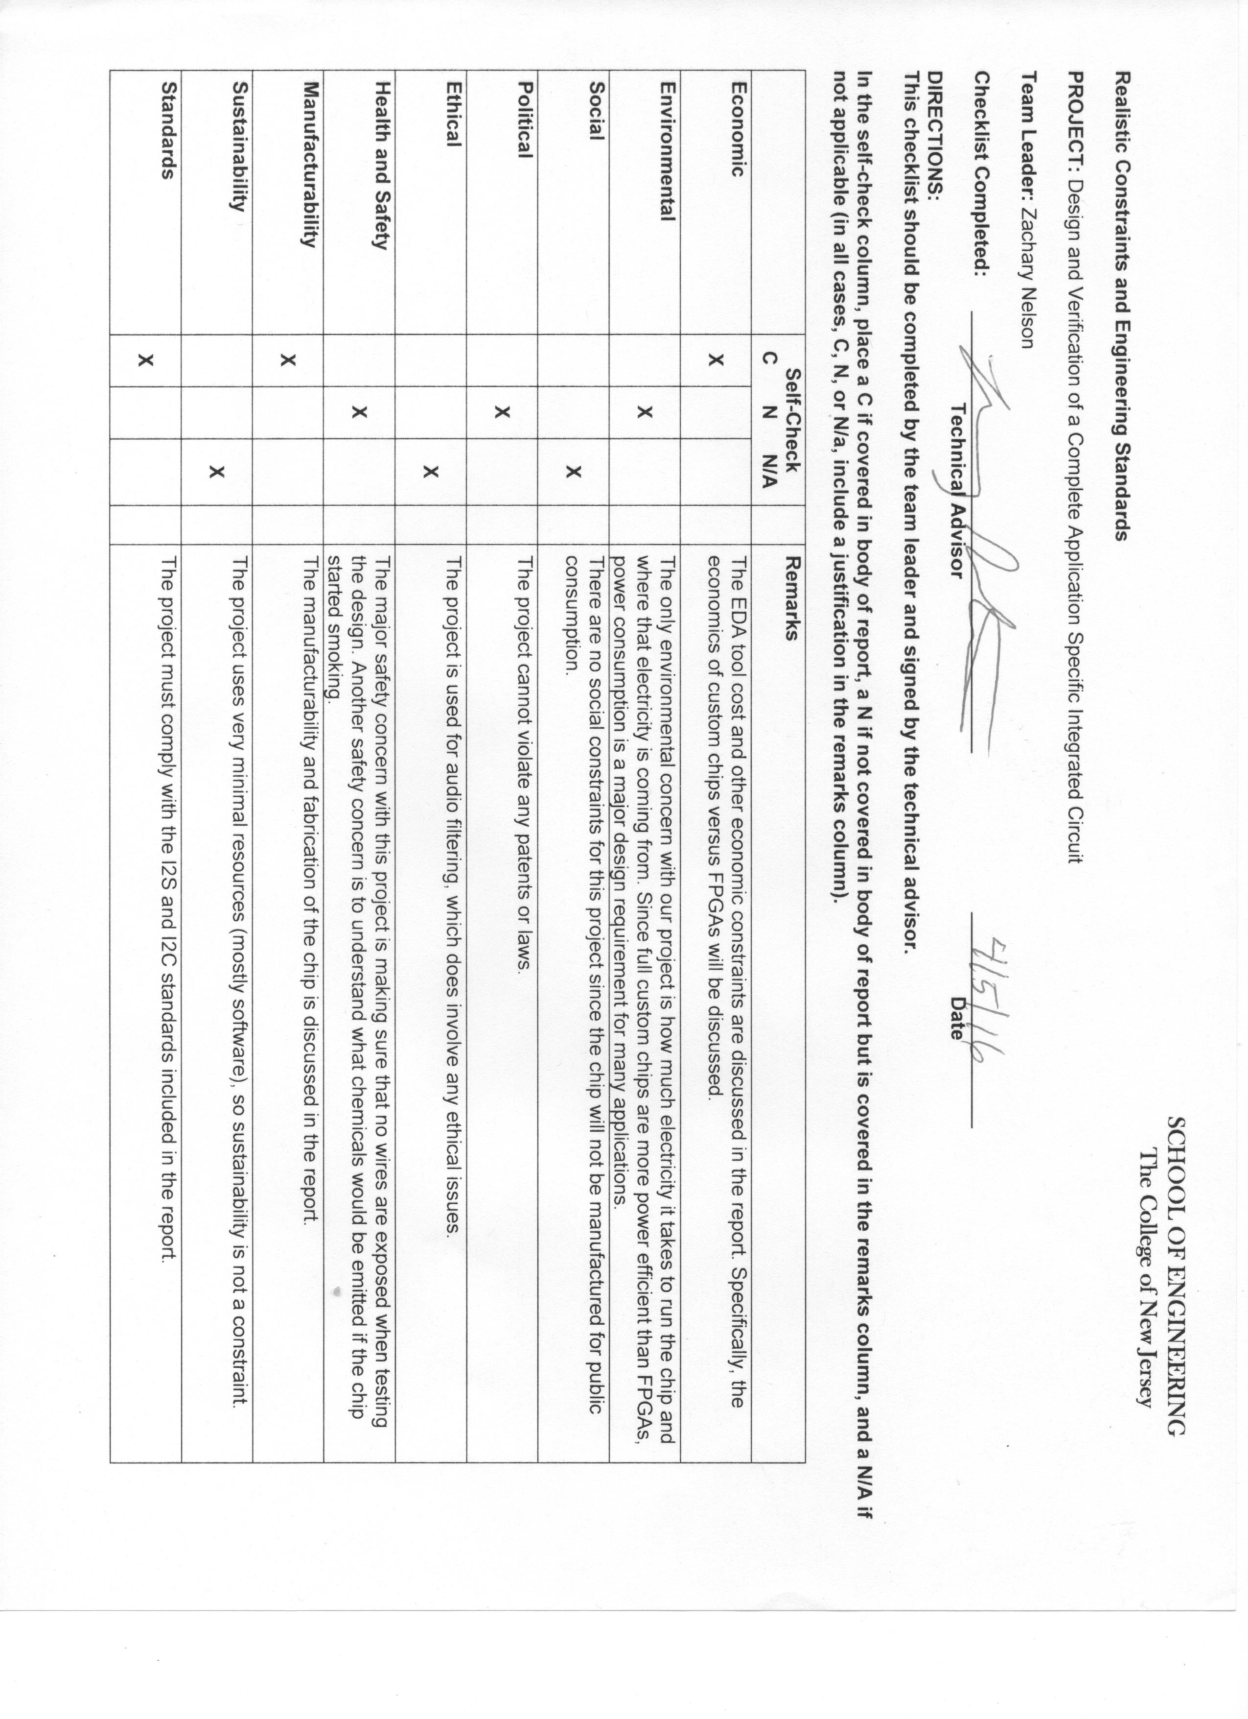

**Engineering Standards, Specifications, and Codes:**

* *I2C:* A serial communication standard that we used for uploading and reading registers to our FPGA. The details of this standard can be found in Appendix E.
* *I2S:* A serial communication standard for transferring digital audio. The I2S bus uses a bit clock line, word clock line, and data line. The details of this standard can be found in Appendix E.
* *Verilog:*A hardware description language (HDL) that can be used to design digital systems (such as an FPGA). This language is a high-level abstraction of a design that can be synthesized into low-level logic gates.

**Modern Engineering Tools:**

* *CORE 9*: System design software that we used to model the basic structure of the system. We also used it to keep track of the system requirements and use cases.
* *DropBox*: Cloud storage service that we used to store all confidential materials.
* *Git/GitHub*: Revision control software that allows a group to keep multiple versions of source code. We stored all documents and code in the public GitHub repository.
* *Linux RedHat Operating System*: Operating system that was required for all Mentor Graphics software (ModelSim and Pyxis).
* *Microsoft Project*: Project management tool that we used to keep track of the group’s schedule and progress.
* *ModelSim HDL Simulator*: Simulation and verification tool that we used to test our Verilog code.
* *Pyxis Custom IC Design Platform*: Multiple pieces of software that we used for the design of our simple chip.
* *Xilinx ISE Design Suite*: Design environment for Xilinx FPGA products. We used this tool for writing Verilog code, writing Verilog test benches, debugging Verilog code, synthesizing our design, and programming the FPGA.

**Appendix B: Management**

Schedule 4

Meeting Minutes 4

List of Contacts 4

Safety Considerations 4

Materials List 4

Financial Budget 4

**Schedule:**

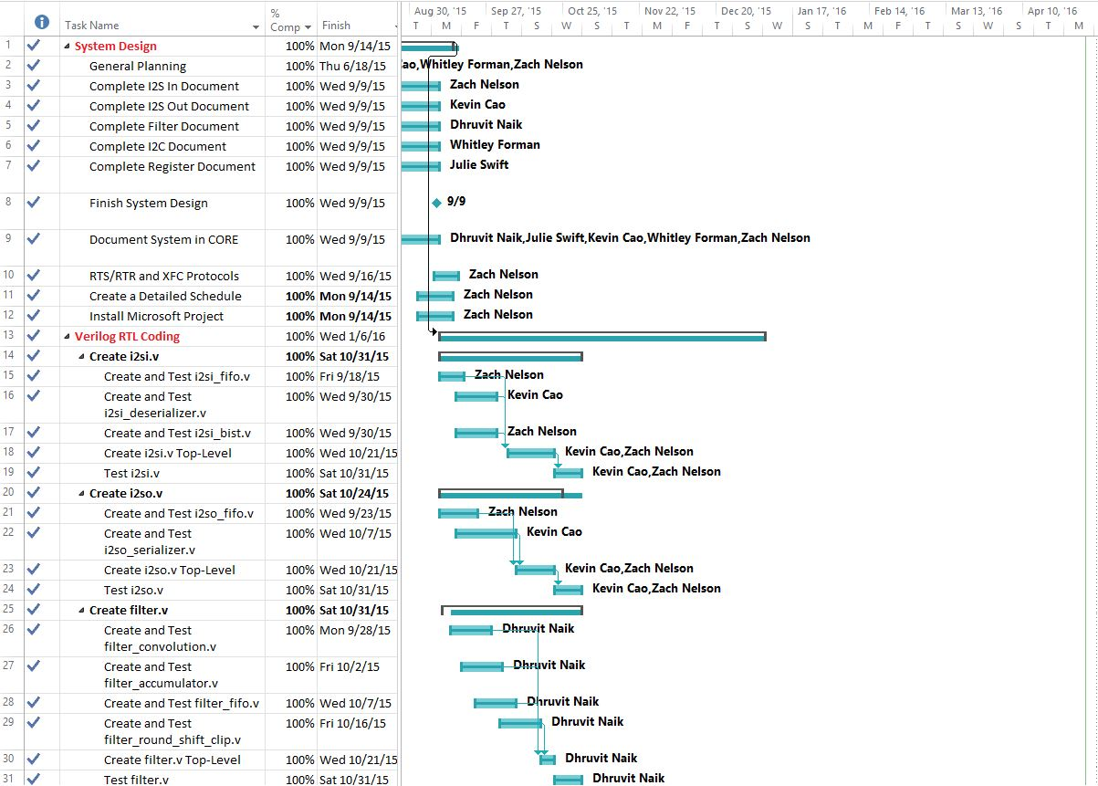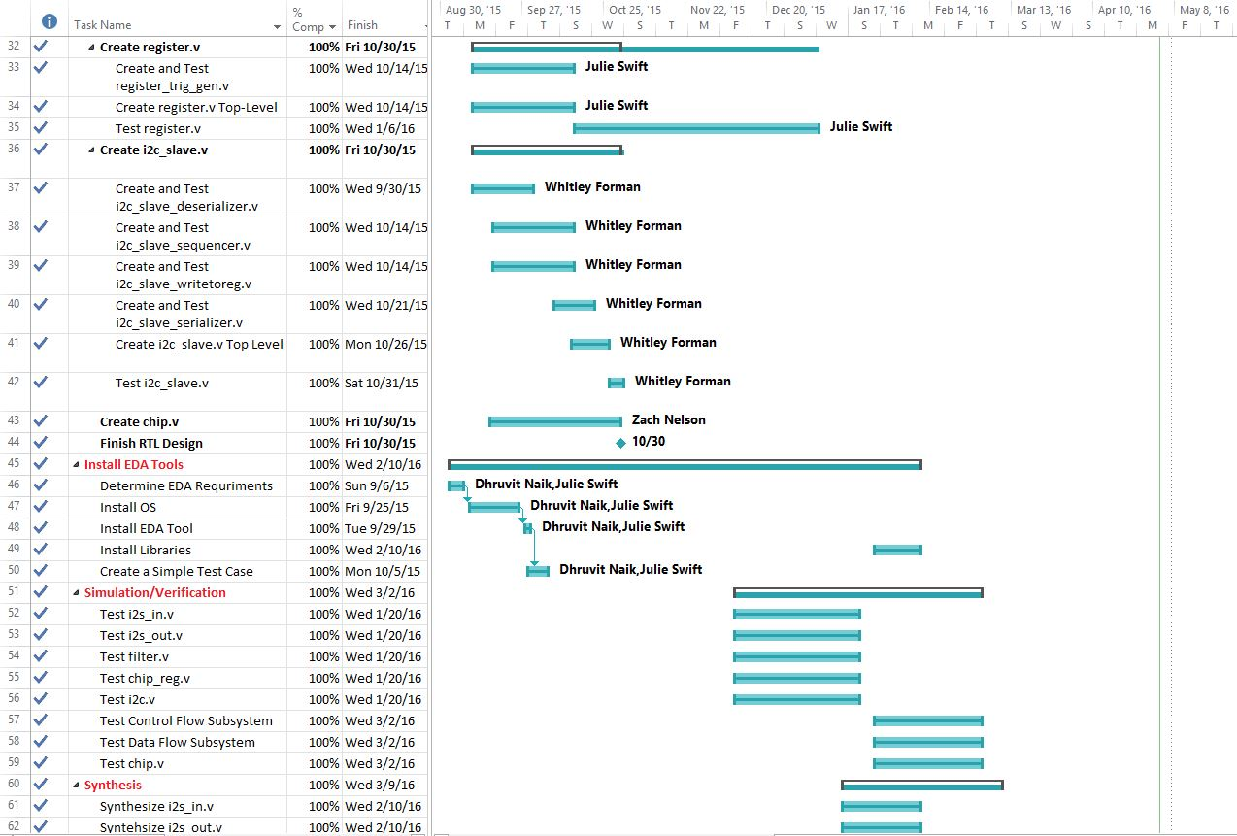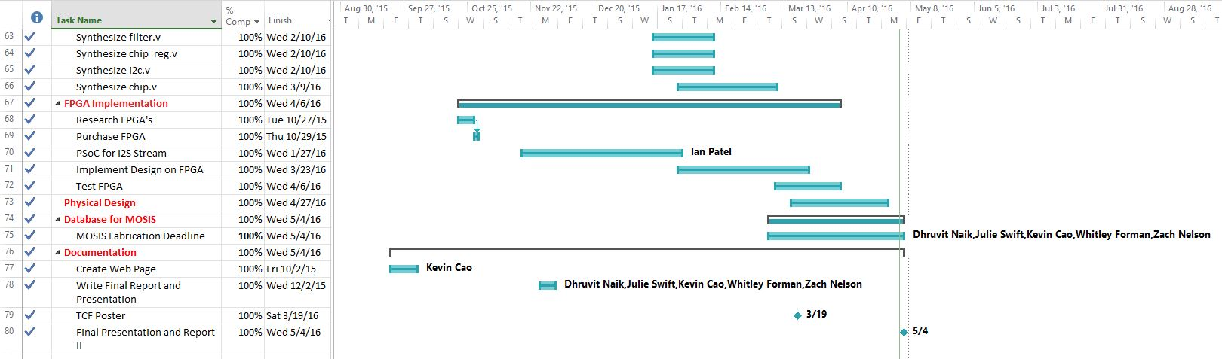

**Meeting Minutes:**

**Chip Requirements (June 11th Meeting)**

**Members in Attendance:** Dr. Pearlstein, Julie Swift and Zachary Nelson

* **Overall Goal**
  + **Produce an Audio Processing Integrated Circuit**
* I2S Interface
  + Audio Input: 2 channel stereo channel I2S (master interface)
  + Support audio input sample rates of 8kilosample/sec – 48kilosamples/sec
  + Output is the same sample rate as the input and I2S
  + Digital audio bit clock and the word select (ws) line will be controlled from master
  + Input and Output will be 2 channel 16 bits
* I2C Interface
  + Support single master configuration
  + 7-bit addressing and we will consume entire I2C address space
* Uses an external clock input
  + Clock frequency will be a minimum of 1200 times the audio sampling rate
  + Maximum clock rate will be 100 MHz
* Has an external reset pin
  + Power on reset
* Register Block
  + 512 bit frequency coefficients
  + 10k register bits
  + Register fields will include
    - Source select bit
      * Allows user to select between I2S and BIST (built in self test)
    - Filter Bypass Bit
      * 0 doesn’t bypass, 1 bypass
    - 512 16-bit signed coefficients stored as 2’s compliment
      * The effective radix point of the coefficients (4 bit number for data point, 4 bit number for coefficient)
    - Read only status register bits
      * Overflow/saturation detector – audio clipping
      * Input FIFO overrun
      * Output FIFO underrun
    - Control Bit Fields
      * 1 sticky bit to clear overrun
      * 1 sticky bit to clear underrun (stay until you clear them)
      * Clear Overflow Flag
      * Filter Order to Support
        + 9 bit number to represent 1 to 512
  + Presents an array of registers for hosts control and status monitoring (through I2C read and write operations).
* Provide built in self test function
  + Test gadgets for I2S
    - Test by converting I2S to audio coeffs
    - Audio coeffs to I2S
* Chips made by service call MOSIS
  + IBM7RF process, geometry, drawn gate length, 180nm gates, mixed signals,
  + Chip Area: no more than 3 by 3 squared mm
* Filter Audio
  + Implement an FIR filter on the input data based on the coefficients stored in the programmable registers
    - Programmable from 1-512 taps
    - Filter Order Control (9-bit number)
      * Support filter from 1-512 taps
    - Maintain intermediate precision of 4
* Produce a microcontroller platform to configure the audio input and output modules
  + UDA 1380
  + Produce a test fixture to show that the chip works
    - Sample analog audio and covert it to I2S
    - Receive I2S and convert it to analog audio
    - Allow user to create filter coeffs and upload them to the chip that was designed
    - Has to have software to configure the analog audio subsystem
    - Parametrize low pass filters, high pass, band pass, and comb filters
      * Use a button on a PSOC?
      * Could use slider on PSOC to change the frequency and upload the new coeffs to the chip
    - Create a board that we can plug the chip into to do testing
      * Bread board?
    - Will not have to design a printed circuit board for this chip

**June 18th Senior Project Meeting**

**Armstrong 144, 3:30 P.M – 5:05 P.M.**

**Members in Attendance:** Dr. Pearlstein, Zachary Nelson, Julie Swift, Whitley Forman and Dhruvit Naik

* Went through the CORE requirements hierarchy for the chip **(System Design Step)**
  + Zach will make the top-level requirements the elements from the chip block diagram so that the requirements are broken down in a more logical way
  + Zach will make an Enhanced Functional Flow Block Diagram (EFFBD) on CORE with the functions that were generated as part of creating the requirements
* Discussed the design flow of creating an integrated circuit
  + A figure illustrating this is on GitHub under Chip-Design/proj_asic/docs/design_flow.png
  + Major Steps
    - System Design
    - RTL Design
    - Logic Synthesis
    - Design for Test (DFT) Implementation – may be able to skip this
    - Floor Planning
    - Place and Optimization
    - Routing
    - Verification
* Deadline for the chip
  + November 30th: We would get the chip back in the Spring semester and be able to see if it works
  + March 2016: Would get the chip back after graduation and would implement our design on a FPGA during the Spring semester instead
* Dropbox will be used for storing private files
  + The rest of the code and documents will be stored on the public GitHub account
* Assigned Verilog modules to group members **(RTL Design Step)**
  + Everyone will start working on the modules over the summer
  + Zach: i2s_in.v and i2s_out.v
  + Julie: register.v
  + Whitley: i2c_slave.v
  + Dhruvit: filter.v
  + Kevin: chip.v
* Julie and Whitley need to hand in the NDA forms (electronically or in person)
* Kevin and Dhruvit need to accept the invite to the GitHub account

**July 7th I2S Senior Project Meeting**

**Dr. Pearlstein’s Office, 2:00 P.M – 5:10 P.M.**

**Members in Attendance:** Dr. Pearlstein and Zachary Nelson

* Register block bits will either start with “ro”, “rf”, or “trig”.
  + ro label for input.
  + rf label for outputs.
  + trig label when the bit causes something to trigger.
* Add the bit i2s_in_en to the I2S_IN block.
  + Low to high: coming out of reset.
  + High to low: goes back into a reset state.
* Need variables to characterize the BIST saw-tooth wave.
  + rf_bist_start_val (16 bit signed value) – start value.
  + rf_bist_inc (8 bit integer) – increment between 0 and 255.
  + rf_bist_upper_limit (16 bit signed value) – upper limit.
* We will create a synthesized sclk by dividing the system clock.
* Make all the flops clock with the system clock (always statements must be with clk).
* We will have a register holder that takes in one bit at a time.
* Add trig_i2sin_fifo_overrun_rst bit
  + Example:

if (ro_fifo_overrun) 🡪 happens when rts=1 and rtr=0

ro_fifo_overrun = 1

else if (trig_i2sin_fifo_overrun_rst)

ro_fifo_overrun = 0

**July 30th Senior Project Meeting**

**Dr. Pearlstein’s Office, 2:00 P.M – 3:40 P.M.**

**Members in Attendance:** Dr. Pearlstein and Zachary Nelson

* Discussed how register.v will use register addressing to access data.
* Discussed cell utilization and a rough approximation about how much area our chip will use (60% utilization)
* Went through **register_map.xlsx** with Dr. Pearlstein
  + Added new registers
  + Fixed register addressing
  + Added missing default values
* Added register fields that enable clipping for the filter and one that shifts the number of bit positions after the filter accumulator.
* Reviewed the block diagram of the **i2si.v** block.
  + This diagram seems to be correct and the block can start being designed and verification tests can be created.
* Discussed details of how the **i2so.v** will work.
  + Clock divider will go in this block
  + Zach wrote down a quick block diagram
* Block Documents Status
  + register.v – not started
  + i2si.v – near completion
  + i2so.v – not started
  + filter.v - not started
  + i2c.v - not started
* Zach and Kevin will switch roles.
  + Zach will be responsible for chip.v and can help with all blocks (especially i2s blocks)
  + Kevin will be responsible for the i2s blocks.

**September 2nd Register Senior Project Meeting**

**Dr. Pearlstein’s Office, 1:00-2:30**

**Members in Attendance:** Dr. Pearlstein, Zachary Nelson, and Julie Swift

* Project Goals Slide
  + Why are we doing this project?
    - This is not a common project for undergraduates because of the high cost associated with the fabrication of a chip.
    - Describe the MOSIS Education Service
    - Free fabrication for 3mm by 3mm
  + Also refer to this as VLSI
  + Explain the difference between an FPGA and an Integrated Circuit
  + Why did we choose to process audio as our application?
    - Complex and interesting enough
    - Not too hard so that this project is able to be completed
  + Take out parameterized filters
  + Put a picture of a chip
* Chip Overview Slide
  + I2S is digital but represents an analog signal
* DropBox is for confidential files while GitHub is for everything else
* I2C Slide
  + sda_in and sda_out are both interfaces
* Filter Slide
  + Fix the summation sign
* DFT Slide
  + We will most likely not be doing this task but it is good to have as background information.
* Gate Level Simulation
  + We will not do gate level simulation that intensively.
* Place and Route
  + We will not manually do the place and route, the EDA tools will do it for us.
  + We may be doing manual floor planning.
* Create a Block Level Testbenches Slide
  + We will have tb for each individual block as well as the overall chip
* Discussed interfaces for the register.v module
* Discussed a block diagram of the register.v module.
  + Ask Julie or Zach for more specifics
* MOSIS information
  + We can order one lot of 40 chips
  + We will fab using the Global Foundries 180 nm CMOS (7HV) process
  + MOSIS technology code for the 7HV process is GF_7HV
  + Customer Submission date for 7HV is **March 7th, 2016**

**September 2nd Senior Project Meeting**

**Armstrong Hall 137, 3:30 - 4:15 P.M.**

**Members in Attendance:** All Members

* Add a presentation slide on input/output cells
* The Format of the weekly meeting will be:
  + Discuss what the team has done over the past week
  + Discuss what the team is going to do over the next week and beyond
  + The most important thing is to discuss any roadblocks that we have
* One goal is to have the design implemented on a FPGA by the end of the fall semester
* Some tasks that can take place during the spring semester:
  + Place and Route
  + Verification
* We need to adopt a project management tool and create a schedule that is more sophisticated than the one that Dr. Katz has provided us with
  + One potential tool that we will look into is Microsoft Project
  + Be specific enough for about 3 milestones per week
* Manage the amount of time being put into senior project
  + Put the needed amount of time into the project but if we find ourselves each putting much more than 6 hours/week, we may need to narrow the scope of the project.
* Grading for Senior Project
  + 2 students will be graded by Dr. Hernandez and 3 students will be graded by Dr. Pearlstein
  + The rubrics for Senior Project I and II was distributed by Dr. Katz in an email
* What FPGA will we use for the project?
  + We could use one that is already in stock
  + We could purchase one with the $500 that the group has
* Julie and Dhruvit will be responsible for EDA Installation
  + Step 1: Figure out the EDA requirements and install OS
  + Step 2: Install EDA
  + Step 3: Simple test case with libraries from MOSIS and doing a place and route test
* We need to discuss who will be responsible for configuring the test fixtures.
* We will hold off on the website design until we hear more information.

**For Next Week:**

* We need to create a detailed plan/schedule for the project using a tool like Microsoft Project
* Everybody needs to finish their block documents for their specific modules
* Everybody needs to add the information about their module to the CORE 9 project

**September 9th Senior Project Meeting**

**Armstrong Hall 137 and 144: 4:00 – 5:15 P.M.**

**Members in Attendance:** All Members

**Next Week’s Work Plans:**

* **Zach**
  + Fix Schedule
  + RTR/RTS and XFC Protocol
  + Buying an FPGA and seeing if the school one will work
  + CORE for I2S Blocks
  + Start coding one of the I2S submodules (BIST Generator?)
* **Whitley**
  + Start coding the I2C module
  + CORE 9 for I2C Requirements
* **Julie**
  + EDA Tool Installation
  + Complete Register Block Documentation
  + Start coding the Register module
  + CORE 9 for Register Requirements
* **Kevin**
  + Complete one submodule for the I2S Block (Deserializer?)
  + Create test benches and test this submodule
  + CORE 9 for I2S Blocks
* **Dhruvit**
  + EDA Tool Installation
  + Start coding the Filter module
  + CORE 9 for the Filter module

**Meeting Notes:**

* The RTS/RTR and XFC protocols need to be in one place
  + Zach assigned as the owner to this
  + Should be finished by next Wednesday
* EDA Tools should be installed and a simple place and route test should be completed by next week
  + We will be downloading Mentor Tools
  + An action item is to contact by email or in person Mike about installing the tools
* Things that need to be added/changed for the Microsoft Project schedule
  + Creating test benches
  + Create test cases for individual blocks
  + Creating test cases
  + Correction: Microcontroller not “board” will be linked to the chip
  + Shorten the milestone names
  + Block level synthesis
  + Full chip simulation
* CORE requirements and use cases can be integrated to write test specifications
  + The new CORE license works
* Dr. Hernandez will give feedback on the schedule
* Dhruvit and Julie have access to 144-B
  + This is where we will be installing the EDA tools
  + Can we remotely connect to this computer-Ask Mike?
* Chip.v
  + Will instantiate everyone’s modules
  + We will need to create input/output submodules
* Create model in another environment that takes in the register states and inputs and produces the correct output
  + An end to end test case
  + This is used to verify that we are producing the correct outputs in our chip
  + Does not need to be the most sophisticated model due to time
* Test benches will be stored on the “tb” folder on GitHub
* FIFO will be very similar for all blocks
  + The only difference will be the size and the width
* Need to buy crystal oscillators (10, 20, or 100?)
* Whitley will do board design in spring semester
* PSoC configuration will take 1-2 weeks of time
  + Whitley may be assigned to this task

**September 23rd Senior Project Meeting**

**Armstrong Hall 137: 3:30-4:00 P.M.**

**Members in Attendance:** Dr. Orlando Hernandez, Zachary Nelson, Julie Swift, Dhruvit Naik and Kevin Cao

**Last Week’s Work:**

* Zach
  + Cleaned up RTS/RTR and XFC Protocols
  + Updated CORE 9 Files
  + Updated Schedule on Microsoft Project
    - Everyone agreed on due dates
    - Created a calendar on Google
  + Continued working on i2si_bist_gen.v
* Kevin
  + Continued working on i2si_deserializer.v
  + Looked into setting up the project website
* Dhruvit
  + Continued working on filter_convolution.v
* Julie
  + Continued working on register block document and register.v
* Whitley
  + Continued working on i2c_slave_deserializer.v

**Next Week’s Due Dates:**

* Friday, September 25th
  + Install Linux on Machine in Room 144B (Dhruvit and Julie)
* Monday, September 28th
  + Finish Design and Testing: filter_convolution.v (Dhruvit)
  + Install EDA Tool on Machine in Room 144b (Dhruvit)
* Wednesday, September 30th
  + Finish Design and Testing: i2c_salve_deserializer.v (Whitley)
  + Finish Design and Testing: i2si_bist_gen.v (Zach)
  + Finish Design and Testing: i2si_deserializer (Kevin)

**Meeting Notes:**

* We should have a testing specification when we perform testing
  + Multiple smaller unit tests are better than a couple of large comprehensive tests for our blocks
* Dr. Hernandez offered to present his presentation slides on Verilog to the group
  + All of the Verilog modules will have 3 always statements
  + The group will look over the slides and let Dr. Hernandez know if this will be beneficial

**September 30th Senior Project Meeting**

**Armstrong Hall 137: 3:30-3:30**

**Members in Attendance:** All Members

**Last Week’s Work:**

* Linux Installed
  + Permission errors
  + Need to email passwords
  + Root password: icchip2015
* Zach
  + Bist generator
  + Rts and rtr

**Next Week’s Due Dates:**

* Last Week:
  + Finish Design and Testing of i2si_deserializer.v (Zach and Kevin)
    - 1 week for the deserializer.v
  + filter_convolution.v (Dhruvit)
  + Testing of Whitley’s block
    - 1 week for testing
* Friday, September 2nd
  + Create Web Page (Kevin)
  + Finish Design and Testing of filter_accumulator.v (Dhuvit)
* Wednesday, September 7th
  + Finish Design and Testing of i2so_serializer.v (Zach and Kevin)
  + Finish EDA Tool Installation (Dhruvit and Julie)
  + Place and Route Test (Dhruvit and Julie)
  + PDR Presentation #2 (All)

**Meeting Notes:**

* Zach will make a test fixture
* Action items
  + Investigate the use of mentor tools for place and route ()
* Asynchronous vs synchronous reset
  + We will use asynchronous
  + Add to rtr protocols

**January 26th Senior Project Meeting**

**Armstrong Hall 148: 2:00PM – 2:45PM**

**Members in Attendance:** All Members

**Goals for Next Week:**

* Kevin
  + Fix BIST issues
  + Testbenches with different clock ratios
  + Learn how to use Mentor Tools
* Dhruvit
  + Fix Filter Warnings
  + Mentor Tools
* Whitley
  + Register/I2C Subsystem
  + Subsystem Test
* Zach
  + I2S/Filter Subsystem
  + Register Help
  + FPGA
* Julie
  + Register/I2C Subsystem
  + Subsystem Test
* Ian
  + PSoC Program

**February 2nd Senior Project Meeting**

**Armstrong Hall 148: 2:00PM – 3:00PM**

**Members in Attendance:** All Members

**Goals for Next Week:**

* Updated Microsoft Project Plan
  + Plan 2.0
* Coordinate with Ian
* Whitley
  + Last Week
    - Got the submodule test finished
  + Next Week
* Julie
  + Last Week
    - Got the submodule test finished
  + Next Week
    - Continue working on
* Kevin
  + Last Week
    - More testing on I2S
    - Looked into EDA tools
    - Matching tools with different stools
  + Next Week
    - Get libraries installed
    - Place and Route
    - Working with Dhruvit
* Zach
  + Last Week
    - Fixed issues
  + Next Week
    - Coordinate with Ian
    - Create New Plan
    - FPGA Implementation
* Dhruvit
  + Last Week
    - EDA tools are stables
  + Next Week
* Steps
  + Coding
  + Simulation/Verification
  + Synthesis 🡪 netlist
  + Physical Design
  + Place and Route
  + GSDII Masks File

OR you can start

* Manual schematic capture of IO cells

**February 10th Senior Project Meeting**

**Armstrong Hall 148: 2:00PM – 3:00PM**

**Members in Attendance:** All Members

* Zachary
  + Last Week
    - Created the presentation
    - Worked on the I2S/Filter Subsystem
    - Updated the top-level drawing
    - Created an updated schedule
    - Added all code to chip.v
      * All Verilog code is in chip.v and is synthesizable
      * Need help with a testbench
  + Next Week
    - Top-level testbench
    - Work on chip.v
* Whitley and Julie
  + Last Week
    - Register and I2C blocks working together
    - Loading register values works
  + Next Week
    - Top-level testbench
    - Implement FPGA for I2C
* Kevin
  + Last Week
    - Helped I2S/Filter module
    - EDA Tools tutorials
* Dhruvit
  + Last Week
  + Next Week
    - More verification of filter block

**March 1st Senior Project Meeting**

**Armstrong Hall 148: 2:00PM – 2:45PM**

**Members in Attendance:** All members

* Zach
  + Last Week
    - Uploaded Ian’s PSoC Program
    - Updated chip.v
    - Worked TCF poster
    - Updated schedule
    - Worked with PlanAhead Tutorial
    - Created document for final report
    - Realistic constraints form
    - Xilinx ISE will work
  + Next Week
    - Work with PlanAhead
    - Help finish Ian’s I2S PSoC Program
    - Work on TCF Poster
  + Questions
    - When should we give you a TCF poster draft by?
      * Before break
    - What speed is FPGA? -3, -2, -1
      * Look in the data sheet
    - Can you help with PlanAhead?
      * Will meet with Dr. Pearlstein
    - How do we specify the I/O ports?
      * Will meet with Dr. Pearlstein
* Julie
  + Last Week
    - Looked into EDA tools from Princeton
    - Updated register Verilog code
    - Updated register Excel document
  + Next Week
    - Physical Design
* Dhruvit
  + Last Week
    - Filter model in Java
    - Fixed issues with filter Verilog code
  + Next Week
    - Physical Design
* Kevin
  + Last Week
    - Top-level simulation/verifications
    - I2S debugging
  + Next Week
    - Continue verification
* Whitley
  + Last Week
    - Created multiple test benches with different register values
  + Next Week
    - Continue verification
* Additional Comments
  + Source and sink could come from UDA 1300
  + Might need to buy this

**March 8th Senior Project Meeting**

**Armstrong Hall 148: 2:00PM – 2:30PM**

**Members in Attendance:** Zach, Dhruvit, Kevin, Whitley, Dr. Hernandez, and Dr. Pearlstein

* Zach
  + Last Week
    - Finished TCF Poster
    - Learned how to use Plan Ahead software
    - Set up clock signal and specified I/O ports
    - Fixed Realistic Constraints Form
  + This Week
    - Warnings for Xilinx ISE
    - Finish design in Plan Ahead
    - Get poster printed
* Dhruvit
  + Last Week
    - Top-Level Simulation
    - Looked at Physical Design presentation
  + This Week
    - Get a plan for the physical design
* Julie
  + Last Week
    - Looked at Physical Design presentation
  + This Week
    - Get a plan for the physical design
* Kevin
  + Last Week
    - Top-Level Simulation
    - Text file comparison
  + This Week
    - Install Model-Sim (Dhruvit might help)
    - Fix warnings
    - Clean up code
* Whitley
  + Last Week
    - Top-Level Simulation
  + This Week
    - I2C PSoC Program
    - Fix I2C always block
* Automate testing process using make file

**March 22nd Senior Project Meeting**

**Armstrong Hall 148: 2:00PM – 3:00PM**

**Members in Attendance:** Zach, Dhruvit, Kevin, Whitley, and Dr. Pearlstein

* Zach
  + Last Week
    - Fixed Abstract
    - Worked with I2S PSoC program
    - Fixed some RTL issues
  + This Week
    - Work with Ian on PSoC program
    - Keep updating top-level
    - Get clock verified on FPGA
    - Open drain and resistor for I2C
    - Output voltage on Artix board
    - DA conversion in PSoC
* Dhruvit
  + Last Week
    - Researched how to use EDA tools
    - Having trouble logging into machine while on campus
  + This Week
    - Continue working with physical design
* Kevin
  + Last Week
    - Downloaded ModelSIM
    - I2S block works without optimization
  + This Week
    - Continue fixing synthesis warnings
* Whitley
  + Last Week
    - Started I2C PSoC program
  + This Week
    - Continue I2C PSoC program
    - Test I2C on FPGA

**March 29th Senior Project Meeting**

**Armstrong Hall 148: 2:00PM –**

**Members in Attendance:** Zach, Dhruvit, Kevin, Whitley, and Dr. Pearlstein

* Zach
  + Last Week
    - Got all correct port mappings
    - Fixed all but one FPGA warnings
    - Ian finished PSoC program and show me how to use it
      * I tested it and it seems to work
    - Wrote FPGA guide
    - Created a realistic test environment with I2S input stream
      * Nothing on I2S output (might be a reset issue)
    - Updated website
  + This Week
    - Further testing and debugging of FPGA
    - More code documentation
* Dhruvit
  + Last Week
    - Drew a transistor in EDA tools
  + This Week
    - Design rule check
    - Research on how to make inductor
    - Power and ground routing
    - MOSIS GSDII file requirements
    - Implementation warning
* Kevin
  + Last Week
    - Fixed warnings
  + This Week
    - Help Dhruvit
* Whitley
  + Last Week
    - Fixed I2C warnings
    - PSoC I2C program
  + This Week
    - I2C program
    - Default register state
* Julie
  + Last Week
    - Playing around and learning the EDA tool
    - Fixed overrun/underrun setting that Kevin told me to correct
    - Added comments to code
  + This Week
    - Help Dhruvit

**April 5th Senior Project Meeting**

**Armstrong Hall 148: 2:00PM – 3:00PM**

**Members in Attendance:** Zach, Dhruvit, Kevin, Whitley, Dr. Pearlstein, and Dr. Hernandez

* Zach
  + Last Week
    - Set up final report and presentation
    - Added comments to code
    - Fixed chip output
    - Passed sine, triangular, and square wave through FPGA
    - Started a testing document for FPGA
  + This Week
    - Work on reset warning
    - Further testing of FPGA (maybe with filtering and I2C)
  + Questions
    - VDDIO on PSoC? 🡪 Should be fixed now
* Dhruvit
  + Last Week
    - Made some changes to register.v, filter_mux.v, filter_round_truncate.v
    - Created a new testbench that does not use I2C
    - Worked with EDA tools
    - Worked on FPGA warning
  + This Week
    - Create different filter coefficient combinations to test on FPGA
    - Continue working with physical design of a chip
* Kevin
  + Last Week
    - Testing of chip.v
    - Worked with EDA tools
  + This Week
    - Continue working with physical design of a chip
* Whitley
  + Last Week
    - Worked on I2C PSoC program
  + This Week
    - Finish I2C PSoC program
    - Test I2C PSoC program on FPGA
* Julie
  + Last Week
    - Worked with EDA tools
  + This Week
    - Continue working with physical design of a chip

**List of Contacts:**

* Ann Zsilavetz - Computer Science Program Assistant (zsilave2@tcnj.edu)
* Chris Collins - Lab Technician (collinsc@tcnj.edu)
* Katie Thacker - CORE University Program Coordinator (kthacker@vitechcorp.com)
* Michael Mensch – Information Technology (mensch@tcnj.edu)

**Safety Considerations:**

The major safety concern with this project involved interfacing the microcontroller with the FPGA. By taking the following precautions, no events compromising the safety of the team occurred. Since both the FPGA and microcontroller used 3.3V logic, we did not have to worry about any problems with high voltage. We made sure there were no loose wires by keeping our wiring as organized as possible. When working with the FPGA, we did not allow any food or drinks around the board in order to prevent damage. We were also aware of the fact that either the microcontroller or FPGA could start smoking. These chemicals could potentially be dangerous and we were aware to contact Chris Collins if this ever occurred.

**Material List:**

*Software Materials*:

* CORE 9 University
* Dropbox
* Git/GitHub
* Linux RedHat Operating System
* Microsoft Project 2013
* Mentor Graphics Software
* ISE Design Suite 14.7

*Hardware Materials*:

* CY8CKIT-050 PSoC 5LP Development Kit
* Nexys 4 Artix-7 FPGA Board
* Stock Room Materials (wires, wire cutters, etc.)

**Financial Budget:**

|  |  |  |
| --- | --- | --- |
| **Item** | **Cost** | **Comment** |
| CORE 9 University | $0.00 | Vitech’s CORE in the Classroom program |
| Dropbox | $0.00 | Free up to 2GB of storage |
| Git/GitHub | $0.00 | Free software |
| Linux RedHat Operating System | $0.00 | TCNJ Subscription |
| Microsoft Project 2013 | $0.00 | Free from the Computer Science Department’s DreamSpark Program |
| Mentor Graphics Software | $0.00 | TCNJ Subscription |
| ISE Design Suite 14.7 | $0.00 | Free software |
| CY8CKIT-050 PSoC 5LP Development Kit | $0.00 | School already owns |
| TI PCM9211 Digital Audio Transceiver and ADC | $72.87 | Purchased from Digilent |
| Nexys 4 Artix-7 FPGA Board | $192.41 | Purchased from Digilent |
| **Total Budget** | $500.00 |  |
| **Total Costs** | $265.28 |  |
| **End Balance** | $234.72 | Well under-budget |

**Appendix C: Source Code**

chip.v (top-level module) 4

Filter Code 4

filter.v 4

filter_accumulator.v 4

filter_mux.v 4

filter_stm.v 4

filter_storage.v 4

filter_round_truncate.v 4

I2C Code 4

i2c.v 4

i2c_deserializer.v 4

i2c_sequencer.v 4

i2c_serializer.v 4

I2S Input Code 4

fifo.v 4

i2s_in.v 4

i2si_bist_gen.v 4

i2si_deserializer.v 4

i2si_mux.v 4

i2si_synchronizer.v 4

I2S Output Code 4

i2s_out.v 4

i2so_serializer.v 4

Register Code 4

chip_reg.v 4

register.v 4

trig_generator.v 4

WILL BE PROVIDED IN FINAL DRAFT

**Appendix D: Test Benches**

chip.v (top-level module) 4

WILL BE PROVIDED IN FINAL DRAFT

**Appendix E: Industry Specifications**

I2C Specification 4

I2S Specification 4

WILL BE PROVIDED IN FINAL DRAFT